

**MCA Semester – III**

**Front End Development Project**

|  |  |
| --- | --- |
| **Name** | **Dikshitha P Jain** |
| **USN** | **212VMTR00717** |
| **Elective** | **Full Stack Development** |
| **Date of Submission** | **9th June 2023** |



# Front End Development Project - Report

Project Report submitted to Jain Online (Deemed-to-be University) as part of the course “Front End Development Project”

# Master of Computer Applications

*Submitted by*

**Dikshitha P Jain**

*USN*

**212VMTR00717**

*Under the guidance of*

**Ms. Priti Sekhsaria**

# DECLARATION

I, *Dikshitha P Jain,* hereby declare that this Project Report has been prepared by me under the guidance of *Ms. Priti Sekhsaria.* I declare that this Project is towards the partial fulfillment of the credit requirement for the course “Front End Development Project,” which is part of the Master of Computer Applications degree given by Jain University, Bengaluru. I declare that the work done by me towards this Project is original in nature and is my own contribution.

|  |  |
| --- | --- |
| Place: Bangalore | ______________________ |
| Date: 6 May, 2023 | *Dikshitha P Jain* |

*USN:212VMTR00717*

# CERTIFICATE

This is to certify that the Project report submitted by Ms. *Dikshitha P Jain* bearing *(212VMTR00717)* on the title **“Front End Development Project”** is a record of project work done by her during the academic year 2022-23 under my guidance and supervision in partial fulfillment of Master of Computer Applications.

Place: ____________________

Date: *Faculty Guide*

# ACKNOWLEDGEMENT

Working on this *Frontend Development Project* was interesting. During these six months I learnt a lot about website building. It enhanced my knowledge of both bootstrap and javascript.

Therefore, I am grateful to the people of JAIN Online for the chance to make this project. I especially want to thank Professor Priti Sekhsaria and Program manager Shreya Arora for giving me the possibility to attend and complete this project successfully.

Further on, I want to thank the students who made this demanding time joyful but always efficient.

____________________

*Dikshitha P Jain*

*USN:212VMTR00717*

# EXECUTIVE SUMMARY

Spring Flowers School has created an online portal for their students. This portal contains all the information about a student including their results, timetable, activities etc.

To access the portal, the student first has to login with the username and password provided by the School. They are prompted with an appropriate error message in case of invalid login.

Upon logging in, the student is redirected to the home page of this portal where he/she can find few images of the university. This page will also showcase the extra activities performed by the student.

The student can navigate between different pages of the portal by choosing the requirement from the navigation bar. The sections that the student can visit are:

1. Time table page
2. Exam result page
3. Extra activities page
4. Profile page

The time table page of the portal contains the time table of the student along with the timing for each class and break/lunch hours. This can also be customised to display different time table for each class by using JSON.

The exam result page contains the result of each subject. It also has an option to view the consolidated report of all the subjects along with the grade. This result is different for each student. It is based on the marks obtained by the student as per the information that is provided in the JSON file. Depending on the marks obtained, the grade is calculated based on the following criteria:

|  |  |
| --- | --- |
| **Marks Obtained** | **Grade** |
| 85-100 | Distinction |
| 75-84 | First Class |
| 60-74 | Second Class |
| 40-59 | Third Class |
| 0-39 | Fail |

The profile page of the portal contains all the information of the student. It includes the following:

1. Student name
2. Student id
3. Date of birth
4. Student address
5. Student phone
6. Student email
7. Student blood group
8. Class
9. Father’s name
10. Father’s email
11. Father’s phone
12. Mother’s name
13. Mother’s email
14. Mother’s phone

This information is displayed by gathering the details from the JSON file. Therefore, it is different for each student.

The portal also contains a footer on each page by using which a user can navigate to different pages of the portal. It also contains information about the school such as location (it redirects the student to the google map), phone and email.

# TABLE OF CONTENTS

|  |  |
| --- | --- |
| **Title** | **Page Nos.** |
| Executive Summary | 6 |
| Introduction | 9 |
| Objectives | 11 |
| Project Description | 13 |
| Additional Features | 15 |
| Flowchart | 16 |
| Coding | 17 |
| Output | 93 |
| Validation | 113 |
| Conclusion | 114 |

# Introduction

## 1.1 Problem Statement – 1

* Student Management
* Spring Flowers school wants to create a online portal for their students.
* User Stories: -

1. As a student, I should be able to see the Welcome page of my application.
2. As a Student, I should be able to see a MENU bar and School logo in the welcome page.
3. The MENU bar should contain the following options:

* Time Table
* Exam Result
* Extra Activity
* Student Profile
  + - Instructions: -
* Use HTML 5 and CSS 3 concepts.
  1. **Problem Statement – 2**
* Student Management
* Spring Flowers school wants to create a online portal for their students.
  + - User Stories:-
      * As a student, I should be able to see my Time Table in a new web page after clicking the timetable button.
      * As a student, I should be able to see my Information in a new web page after clicking the Student Profile Button.
      * As a student, I should be able to see the grades of a student in a new webpage after clicking the exam results button. Subject should be selected from the drop box.
    - Instructions:-
      * Please use HTML 5 and CSS 3 concepts
  1. **Problem Statement – 3**
* Student Management
* Spring Flowers school wants to create a online portal for their students.
  + - User Stories:-
      * As a student, I should be able to see login page as a first page. In the login page, I should be able to enter my user name and password and click on the login button.
      * As a student, I should be able to see the Welcome page only if the student is valid.
      * As a Student, I should be able to see my name on the top of the application on every page once I have logged in the application.
      * As a student, I should be able to enter the extra activities I have done for the day in a new page after clicking the Extra Activity Button. Once submitted I should be able to see the activity on the welcome page
    - Instructions:-
      * Please use HTML 5 and CSS 3 concepts.
      * Use JavaScript for Onclick activities.

## 1.4 Problem Statement - 4

* Student Management
* Spring Flowers school wants to create a online portal for their students.
  + - User Stories:-
      * Multiple users should be able to login to the application with different username and password for each user. (Minimum 3)
      * The grade for each user must be different and should be displayed on the exam result page when clicked.
      * The Student Profile page should display the student profile according to the user that has logged in.
    - Instructions:-
      * Please use HTML 5 and CSS 3 concepts.
      * Use JavaScript for Onclick activities.
      * Please use JSON file instead of arrays.

# 2. Objectives

## 2.1 Problem Statement – 1

## To create an online portal for Spring Flowers school students that provides access to their academic information and resources.

## The portal should have a Welcome page with a MENU bar and School logo, and the MENU bar should contain options for viewing the student's Time Table, Exam Result, Extra Activity, and Student Profile.

## The project should be implemented using HTML 5 and CSS 3 concepts, and should provide a user-friendly and visually appealing interface for students to easily navigate and access their academic information.

## The end result should be a reliable and efficient student management system that enhances the overall learning experience for the students.

**2.2 Problem Statement - 2**

* To display the time table when the user navigates to the time-table page.
* To display the Student and Parent information in Student Profile.
* To display the marks of the student as per the chosen Subject.

Use the concepts of HTML, CSS, BootStrap and JavaScript to implement the same such that the website is responsive on all kinds of devices.

**2.3 Problem Statement - 3**

* To display login page as the first page and verify if the inputs are valid or not before logging in.
* To display home page only if the user is valid.
* To display the name of the Student on every page along with a dropdown to view student profile or logout.
* To gather extra activities details. Save them and display on home page.

Use the concepts of HTML, CSS, BootStrap and JavaScript to implement the same such that the website is responsive on all kinds of devices.

## 2.4 Problem Statement – 4

* To allow multiple users to log into the portal based on the username and password in the JSON file.
* To display a different result for each user when he/she navigates to the Exam Result page.
* To display the student profile according the user that has logged in.

Use the concepts of HTML, CSS, BootStrap and JavaScript to implement the same such that the website is responsive on all kinds of devices. Also, use JSON file instead of arrays for displaying information for a specific student.

# 3. Project Description

## 3.1 Problem Statement – 1

## Spring Flowers school has decided to create an online portal for their students to access their academic information and resources. The goal of this project is to develop a user-friendly and visually appealing platform that provides easy access to important information related to the student's academic progress and activities.

## The Student Management Portal will have a Welcome page that will serve as the landing page for the application. The Welcome page will have a MENU bar and the school logo, which will be prominently displayed to help students navigate the portal. The MENU bar will contain options for viewing the student's Time Table, Exam Result, Extra Activity, and Student Profile.

## The project will be implemented using HTML 5 and CSS 3 concepts to create a visually appealing and responsive design that can be easily accessed on desktop and mobile devices. The website should be designed in a way that provides a seamless user experience and enhances the overall learning experience for the students.

**3.2 Problem Statement – 2**

* The website will be responsive and adjust itself according to the device type. It is implemented using HTML, CSS, BootStrap and JavaScript.
* When the user selects the Time table item of the navbar menu, he/she will be redirected to the time table webpage where they can find their time table.
* When the user selects the result item of the navbar menu, he/she will be able to find the marks obtained in a subject along with the grade. The student can also view their consolidated marks in the form of a table.
* Upon selecting the student profile item, the student will be able to view the details provided. It will include their name, USN, self and parent details.

**3.3 Problem Statement – 3**

* The website will be responsive and adjust itself according to the device type. It is implemented using HTML, CSS, BootStrap and JavaScript.
* When the user enters their details to login, their credentials will be verified before they are logged in and redirected to the home page. An error message will be displayed in case the user enters no or wrong details. He/she will be redirected to the home page if the login is valid.
* The user will be able to view their username on every page of the website. This username is stored using sessionStorage upon successful login.
* The user will be able to add any kind of extra activity done by him/her along with a description. These details are stored using localStorage. This list of extra activities will be displayed on the home page.

## 3.4 Problem Statement – 4

* The website will be responsive and adjust itself according to the device type. It is implemented using HTML, CSS, BootStrap and JavaScript.
* When the user enters their details to login, their credentials will be verified before they are logged in and redirected to the home page. An error message will be displayed in case the user enters no or wrong details. He/she will be redirected to the home page if the login is valid. As of now, 3 different users (details of which are mentioned in the JSON file) can login to the portal.
* The result of each student will be different. It will be based on the information that is provided in the JSON file.
* The student profile page will display the student details as per the information provided in the JSON file.

# Additional Features

* View consolidated result of all subjects.
* External link to a google map which will redirect user to the school’s location.

# 5. Flowchart

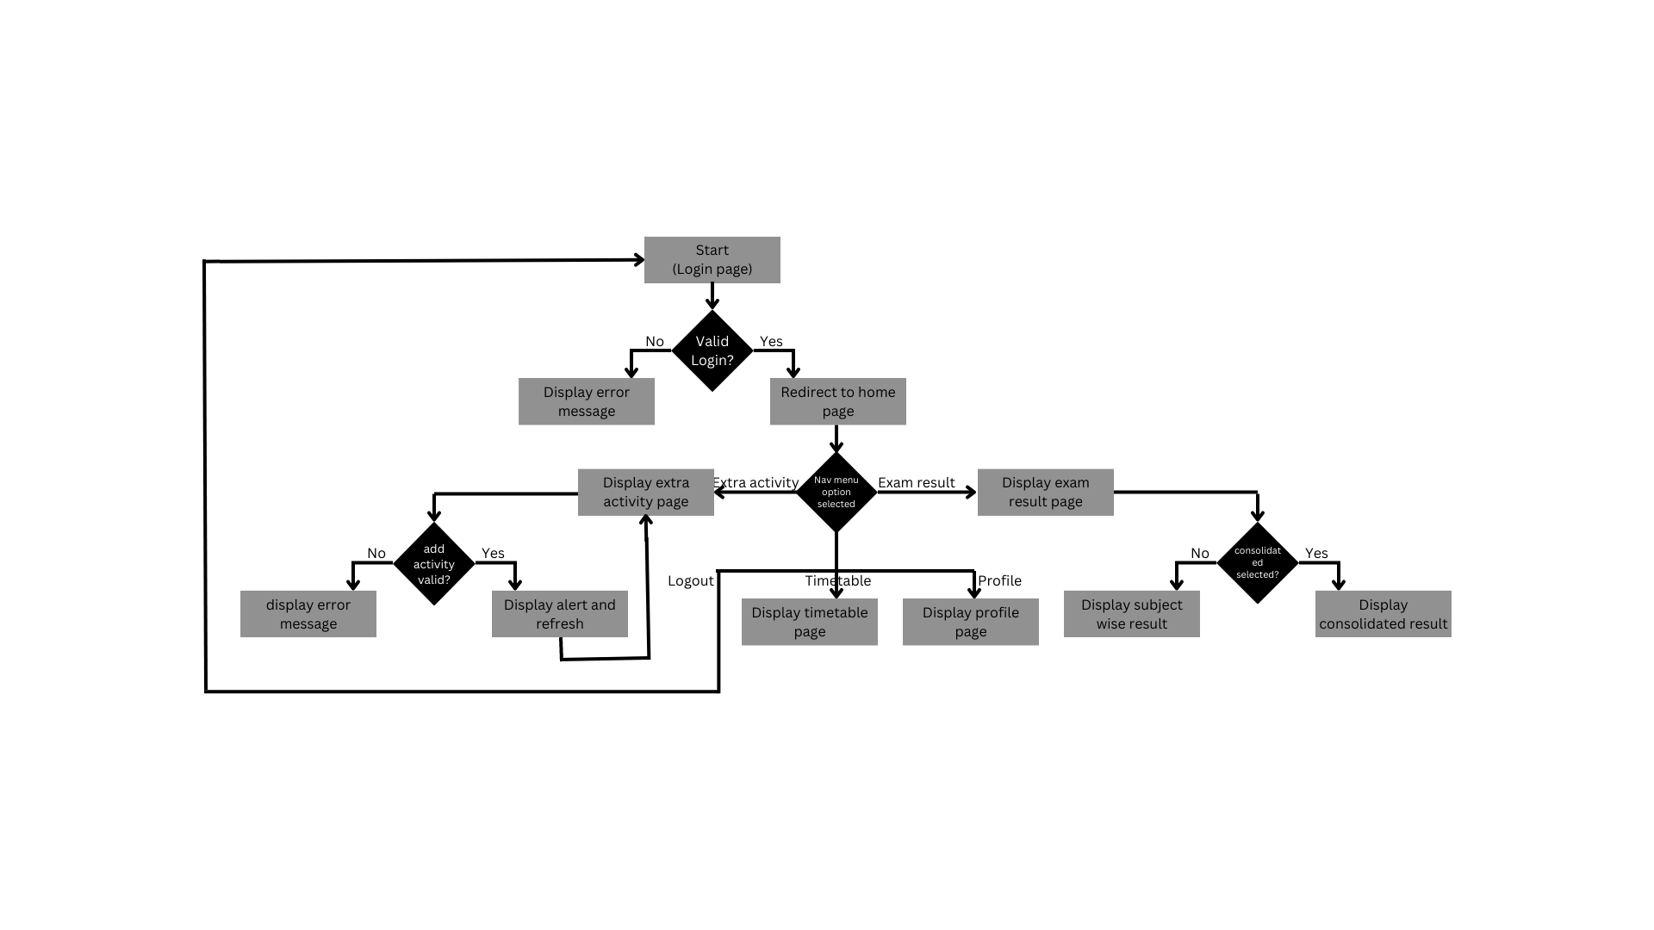

# Coding

**6.1 Checkpoint – 1:**

Index.html

<!DOCTYPE html>

<html lang="en">

<head>

<meta charset="UTF-8">

<meta http-equiv="X-UA-Compatible" content="IE=edge">

<meta name="viewport" content="width=device-width, initial-scale=1.0">

<title>Spring Flowers School</title>

<link href="https://cdn.jsdelivr.net/npm/bootstrap@5.3.0-alpha3/dist/css/bootstrap.min.css" rel="stylesheet" integrity="sha384-KK94CHFLLe+nY2dmCWGMq91rCGa5gtU4mk92HdvYe+M/SXH301p5ILy+dN9+nJOZ" crossorigin="anonymous">

<link rel="stylesheet" href="index.css">

</head>

<body>

<nav class="navbar navbar-expand-lg">

<div class="container-fluid">

<a href="#" class="navbar-brand"><img src="logo.png" alt="School logo" width="30" height="24">

Spring Flowers School

</a>

<div id="navbarNav">

<ul class="navbar-nav">

<li class="nav-item"><a class="nav-link" href="#">Time Table</a></li>

<li class="nav-item"><a class="nav-link" href="#">Exam Result</a></li>

<li class="nav-item"><a class="nav-link" href="#">Extra Activity</a></li>

<li class="nav-item"><a class="nav-link" href="#">Student Profile</a></li>

</ul>

</div>

</div>

</nav>

<!-- <img class="display-img"src="school.jpeg" alt="School Image"> -enecccbjevdjfkdirnftlvuhnhthifbnvnbivbgtkvie -->

<script src="https://cdn.jsdelivr.net/npm/bootstrap@5.3.0-alpha3/dist/js/bootstrap.bundle.min.js" integrity="sha384-ENjdO4Dr2bkBIFxQpeoTz1HIcje39Wm4jDKdf19U8gI4ddQ3GYNS7NTKfAdVQSZe" crossorigin="anonymous"></script>

</body>

</html>

Index.css

body {

background-image: url(school.jpeg);

object-fit: cover;

background-repeat: no-repeat;

background-size: cover;

}

.navbar {

background-color:lavender ;

}

**6.2 Checkpoint – 2:**

Index.html

<!DOCTYPE html>

<html lang="en">

<head>

<meta charset="UTF-8">

<meta http-equiv="X-UA-Compatible" content="IE=edge">

<meta name="viewport" content="width=device-width, initial-scale=1.0">

<title>Spring Flowers School</title>

<link rel="shortcut icon" href="school_logo.png" type="image/x-icon">

<link href="https://cdn.jsdelivr.net/npm/bootstrap@5.3.0-alpha3/dist/css/bootstrap.min.css" rel="stylesheet" integrity="sha384-KK94CHFLLe+nY2dmCWGMq91rCGa5gtU4mk92HdvYe+M/SXH301p5ILy+dN9+nJOZ" crossorigin="anonymous">

<link rel="stylesheet" href="index.css">

</head>

<body>

<!-- Nav bar -->

<nav class="navbar navbar-expand-lg">

<div class="container-fluid">

<a href="#" class="navbar-brand"><img src="school_logo.png" alt="School logo" width="30" height="24">

Spring Flowers School

</a>

<button class="navbar-toggler" type="button" data-bs-toggle="collapse" data-bs-target="#navbarSupportedContent" aria-controls="navbarSupportedContent" aria-expanded="false" aria-label="Toggle navigation">

<span class="navbar-toggler-icon"></span>

</button>

<div class="collapse navbar-collapse navbar-text" id="navbarSupportedContent">

<ul class="navbar-nav me-auto mb-2 mb-lg-0">

<li class="nav-item"><a class="nav-link" href="timetable.html">Time Table</a></li>

<li class="nav-item">

<a class="nav-link" href="exam_result.html">Exam Result</a>

</li>

<li class="nav-item"><a class="nav-link" href="#">Extra Activity</a></li>

<li class="nav-item"><a class="nav-link" href="student_profile.html">Student Profile</a></li>

</ul>

</div>

</div>

</nav>

<!-- Image slider -->

<div id="carouselExampleAutoplaying" class="carousel slide" data-bs-ride="carousel">

<div class="carousel-indicators">

<button type="button" data-bs-target="#carouselExampleDark" data-bs-slide-to="0" class="active" aria-current="true" aria-label="Slide 1"></button>

<button type="button" data-bs-target="#carouselExampleDark" data-bs-slide-to="1" aria-label="Slide 2"></button>

<button type="button" data-bs-target="#carouselExampleDark" data-bs-slide-to="2" aria-label="Slide 3"></button>

</div>

<div class="carousel-inner">

<div class="carousel-item active">

<img src="school.jpeg" class="d-block w-100" alt="...">

</div>

<div class="carousel-item">

<img src="school_2.jpeg" class="d-block w-100" alt="...">

</div>

<div class="carousel-item">

<img src="school_3.jpeg" class="d-block w-100" alt="...">

</div>

</div>

<button class="carousel-control-prev" type="button" data-bs-target="#carouselExampleAutoplaying" data-bs-slide="prev">

<span class="carousel-control-prev-icon" aria-hidden="true"></span>

<span class="visually-hidden">Previous</span>

</button>

<button class="carousel-control-next" type="button" data-bs-target="#carouselExampleAutoplaying" data-bs-slide="next">

<span class="carousel-control-next-icon" aria-hidden="true"></span>

<span class="visually-hidden">Next</span>

</button>

</div>

<!-- Footer -->

<footer class="bd-footer py-4 py-md-5 mt-5 bg-secondary-subtle">

<div class="container py-4 py-md-5 px-4 px-md-3 text-body-secondary">

<div class="row">

<div class="col-lg-3 mb-3">

<a class="d-inline-flex align-items-center mb-2 text-body-emphasis text-decoration-none" href="/">

<span class="fs-5">Spring Flowers School</span>

</a>

<ul class="list-unstyled small">

<li class="mb-2">Designed and built with all the love in the world by Dikshitha.

</ul>

</div>

<div class="col-6 col-lg-2 offset-lg-1 mb-3">

<h5>Links</h5>

<ul class="list-unstyled">

<li class="mb-2"><a href="#">Home</a></li>

<li class="mb-2"><a href="timetable.html">Time table</a></li>

<li class="mb-2"><a href="exam_result.html">Results</a></li>

<li class="mb-2"><a href="#">Activities</a></li>

<li class="mb-2"><a href="student_profile.html">Profile</a></li>

</ul>

</div>

<div class="col-6 col-lg-2 offset-lg-1 mb-3">

<h5>Location</h5>

<p><a href="https://www.google.com/maps/place/SPRING+FLOWERS+SCHOOL/@22.9814953,72.6391202,17z/data=!4m14!1m7!3m6!1s0x395e870a96d16a2d:0xc89fbc0cd6728628!2sSPRING+FLOWERS+SCHOOL!8m2!3d22.9814904!4d72.6417005!16s%2Fg%2F11rvc67b93!3m5!1s0x395e870a96d16a2d:0xc89fbc0cd6728628!8m2!3d22.9814904!4d72.6417005!16s%2Fg%2F11rvc67b93">View location</a></p>

</div>

<div class="col-6 col-lg-2 offset-lg-1 mb-3">

<h5>Contact Us</h5>

<p>Phone:<br>+91 23415 67098</p>

<p>Email:<br>springflowersschool@education.in</p>

</div>

</div>

</div>

</footer>

<script src="https://cdn.jsdelivr.net/npm/bootstrap@5.3.0-alpha3/dist/js/bootstrap.bundle.min.js" integrity="sha384-ENjdO4Dr2bkBIFxQpeoTz1HIcje39Wm4jDKdf19U8gI4ddQ3GYNS7NTKfAdVQSZe" crossorigin="anonymous"></script>

</body>

</html>

Timetable.html

<!DOCTYPE html>

<html lang="en">

<head>

<meta charset="UTF-8">

<meta http-equiv="X-UA-Compatible" content="IE=edge">

<meta name="viewport" content="width=device-width, initial-scale=1.0">

<title>Time table</title>

<link rel="shortcut icon" href="school_logo.png" type="image/x-icon">

<link rel="stylesheet" href="index.css">

<link href="https://cdn.jsdelivr.net/npm/bootstrap@5.3.0-alpha3/dist/css/bootstrap.min.css" rel="stylesheet" integrity="sha384-KK94CHFLLe+nY2dmCWGMq91rCGa5gtU4mk92HdvYe+M/SXH301p5ILy+dN9+nJOZ" crossorigin="anonymous">

</head>

<body class="font-family-sans-serif">

<!-- Nav bar -->

<nav class="navbar navbar-expand-lg">

<div class="container-fluid">

<a href="index.html" class="navbar-brand"><img src="school_logo.png" alt="School logo" width="30" height="24">

Spring Flowers School

</a>

<button class="navbar-toggler" type="button" data-bs-toggle="collapse" data-bs-target="#navbarSupportedContent" aria-controls="navbarSupportedContent" aria-expanded="false" aria-label="Toggle navigation">

<span class="navbar-toggler-icon"></span>

</button>

<div class="collapse navbar-collapse navbar-text" id="navbarSupportedContent">

<ul class="navbar-nav me-auto mb-2 mb-lg-0">

<li class="nav-item"><a class="nav-link active" aria-current="page" href="#">Time Table</a></li>

<li class="nav-item"><a class="nav-link" href="exam_result.html">Exam Result</a></li>

<li class="nav-item"><a class="nav-link" href="#">Extra Activity</a></li>

<li class="nav-item"><a class="nav-link" href="student_profile.html">Student Profile</a></li>

</ul>

</div>

</div>

</nav>

<!-- Heading -->

<h2 class="m-5 text-primary-emphasis">Time table</h2>

<!-- Time table -->

<div class="table-responsive m-5">

<table class="table align-middle table-striped table-warning table-bordered boredr-dark">

<tr class="table-primary ">

<th>Class</th>

<th>1<br>08:00-08:45</th>

<th>2<br>08:45-09:30</th>

<th>3<br>09:30-10:15</th>

<th><br>10:15-10:30</th>

<th>4<br>10:30-11:15</th>

<th>5<br>11:15-12:00</th>

<th>6<br>12:00-12:45</th>

<th><br>12:45-01:30</th>

<th>7<br>01:30-02:15</th>

<th>8<br>02:15-03:00</th>

</tr>

<tr>

<th class="table-success">Monday</th>

<td>Maths</td>

<td>Chemistry</td>

<td>History</td>

<th class="table-success" rowspan="5">B<br>R<br>E<br>A<br>K</th>

<td>English 1</td>

<td>Biology</td>

<td>PE</td>

<th class="table-success" rowspan="5">L<br>U<br>N<br>C<br>H</th>

<td>Computer</td>

<td>Hindi</td>

</tr>

<tr>

<th class="table-success">Tuesday</th>

<td>Physics</td>

<td>Geography</td>

<td>English 2</td>

<td>Hindi</td>

<td>Maths</td>

<td>Computer</td>

<td>Chemistry</td>

<td>PE</td>

</tr>

<tr>

<th class="table-success">Wednesday</th>

<td>History</td>

<td>Biology</td>

<td>English1</td>

<td>Maths</td>

<td>Englsih 2</td>

<td>Chemistry</td>

<td>Geography</td>

<td>Physics</td>

</tr>

<tr>

<th class="table-success">Thursday</th>

<td>Hindi</td>

<td>History</td>

<td>English 1</td>

<td>Computer</td>

<td>Biology</td>

<td>PE</td>

<td>Maths</td>

<td>Chemistry</td>

</tr>

<tr>

<th class="table-success">Friday</th>

<td>History</td>

<td>English 1</td>

<td>Biology</td>

<td>Computer</td>

<td>Hindi</td>

<td>Physics</td>

<td>Geography</td>

<td>English 2</td>

</tr>

</table>

</div>

<!-- Footer -->

<footer class="bd-footer py-4 py-md-5 mt-5 bg-secondary-subtle">

<div class="container py-4 py-md-5 px-4 px-md-3 text-body-secondary">

<div class="row">

<div class="col-lg-3 mb-3">

<a class="d-inline-flex align-items-center mb-2 text-body-emphasis text-decoration-none" href="/">

<span class="fs-5">Spring Flowers School</span>

</a>

<ul class="list-unstyled small">

<li class="mb-2">Designed and built with all the love in the world by Dikshitha.

</ul>

</div>

<div class="col-6 col-lg-2 offset-lg-1 mb-3">

<h5>Links</h5>

<ul class="list-unstyled">

<li class="mb-2"><a href="#">Home</a></li>

<li class="mb-2"><a href="timetable.html">Time table</a></li>

<li class="mb-2"><a href="exam_result.html">Results</a></li>

<li class="mb-2"><a href="#">Activities</a></li>

<li class="mb-2"><a href="student_profile.html">Profile</a></li>

</ul>

</div>

<div class="col-6 col-lg-2 offset-lg-1 mb-3">

<h5>Location</h5>

<p><a href="https://www.google.com/maps/place/SPRING+FLOWERS+SCHOOL/@22.9814953,72.6391202,17z/data=!4m14!1m7!3m6!1s0x395e870a96d16a2d:0xc89fbc0cd6728628!2sSPRING+FLOWERS+SCHOOL!8m2!3d22.9814904!4d72.6417005!16s%2Fg%2F11rvc67b93!3m5!1s0x395e870a96d16a2d:0xc89fbc0cd6728628!8m2!3d22.9814904!4d72.6417005!16s%2Fg%2F11rvc67b93">View location</a></p>

</div>

<div class="col-6 col-lg-2 offset-lg-1 mb-3">

<h5>Contact Us</h5>

<p>Phone:<br>+91 23415 67098</p>

<p>Email:<br>springflowersschool@education.in</p>

</div>

</div>

</div>

</footer>

<script src="https://cdn.jsdelivr.net/npm/bootstrap@5.3.0-alpha3/dist/js/bootstrap.bundle.min.js" integrity="sha384-ENjdO4Dr2bkBIFxQpeoTz1HIcje39Wm4jDKdf19U8gI4ddQ3GYNS7NTKfAdVQSZe" crossorigin="anonymous"></script>

</body>

</html>

Exam_result.html

<!DOCTYPE html>

<html lang="en">

<head>

<meta charset="UTF-8">

<meta http-equiv="X-UA-Compatible" content="IE=edge">

<meta name="viewport" content="width=device-width, initial-scale=1.0">

<title>Exam Result</title>

<link rel="shortcut icon" href="school_logo.png" type="image/x-icon">

<link rel="stylesheet" href="index.css">

<link href="https://cdn.jsdelivr.net/npm/bootstrap@5.3.0-alpha3/dist/css/bootstrap.min.css" rel="stylesheet" integrity="sha384-KK94CHFLLe+nY2dmCWGMq91rCGa5gtU4mk92HdvYe+M/SXH301p5ILy+dN9+nJOZ" crossorigin="anonymous">

</head>

<body>

<!-- Nav bar -->

<nav class="navbar navbar-expand-lg">

<div class="container-fluid">

<a href="index.html" class="navbar-brand"><img src="school_logo.png" alt="School logo" width="30" height="24">

Spring Flowers School

</a>

<button class="navbar-toggler" type="button" data-bs-toggle="collapse" data-bs-target="#navbarSupportedContent" aria-controls="navbarSupportedContent" aria-expanded="false" aria-label="Toggle navigation">

<span class="navbar-toggler-icon"></span>

</button>

<div class="collapse navbar-collapse navbar-text" id="navbarSupportedContent">

<ul class="navbar-nav me-auto mb-2 mb-lg-0">

<li class="nav-item"><a class="nav-link" href="timetable.html">Time Table</a></li>

<li class="nav-item"><a class="nav-link active" aria-current="page" href="#">Exam Result</a></li>

<li class="nav-item"><a class="nav-link" href="#">Extra Activity</a></li>

<li class="nav-item"><a class="nav-link" href="student_profile.html">Student Profile</a></li>

</ul>

</div>

</div>

</nav>

<!-- Heading -->

<h2 class="m-5 text-primary-emphasis">Exam Results</h2>

<!-- Dropdown -->

<div class="dropdown m-2 text-center">

<button class="btn btn-secondary dropdown-toggle" type="button" data-bs-toggle="dropdown" id="dropdown-btn">

Select subject

</button>

<ul class="dropdown-menu">

<li><a href="#" class="dropdown-item" onclick="result('Consolidated')">Consolidated</a></li>

<li><hr class="dropdown-divider"></li>

<li><a href="#" class="dropdown-item" onclick="result('Maths')">Maths</a></li>

<li><hr class="dropdown-divider"></li>

<li><a href="#" class="dropdown-item" onclick="result('Physics')">Physics</a></li>

<li><hr class="dropdown-divider"></li>

<li><a href="#" class="dropdown-item" onclick="result('Chemistry')">Chemistry</a></li>

<li><hr class="dropdown-divider"></li>

<li><a href="#" class="dropdown-item" onclick="result('Biology')">Biology</a></li>

<li><hr class="dropdown-divider"></li>

<li><a href="#" class="dropdown-item" onclick="result('History')">History</a></li>

<li><hr class="dropdown-divider"></li>

<li><a href="#" class="dropdown-item" onclick="result('Geography')">Geography</a></li>

<li><hr class="dropdown-divider"></li>

<li><a href="#" class="dropdown-item" onclick="result('English 1')">English 1</a></li>

<li><hr class="dropdown-divider"></li>

<li><a href="#" class="dropdown-item" onclick="result('English 2')">English 2</a></li>

<li><hr class="dropdown-divider"></li>

<li><a href="#" class="dropdown-item" onclick="result('Hindi')">Hindi</a></li>

<li><hr class="dropdown-divider"></li>

<li><a href="#" class="dropdown-item" onclick="result('Computer')">Computer</a></li>

</ul>

</div>

<!-- Subject marks -->

<div id="card-marks-grade" class="" style="display: none; margin: auto; width: fit-content;">

<div class="p-2">

<span class="p-3 text-bg-primary border border-primary rounded-start" style="display: inline-block;">Marks</span><span class="p-3 border border-primary rounded-end" id="marks" style="display: inline-block; width: 150px;"></span>

</div>

<div class="p-2">

<span class="p-3 text-bg-primary border border-primary rounded-start" style="display: inline-block;">Grade</span><span class="p-3 border border-primary rounded-end" id="grade" style="display: inline-block; width: 150px;"></span>

</div>

</div>

<!-- Consolidated marks -->

<div id="table-consolidated" class="table-responsive m-5" style="display: none;">

<table class="table align-middle table-bordered boredr-dark">

<tr class="table-primary ">

<th rowspan="3">Subject<br>Marks<br>Grade</th>

<th>Maths</th>

<th>Physics</th>

<th>Chemistry</th>

<th>Biology</th>

<th>History</th>

<th>Geography</th>

<th>English 1</th>

<th>English 2</th>

<th>Hindi</th>

<th>Computer</th>

</tr>

<tr>

<td>100</td>

<td>60</td>

<td>08</td>

<td>78</td>

<td>85</td>

<td>42</td>

<td>69</td>

<td>55</td>

<td>20</td>

<td>98</td>

</tr>

<tr>

<td>Distinction</td>

<td>Second Class</td>

<td>Fail</td>

<td>First Class</td>

<td>Distinction</td>

<td>Third Class</td>

<td>Second Class</td>

<td>Third Class</td>

<td>Fail</td>

<td>Distinction</td>

</tr>

</table>

</div>

<!-- Footer -->

<footer class="bd-footer py-4 py-md-5 mt-5 bg-secondary-subtle">

<div class="container py-4 py-md-5 px-4 px-md-3 text-body-secondary">

<div class="row">

<div class="col-lg-3 mb-3">

<a class="d-inline-flex align-items-center mb-2 text-body-emphasis text-decoration-none" href="/">

<span class="fs-5">Spring Flowers School</span>

</a>

<ul class="list-unstyled small">

<li class="mb-2">Designed and built with all the love in the world by Dikshitha.

</ul>

</div>

<div class="col-6 col-lg-2 offset-lg-1 mb-3">

<h5>Links</h5>

<ul class="list-unstyled">

<li class="mb-2"><a href="#">Home</a></li>

<li class="mb-2"><a href="timetable.html">Time table</a></li>

<li class="mb-2"><a href="exam_result.html">Results</a></li>

<li class="mb-2"><a href="#">Activities</a></li>

<li class="mb-2"><a href="student_profile.html">Profile</a></li>

</ul>

</div>

<div class="col-6 col-lg-2 offset-lg-1 mb-3">

<h5>Location</h5>

<p><a href="https://www.google.com/maps/place/SPRING+FLOWERS+SCHOOL/@22.9814953,72.6391202,17z/data=!4m14!1m7!3m6!1s0x395e870a96d16a2d:0xc89fbc0cd6728628!2sSPRING+FLOWERS+SCHOOL!8m2!3d22.9814904!4d72.6417005!16s%2Fg%2F11rvc67b93!3m5!1s0x395e870a96d16a2d:0xc89fbc0cd6728628!8m2!3d22.9814904!4d72.6417005!16s%2Fg%2F11rvc67b93">View location</a></p>

</div>

<div class="col-6 col-lg-2 offset-lg-1 mb-3">

<h5>Contact Us</h5>

<p>Phone:<br>+91 23415 67098</p>

<p>Email:<br>springflowersschool@education.in</p>

</div>

</div>

</div>

</footer>

<script defer>

function result(sub) {

document.getElementById("dropdown-btn").innerText = sub;

const cardMarksGrade = document.getElementById("card-marks-grade");

const tableConsolidated = document.getElementById("table-consolidated");

const marksEle = document.getElementById("marks");

const gradeEle = document.getElementById("grade");

if(sub=="Maths") {

cardMarksGrade.style.display = "block";

tableConsolidated.style.display = "none";

marksEle.innerText = "100";

}

else if(sub=="Physics") {

cardMarksGrade.style.display = "block";

tableConsolidated.style.display = "none";

marksEle.innerText = "60";

}

else if(sub=="Chemistry") {

cardMarksGrade.style.display = "block";

tableConsolidated.style.display = "none";

marksEle.innerText = "08";

}

else if(sub=="Biology") {

cardMarksGrade.style.display = "block";

tableConsolidated.style.display = "none";

marksEle.innerText = "78";

}

else if(sub=="History") {

cardMarksGrade.style.display = "block";

tableConsolidated.style.display = "none";

marksEle.innerText = "85";

}

else if(sub=="Geography") {

cardMarksGrade.style.display = "block";

tableConsolidated.style.display = "none";

marksEle.innerText = "42";

}

else if(sub=="English 1") {

cardMarksGrade.style.display = "block";

tableConsolidated.style.display = "none";

marksEle.innerText = "69";

}

else if(sub=="English 2") {

cardMarksGrade.style.display = "block";

tableConsolidated.style.display = "none";

marksEle.innerText = "55";

}

else if(sub=="Hindi") {

cardMarksGrade.style.display = "block";

tableConsolidated.style.display = "none";

marksEle.innerText = "20";

}

else if(sub=="Computer") {

cardMarksGrade.style.display = "block";

tableConsolidated.style.display = "none";

marksEle.innerText = "98";

}

else if(sub=="Consolidated") {

cardMarksGrade.style.display = "none";

tableConsolidated.style.display = "block";

}

if(parseInt(marksEle.innerText) >= 85) {

gradeEle.innerText = "Distinction";

}

else if(parseInt(marksEle.innerText) >= 75) {

gradeEle.innerText = "First Class";

}

else if(parseInt(marksEle.innerText) >= 60) {

gradeEle.innerText = "Second Class";

}

else if(parseInt(marksEle.innerText) >= 40) {

gradeEle.innerText = "Third Class";

}

else {

gradeEle.innerText = "Fail";

}

}

</script>

<script src="https://cdn.jsdelivr.net/npm/bootstrap@5.3.0-alpha3/dist/js/bootstrap.bundle.min.js" integrity="sha384-ENjdO4Dr2bkBIFxQpeoTz1HIcje39Wm4jDKdf19U8gI4ddQ3GYNS7NTKfAdVQSZe" crossorigin="anonymous"></script>

</body>

</html>

Student_profile.html

<!DOCTYPE html>

<html lang="en">

<head>

<meta charset="UTF-8">

<meta http-equiv="X-UA-Compatible" content="IE=edge">

<meta name="viewport" content="width=device-width, initial-scale=1.0">

<title>Student Profile</title>

<link rel="shortcut icon" href="school_logo.png" type="image/x-icon">

<link rel="stylesheet" href="index.css">

<link href="https://cdn.jsdelivr.net/npm/bootstrap@5.3.0-alpha3/dist/css/bootstrap.min.css" rel="stylesheet" integrity="sha384-KK94CHFLLe+nY2dmCWGMq91rCGa5gtU4mk92HdvYe+M/SXH301p5ILy+dN9+nJOZ" crossorigin="anonymous">

</head>

<body>

<!-- Nav bar -->

<nav class="navbar navbar-expand-lg">

<div class="container-fluid">

<a href="index.html" class="navbar-brand"><img src="school_logo.png" alt="School logo" width="30" height="24">

Spring Flowers School

</a>

<button class="navbar-toggler" type="button" data-bs-toggle="collapse" data-bs-target="#navbarSupportedContent" aria-controls="navbarSupportedContent" aria-expanded="false" aria-label="Toggle navigation">

<span class="navbar-toggler-icon"></span>

</button>

<div class="collapse navbar-collapse navbar-text" id="navbarSupportedContent">

<ul class="navbar-nav me-auto mb-2 mb-lg-0">

<li class="nav-item"><a class="nav-link" href="timetable.html">Time Table</a></li>

<li class="nav-item"><a class="nav-link" href="exam_result.html">Exam Result</a></li>

<li class="nav-item"><a class="nav-link" href="#">Extra Activity</a></li>

<li class="nav-item"><a class="nav-link active" aria-current="page" href="#">Student Profile</a></li>

</ul>

</div>

</div>

</nav>

<!-- Heading -->

<h2 class="m-5 text-primary-emphasis">Student Profile</h2>

<!-- Top card -->

<div class="card text-center m-3">

<img src="school_logo.png" class="card-img-top" alt="..." style="height: 18rem;">

<div class="card-body">

<h5 class="card-title">Dikshitha P Jain</h5>

<p class="card-text">USN: 212VMTR00717</p>

<p class="card-text"><small class="text-body-secondary">Last updated 3 mins ago</small></p>

</div>

</div>

<!-- Student & Parent info -->

<div class="row m-2">

<div class="col-sm-6 mb-3 mb-sm-0">

<div class="card">

<h5 class="card-header text-bg-primary">Student Information</h5>

<div class="card-body">

<p class="card-text">DOB:<br>29-May-2000</p>

<p class="card-text">Address:<br>Bangalore - 560 042</p>

<p class="card-text">Email:<br>dikshitha@example.com</p>

<p class="card-text">Blood group:<br>B+</p>

<p class="card-text">Class:<br>10</p>

<p class="card-text">Division:<br>E</p>

</div>

</div>

</div>

<div class="col-sm-6">

<div class="card">

<h5 class="card-header text-bg-primary">Parent Information</h5>

<div class="card-body">

<p class="card-text">Father's name:<br>Praveen</p>

<p class="card-text">Father's mobile number:<br>1234567890</p>

<p class="card-text">Father's Email:<br>praveen@example.com</p>

<p class="card-text">Mother's name:<br>Sangeetha</p>

<p class="card-text">Mother's mobile number:<br>0987654321</p>

<p class="card-text">Mother's Email:<br>sangeetha@example.com</p>

</div>

</div>

</div>

</div>

<!-- Footer -->

<footer class="bd-footer py-4 py-md-5 mt-5 bg-secondary-subtle">

<div class="container py-4 py-md-5 px-4 px-md-3 text-body-secondary">

<div class="row">

<div class="col-lg-3 mb-3">

<a class="d-inline-flex align-items-center mb-2 text-body-emphasis text-decoration-none" href="/">

<span class="fs-5">Spring Flowers School</span>

</a>

<ul class="list-unstyled small">

<li class="mb-2">Designed and built with all the love in the world by Dikshitha.

</ul>

</div>

<div class="col-6 col-lg-2 offset-lg-1 mb-3">

<h5>Links</h5>

<ul class="list-unstyled">

<li class="mb-2"><a href="#">Home</a></li>

<li class="mb-2"><a href="timetable.html">Time table</a></li>

<li class="mb-2"><a href="exam_result.html">Results</a></li>

<li class="mb-2"><a href="#">Activities</a></li>

<li class="mb-2"><a href="student_profile.html">Profile</a></li>

</ul>

</div>

<div class="col-6 col-lg-2 offset-lg-1 mb-3">

<h5>Location</h5>

<p><a href="https://www.google.com/maps/place/SPRING+FLOWERS+SCHOOL/@22.9814953,72.6391202,17z/data=!4m14!1m7!3m6!1s0x395e870a96d16a2d:0xc89fbc0cd6728628!2sSPRING+FLOWERS+SCHOOL!8m2!3d22.9814904!4d72.6417005!16s%2Fg%2F11rvc67b93!3m5!1s0x395e870a96d16a2d:0xc89fbc0cd6728628!8m2!3d22.9814904!4d72.6417005!16s%2Fg%2F11rvc67b93">View location</a></p>

</div>

<div class="col-6 col-lg-2 offset-lg-1 mb-3">

<h5>Contact Us</h5>

<p>Phone:<br>+91 23415 67098</p>

<p>Email:<br>springflowersschool@education.in</p>

</div>

</div>

</div>

</footer>

<script src="https://cdn.jsdelivr.net/npm/bootstrap@5.3.0-alpha3/dist/js/bootstrap.bundle.min.js" integrity="sha384-ENjdO4Dr2bkBIFxQpeoTz1HIcje39Wm4jDKdf19U8gI4ddQ3GYNS7NTKfAdVQSZe" crossorigin="anonymous"></script>

</body>

</html>

index.css

h2 {

text-align: center;

}

table {

text-align: center;

border-radius: 4px;

}

.navbar {

background-color:lavender ;

}

.navbar-text .navbar-nav .nav-item .active {

color: blueviolet;

}

.navbar-text .navbar-nav .nav-link:hover {

color: rgb(46, 36, 238);

}

#carouselExampleAutoplaying {

margin: auto;

margin-top: 8px;

width: 80%;

}

#carouselExampleAutoplaying .carousel-inner .carousel-item img {

width: 80%;

}

.bd-footer a {

color: var(--bs-body-color);

text-decoration: none;

}

**6.3 Checkpoint – 3:**

Index.html

<!DOCTYPE html>

<html lang="en">

<head>

<meta charset="UTF-8">

<meta http-equiv="X-UA-Compatible" content="IE=edge">

<meta name="viewport" content="width=device-width, initial-scale=1.0">

<title>Login | Spring Flowers School</title>

<link rel="shortcut icon" href="school_logo.png" type="image/x-icon">

<link href="https://cdn.jsdelivr.net/npm/bootstrap@5.3.0-alpha3/dist/css/bootstrap.min.css" rel="stylesheet" integrity="sha384-KK94CHFLLe+nY2dmCWGMq91rCGa5gtU4mk92HdvYe+M/SXH301p5ILy+dN9+nJOZ" crossorigin="anonymous">

<link rel="stylesheet" href="index.css">

</head>

<body>

<!-- Nav bar -->

<nav class="navbar navbar-expand-lg">

<div class="container-fluid">

<a href="#" class="navbar-brand"><img src="school_logo.png" alt="School logo" width="30" height="24">

Spring Flowers School

</a>

</div>

</nav>

<!-- Image and login -->

<div class="row justify-content-evenly align-middle m-5">

<div class="col-sm-6">

<img src="school_logo.png" alt="Spring flowers school" width="100%">

</div>

<div class="col-sm-6">

<div class="card">

<div class="card-title text-center">

<h2 class="m-5 text-primary-emphasis">Welcome back</h2>

</div>

<div class="card-body">

<div class="mb-3">

<label for="username" class="form-label">Username</label>

<input type="text" class="form-control" id="username" placeholder="Your name here" onfocus=hideLoginError() required>

</div>

<div class="mb-3">

<label for="password" class="form-label">Password</label>

<input type="password" class="form-control" id="password" placeholder="********" onfocus=hideLoginError() required>

</div>

<div class="text-center mt-4">

<p id="loginError" style="color: red; display: none;">Invalid username or password! Please try again.</p>

<button class="btn btn-primary text-center px-3" id="login" onclick=login()>Login</button>

</div>

</div>

</div>

</div>

</div>

<script src="script.js"></script>

<script src="https://cdn.jsdelivr.net/npm/bootstrap@5.3.0-alpha3/dist/js/bootstrap.bundle.min.js" integrity="sha384-ENjdO4Dr2bkBIFxQpeoTz1HIcje39Wm4jDKdf19U8gI4ddQ3GYNS7NTKfAdVQSZe" crossorigin="anonymous"></script>

</body>

</html>

Home.html

<!DOCTYPE html>

<html lang="en">

<head>

<meta charset="UTF-8">

<meta http-equiv="X-UA-Compatible" content="IE=edge">

<meta name="viewport" content="width=device-width, initial-scale=1.0">

<title>Spring Flowers School</title>

<link rel="shortcut icon" href="school_logo.png" type="image/x-icon">

<link href="https://cdn.jsdelivr.net/npm/bootstrap@5.3.0-alpha3/dist/css/bootstrap.min.css" rel="stylesheet" integrity="sha384-KK94CHFLLe+nY2dmCWGMq91rCGa5gtU4mk92HdvYe+M/SXH301p5ILy+dN9+nJOZ" crossorigin="anonymous">

<link rel="stylesheet" href="index.css">

</head>

<body onload=homePageOnLoad()>

<!-- Nav bar -->

<nav class="navbar navbar-expand-lg">

<div class="container-fluid">

<a href="#" class="navbar-brand"><img src="school_logo.png" alt="School logo" width="30" height="24">

Spring Flowers School

</a>

<button class="navbar-toggler" type="button" data-bs-toggle="collapse" data-bs-target="#navbarSupportedContent" aria-controls="navbarSupportedContent" aria-expanded="false" aria-label="Toggle navigation">

<span class="navbar-toggler-icon"></span>

</button>

<div class="collapse navbar-collapse navbar-text" id="navbarSupportedContent">

<ul class="navbar-nav me-auto mb-2 mb-lg-0">

<li class="nav-item"><a class="nav-link" href="timetable.html">Time Table</a></li>

<li class="nav-item">

<a class="nav-link" href="exam_result.html">Exam Result</a>

</li>

<li class="nav-item"><a class="nav-link" href="extra_activity.html">Extra Activity</a></li>

</ul>

<div class="d-flex dropdown m-2 text-center">

<button class="btn btn dropdown-toggle" type="button" data-bs-toggle="dropdown" id="profile-btn">

</button>

<ul class="dropdown-menu">

<li><a href="student_profile.html" class="dropdown-item">Profile</a></li>

<li><hr class="dropdown-divider"></li>

<li><a href="#" class="dropdown-item" onclick=logout()>Logout</a></li>

</div>

</div>

</div>

</nav>

<!-- Image slider -->

<div id="carouselExampleAutoplaying" class="carousel slide" data-bs-ride="carousel">

<div class="carousel-indicators">

<button type="button" data-bs-target="#carouselExampleDark" data-bs-slide-to="0" class="active" aria-current="true" aria-label="Slide 1"></button>

<button type="button" data-bs-target="#carouselExampleDark" data-bs-slide-to="1" aria-label="Slide 2"></button>

<button type="button" data-bs-target="#carouselExampleDark" data-bs-slide-to="2" aria-label="Slide 3"></button>

</div>

<div class="carousel-inner">

<div class="carousel-item active">

<img src="school.jpeg" class="d-block w-100" alt="...">

</div>

<div class="carousel-item">

<img src="school_2.jpeg" class="d-block w-100" alt="...">

</div>

<div class="carousel-item">

<img src="school_3.jpeg" class="d-block w-100" alt="...">

</div>

</div>

<button class="carousel-control-prev" type="button" data-bs-target="#carouselExampleAutoplaying" data-bs-slide="prev">

<span class="carousel-control-prev-icon" aria-hidden="true"></span>

<span class="visually-hidden">Previous</span>

</button>

<button class="carousel-control-next" type="button" data-bs-target="#carouselExampleAutoplaying" data-bs-slide="next">

<span class="carousel-control-next-icon" aria-hidden="true"></span>

<span class="visually-hidden">Next</span>

</button>

</div>

<!-- Extra Activities -->

<div class="card m-5" id="display-activity" style="display: none;">

<h2 class="mx-5 mt-4 text-primary-emphasis">Extra Activities</h2>

<ol class="mx-5 mt-5 px-5" id="activity-list">

</ol>

</div>

<!-- Footer -->

<footer class="bd-footer py-4 py-md-5 mt-5 bg-secondary-subtle">

<div class="container py-4 py-md-5 px-4 px-md-3 text-body-secondary">

<div class="row">

<div class="col-lg-3 mb-3">

<a class="d-inline-flex align-items-center mb-2 text-body-emphasis text-decoration-none" href="/">

<span class="fs-5">Spring Flowers School</span>

</a>

<ul class="list-unstyled small">

<li class="mb-2">Designed and built with all the love in the world by Dikshitha.

</ul>

</div>

<div class="col-6 col-lg-2 offset-lg-1 mb-3">

<h5>Links</h5>

<ul class="list-unstyled">

<li class="mb-2"><a href="#">Home</a></li>

<li class="mb-2"><a href="timetable.html">Time table</a></li>

<li class="mb-2"><a href="exam_result.html">Results</a></li>

<li class="mb-2"><a href="extra_activity.html">Activities</a></li>

<li class="mb-2"><a href="student_profile.html">Profile</a></li>

</ul>

</div>

<div class="col-6 col-lg-2 offset-lg-1 mb-3">

<h5>Location</h5>

<p><a href="https://www.google.com/maps/place/SPRING+FLOWERS+SCHOOL/@22.9814953,72.6391202,17z/data=!4m14!1m7!3m6!1s0x395e870a96d16a2d:0xc89fbc0cd6728628!2sSPRING+FLOWERS+SCHOOL!8m2!3d22.9814904!4d72.6417005!16s%2Fg%2F11rvc67b93!3m5!1s0x395e870a96d16a2d:0xc89fbc0cd6728628!8m2!3d22.9814904!4d72.6417005!16s%2Fg%2F11rvc67b93">View location</a></p>

</div>

<div class="col-6 col-lg-2 offset-lg-1 mb-3">

<h5>Contact Us</h5>

<p>Phone:<br>+91 23415 67098</p>

<p>Email:<br>springflowersschool@education.in</p>

</div>

</div>

</div>

</footer>

<script src="script.js"></script>

<script src="https://cdn.jsdelivr.net/npm/bootstrap@5.3.0-alpha3/dist/js/bootstrap.bundle.min.js" integrity="sha384-ENjdO4Dr2bkBIFxQpeoTz1HIcje39Wm4jDKdf19U8gI4ddQ3GYNS7NTKfAdVQSZe" crossorigin="anonymous"></script>

</body>

</html>

Timetable.html

<!DOCTYPE html>

<html lang="en">

<head>

<meta charset="UTF-8">

<meta http-equiv="X-UA-Compatible" content="IE=edge">

<meta name="viewport" content="width=device-width, initial-scale=1.0">

<title>Time table</title>

<link rel="shortcut icon" href="school_logo.png" type="image/x-icon">

<link rel="stylesheet" href="index.css">

<link href="https://cdn.jsdelivr.net/npm/bootstrap@5.3.0-alpha3/dist/css/bootstrap.min.css" rel="stylesheet" integrity="sha384-KK94CHFLLe+nY2dmCWGMq91rCGa5gtU4mk92HdvYe+M/SXH301p5ILy+dN9+nJOZ" crossorigin="anonymous">

</head>

<body class="font-family-sans-serif" onload=onLoad()>

<!-- Nav bar -->

<nav class="navbar navbar-expand-lg">

<div class="container-fluid">

<a href="home.html" class="navbar-brand"><img src="school_logo.png" alt="School logo" width="30" height="24">

Spring Flowers School

</a>

<button class="navbar-toggler" type="button" data-bs-toggle="collapse" data-bs-target="#navbarSupportedContent" aria-controls="navbarSupportedContent" aria-expanded="false" aria-label="Toggle navigation">

<span class="navbar-toggler-icon"></span>

</button>

<div class="collapse navbar-collapse navbar-text" id="navbarSupportedContent">

<ul class="navbar-nav me-auto mb-2 mb-lg-0">

<li class="nav-item active"><a class="nav-link" href="timetable.html">Time Table</a></li>

<li class="nav-item">

<a class="nav-link" href="exam_result.html">Exam Result</a>

</li>

<li class="nav-item"><a class="nav-link" href="extra_activity.html">Extra Activity</a></li>

</ul>

<div class="d-flex dropdown m-2 text-center">

<button class="btn btn dropdown-toggle" type="button" data-bs-toggle="dropdown" id="profile-btn">

</button>

<ul class="dropdown-menu">

<li><a href="student_profile.html" class="dropdown-item">Profile</a></li>

<li><hr class="dropdown-divider"></li>

<li><a href="#" class="dropdown-item" onclick=logout()>Logout</a></li>

</div>

</div>

</div>

</nav>

<!-- Heading -->

<h2 class="m-5 text-primary-emphasis">Time table</h2>

<!-- Time table -->

<div class="table-responsive m-5">

<table class="table align-middle table-striped table-warning table-bordered boredr-dark">

<tr class="table-primary ">

<th>Class</th>

<th>1<br>08:00-08:45</th>

<th>2<br>08:45-09:30</th>

<th>3<br>09:30-10:15</th>

<th><br>10:15-10:30</th>

<th>4<br>10:30-11:15</th>

<th>5<br>11:15-12:00</th>

<th>6<br>12:00-12:45</th>

<th><br>12:45-01:30</th>

<th>7<br>01:30-02:15</th>

<th>8<br>02:15-03:00</th>

</tr>

<tr>

<th class="table-success">Monday</th>

<td>Maths</td>

<td>Chemistry</td>

<td>History</td>

<th class="table-success" rowspan="5">B<br>R<br>E<br>A<br>K</th>

<td>English 1</td>

<td>Biology</td>

<td>PE</td>

<th class="table-success" rowspan="5">L<br>U<br>N<br>C<br>H</th>

<td>Computer</td>

<td>Hindi</td>

</tr>

<tr>

<th class="table-success">Tuesday</th>

<td>Physics</td>

<td>Geography</td>

<td>English 2</td>

<td>Hindi</td>

<td>Maths</td>

<td>Computer</td>

<td>Chemistry</td>

<td>PE</td>

</tr>

<tr>

<th class="table-success">Wednesday</th>

<td>History</td>

<td>Biology</td>

<td>English1</td>

<td>Maths</td>

<td>Englsih 2</td>

<td>Chemistry</td>

<td>Geography</td>

<td>Physics</td>

</tr>

<tr>

<th class="table-success">Thursday</th>

<td>Hindi</td>

<td>History</td>

<td>English 1</td>

<td>Computer</td>

<td>Biology</td>

<td>PE</td>

<td>Maths</td>

<td>Chemistry</td>

</tr>

<tr>

<th class="table-success">Friday</th>

<td>History</td>

<td>English 1</td>

<td>Biology</td>

<td>Computer</td>

<td>Hindi</td>

<td>Physics</td>

<td>Geography</td>

<td>English 2</td>

</tr>

</table>

</div>

<!-- Footer -->

<footer class="bd-footer py-4 py-md-5 mt-5 bg-secondary-subtle">

<div class="container py-4 py-md-5 px-4 px-md-3 text-body-secondary">

<div class="row">

<div class="col-lg-3 mb-3">

<a class="d-inline-flex align-items-center mb-2 text-body-emphasis text-decoration-none" href="/">

<span class="fs-5">Spring Flowers School</span>

</a>

<ul class="list-unstyled small">

<li class="mb-2">Designed and built with all the love in the world by Dikshitha.

</ul>

</div>

<div class="col-6 col-lg-2 offset-lg-1 mb-3">

<h5>Links</h5>

<ul class="list-unstyled">

<li class="mb-2"><a href="home.html">Home</a></li>

<li class="mb-2"><a href="#">Time table</a></li>

<li class="mb-2"><a href="exam_result.html">Results</a></li>

<li class="mb-2"><a href="extra_activity.html">Activities</a></li>

<li class="mb-2"><a href="student_profile.html">Profile</a></li>

</ul>

</div>

<div class="col-6 col-lg-2 offset-lg-1 mb-3">

<h5>Location</h5>

<p><a href="https://www.google.com/maps/place/SPRING+FLOWERS+SCHOOL/@22.9814953,72.6391202,17z/data=!4m14!1m7!3m6!1s0x395e870a96d16a2d:0xc89fbc0cd6728628!2sSPRING+FLOWERS+SCHOOL!8m2!3d22.9814904!4d72.6417005!16s%2Fg%2F11rvc67b93!3m5!1s0x395e870a96d16a2d:0xc89fbc0cd6728628!8m2!3d22.9814904!4d72.6417005!16s%2Fg%2F11rvc67b93">View location</a></p>

</div>

<div class="col-6 col-lg-2 offset-lg-1 mb-3">

<h5>Contact Us</h5>

<p>Phone:<br>+91 23415 67098</p>

<p>Email:<br>springflowersschool@education.in</p>

</div>

</div>

</div>

</footer>

<script src="script.js"></script>

<script src="https://cdn.jsdelivr.net/npm/bootstrap@5.3.0-alpha3/dist/js/bootstrap.bundle.min.js" integrity="sha384-ENjdO4Dr2bkBIFxQpeoTz1HIcje39Wm4jDKdf19U8gI4ddQ3GYNS7NTKfAdVQSZe" crossorigin="anonymous"></script>

</body>

</html>

Exam_result.html

<!DOCTYPE html>

<html lang="en">

<head>

<meta charset="UTF-8">

<meta http-equiv="X-UA-Compatible" content="IE=edge">

<meta name="viewport" content="width=device-width, initial-scale=1.0">

<title>Exam Result</title>

<link rel="shortcut icon" href="school_logo.png" type="image/x-icon">

<link rel="stylesheet" href="index.css">

<link href="https://cdn.jsdelivr.net/npm/bootstrap@5.3.0-alpha3/dist/css/bootstrap.min.css" rel="stylesheet" integrity="sha384-KK94CHFLLe+nY2dmCWGMq91rCGa5gtU4mk92HdvYe+M/SXH301p5ILy+dN9+nJOZ" crossorigin="anonymous">

</head>

<body onload=onLoad()>

<!-- Nav bar -->

<nav class="navbar navbar-expand-lg">

<div class="container-fluid">

<a href="home.html" class="navbar-brand"><img src="school_logo.png" alt="School logo" width="30" height="24">

Spring Flowers School

</a>

<button class="navbar-toggler" type="button" data-bs-toggle="collapse" data-bs-target="#navbarSupportedContent" aria-controls="navbarSupportedContent" aria-expanded="false" aria-label="Toggle navigation">

<span class="navbar-toggler-icon"></span>

</button>

<div class="collapse navbar-collapse navbar-text" id="navbarSupportedContent">

<ul class="navbar-nav me-auto mb-2 mb-lg-0">

<li class="nav-item"><a class="nav-link" href="timetable.html">Time Table</a></li>

<li class="nav-item">

<a class="nav-link active" href="exam_result.html">Exam Result</a>

</li>

<li class="nav-item"><a class="nav-link" href="extra_activity.html">Extra Activity</a></li>

</ul>

<div class="d-flex dropdown m-2 text-center">

<button class="btn btn dropdown-toggle" type="button" data-bs-toggle="dropdown" id="profile-btn">

</button>

<ul class="dropdown-menu">

<li><a href="student_profile.html" class="dropdown-item">Profile</a></li>

<li><hr class="dropdown-divider"></li>

<li><a href="#" class="dropdown-item" onclick=logout()>Logout</a></li>

</div>

</div>

</div>

</nav>

<!-- Heading -->

<h2 class="m-5 text-primary-emphasis">Exam Results</h2>

<!-- Dropdown -->

<div class="dropdown m-2 text-center">

<button class="btn btn-secondary dropdown-toggle" type="button" data-bs-toggle="dropdown" id="dropdown-btn">

Select subject

</button>

<ul class="dropdown-menu">

<li><a href="#" class="dropdown-item" onclick="result('Consolidated')">Consolidated</a></li>

<li><hr class="dropdown-divider"></li>

<li><a href="#" class="dropdown-item" onclick="result('Maths')">Maths</a></li>

<li><hr class="dropdown-divider"></li>

<li><a href="#" class="dropdown-item" onclick="result('Physics')">Physics</a></li>

<li><hr class="dropdown-divider"></li>

<li><a href="#" class="dropdown-item" onclick="result('Chemistry')">Chemistry</a></li>

<li><hr class="dropdown-divider"></li>

<li><a href="#" class="dropdown-item" onclick="result('Biology')">Biology</a></li>

<li><hr class="dropdown-divider"></li>

<li><a href="#" class="dropdown-item" onclick="result('History')">History</a></li>

<li><hr class="dropdown-divider"></li>

<li><a href="#" class="dropdown-item" onclick="result('Geography')">Geography</a></li>

<li><hr class="dropdown-divider"></li>

<li><a href="#" class="dropdown-item" onclick="result('English 1')">English 1</a></li>

<li><hr class="dropdown-divider"></li>

<li><a href="#" class="dropdown-item" onclick="result('English 2')">English 2</a></li>

<li><hr class="dropdown-divider"></li>

<li><a href="#" class="dropdown-item" onclick="result('Hindi')">Hindi</a></li>

<li><hr class="dropdown-divider"></li>

<li><a href="#" class="dropdown-item" onclick="result('Computer')">Computer</a></li>

</ul>

</div>

<!-- Subject marks -->

<div id="card-marks-grade" class="" style="display: none; margin: auto; width: fit-content;">

<div class="p-2">

<span class="p-3 text-bg-primary border border-primary rounded-start" style="display: inline-block;">Marks</span><span class="p-3 border border-primary rounded-end" id="marks" style="display: inline-block; width: 150px;"></span>

</div>

<div class="p-2">

<span class="p-3 text-bg-primary border border-primary rounded-start" style="display: inline-block;">Grade</span><span class="p-3 border border-primary rounded-end" id="grade" style="display: inline-block; width: 150px;"></span>

</div>

</div>

<!-- Consolidated marks -->

<div id="table-consolidated" class="table-responsive m-5" style="display: none;">

<table class="table align-middle table-bordered boredr-dark">

<tr class="table-primary ">

<th rowspan="3">Subject<br>Marks<br>Grade</th>

<th>Maths</th>

<th>Physics</th>

<th>Chemistry</th>

<th>Biology</th>

<th>History</th>

<th>Geography</th>

<th>English 1</th>

<th>English 2</th>

<th>Hindi</th>

<th>Computer</th>

</tr>

<tr>

<td>100</td>

<td>60</td>

<td>08</td>

<td>78</td>

<td>85</td>

<td>42</td>

<td>69</td>

<td>55</td>

<td>20</td>

<td>98</td>

</tr>

<tr>

<td>Distinction</td>

<td>Second Class</td>

<td>Fail</td>

<td>First Class</td>

<td>Distinction</td>

<td>Third Class</td>

<td>Second Class</td>

<td>Third Class</td>

<td>Fail</td>

<td>Distinction</td>

</tr>

</table>

</div>

<!-- Footer -->

<footer class="bd-footer py-4 py-md-5 mt-5 bg-secondary-subtle">

<div class="container py-4 py-md-5 px-4 px-md-3 text-body-secondary">

<div class="row">

<div class="col-lg-3 mb-3">

<a class="d-inline-flex align-items-center mb-2 text-body-emphasis text-decoration-none" href="/">

<span class="fs-5">Spring Flowers School</span>

</a>

<ul class="list-unstyled small">

<li class="mb-2">Designed and built with all the love in the world by Dikshitha.

</ul>

</div>

<div class="col-6 col-lg-2 offset-lg-1 mb-3">

<h5>Links</h5>

<ul class="list-unstyled">

<li class="mb-2"><a href="home.html">Home</a></li>

<li class="mb-2"><a href="timetable.html">Time table</a></li>

<li class="mb-2"><a href="#">Results</a></li>

<li class="mb-2"><a href="extra_activity.html">Activities</a></li>

<li class="mb-2"><a href="student_profile.html">Profile</a></li>

</ul>

</div>

<div class="col-6 col-lg-2 offset-lg-1 mb-3">

<h5>Location</h5>

<p><a href="https://www.google.com/maps/place/SPRING+FLOWERS+SCHOOL/@22.9814953,72.6391202,17z/data=!4m14!1m7!3m6!1s0x395e870a96d16a2d:0xc89fbc0cd6728628!2sSPRING+FLOWERS+SCHOOL!8m2!3d22.9814904!4d72.6417005!16s%2Fg%2F11rvc67b93!3m5!1s0x395e870a96d16a2d:0xc89fbc0cd6728628!8m2!3d22.9814904!4d72.6417005!16s%2Fg%2F11rvc67b93">View location</a></p>

</div>

<div class="col-6 col-lg-2 offset-lg-1 mb-3">

<h5>Contact Us</h5>

<p>Phone:<br>+91 23415 67098</p>

<p>Email:<br>springflowersschool@education.in</p>

</div>

</div>

</div>

</footer>

<script defer>

function result(sub) {

document.getElementById("dropdown-btn").innerText = sub;

const cardMarksGrade = document.getElementById("card-marks-grade");

const tableConsolidated = document.getElementById("table-consolidated");

const marksEle = document.getElementById("marks");

const gradeEle = document.getElementById("grade");

if(sub=="Maths") {

cardMarksGrade.style.display = "block";

tableConsolidated.style.display = "none";

marksEle.innerText = "100";

}

else if(sub=="Physics") {

cardMarksGrade.style.display = "block";

tableConsolidated.style.display = "none";

marksEle.innerText = "60";

}

else if(sub=="Chemistry") {

cardMarksGrade.style.display = "block";

tableConsolidated.style.display = "none";

marksEle.innerText = "08";

}

else if(sub=="Biology") {

cardMarksGrade.style.display = "block";

tableConsolidated.style.display = "none";

marksEle.innerText = "78";

}

else if(sub=="History") {

cardMarksGrade.style.display = "block";

tableConsolidated.style.display = "none";

marksEle.innerText = "85";

}

else if(sub=="Geography") {

cardMarksGrade.style.display = "block";

tableConsolidated.style.display = "none";

marksEle.innerText = "42";

}

else if(sub=="English 1") {

cardMarksGrade.style.display = "block";

tableConsolidated.style.display = "none";

marksEle.innerText = "69";

}

else if(sub=="English 2") {

cardMarksGrade.style.display = "block";

tableConsolidated.style.display = "none";

marksEle.innerText = "55";

}

else if(sub=="Hindi") {

cardMarksGrade.style.display = "block";

tableConsolidated.style.display = "none";

marksEle.innerText = "20";

}

else if(sub=="Computer") {

cardMarksGrade.style.display = "block";

tableConsolidated.style.display = "none";

marksEle.innerText = "98";

}

else if(sub=="Consolidated") {

cardMarksGrade.style.display = "none";

tableConsolidated.style.display = "block";

}

if(parseInt(marksEle.innerText) >= 85) {

gradeEle.innerText = "Distinction";

}

else if(parseInt(marksEle.innerText) >= 75) {

gradeEle.innerText = "First Class";

}

else if(parseInt(marksEle.innerText) >= 60) {

gradeEle.innerText = "Second Class";

}

else if(parseInt(marksEle.innerText) >= 40) {

gradeEle.innerText = "Third Class";

}

else {

gradeEle.innerText = "Fail";

}

}

</script>

<script src="script.js"></script>

<script src="https://cdn.jsdelivr.net/npm/bootstrap@5.3.0-alpha3/dist/js/bootstrap.bundle.min.js" integrity="sha384-ENjdO4Dr2bkBIFxQpeoTz1HIcje39Wm4jDKdf19U8gI4ddQ3GYNS7NTKfAdVQSZe" crossorigin="anonymous"></script>

</body>

</html>

Extra_activity.html

<!DOCTYPE html>

<html lang="en">

<head>

<meta charset="UTF-8">

<meta http-equiv="X-UA-Compatible" content="IE=edge">

<meta name="viewport" content="width=device-width, initial-scale=1.0">

<title>Extra Activity</title>

<link rel="shortcut icon" href="school_logo.png" type="image/x-icon">

<link rel="stylesheet" href="index.css">

<link href="https://cdn.jsdelivr.net/npm/bootstrap@5.3.0-alpha3/dist/css/bootstrap.min.css" rel="stylesheet" integrity="sha384-KK94CHFLLe+nY2dmCWGMq91rCGa5gtU4mk92HdvYe+M/SXH301p5ILy+dN9+nJOZ" crossorigin="anonymous">

</head>

<body onload=onLoad()>

<!-- Nav bar -->

<nav class="navbar navbar-expand-lg">

<div class="container-fluid">

<a href="home.html" class="navbar-brand"><img src="school_logo.png" alt="School logo" width="30" height="24">

Spring Flowers School

</a>

<button class="navbar-toggler" type="button" data-bs-toggle="collapse" data-bs-target="#navbarSupportedContent" aria-controls="navbarSupportedContent" aria-expanded="false" aria-label="Toggle navigation">

<span class="navbar-toggler-icon"></span>

</button>

<div class="collapse navbar-collapse navbar-text" id="navbarSupportedContent">

<ul class="navbar-nav me-auto mb-2 mb-lg-0">

<li class="nav-item"><a class="nav-link" href="timetable.html">Time Table</a></li>

<li class="nav-item">

<a class="nav-link" href="exam_result.html">Exam Result</a>

</li>

<li class="nav-item"><a class="nav-link active" href="#">Extra Activity</a></li>

</ul>

<div class="d-flex dropdown m-2 text-center">

<button class="btn btn dropdown-toggle" type="button" data-bs-toggle="dropdown" id="profile-btn">

</button>

<ul class="dropdown-menu">

<li><a href="student_profile.html" class="dropdown-item">Profile</a></li>

<li><hr class="dropdown-divider"></li>

<li><a href="#" class="dropdown-item" onclick=logout()>Logout</a></li>

</div>

</div>

</div>

</nav>

<!-- Heading -->

<h2 class="m-5 text-primary-emphasis">Extra Activities</h2>

<!-- Extra Activity inputs -->

<div class="card m-3">

<div class="card-body">

<div class="mt-3 mb-3">

<label for="activity" class="form-label">Activity</label>

<input type="text" class="form-control" id="activity" placeholder="Activity name" onfocus=hideActivityError() required>

</div>

<div class="mb-3">

<label for="description" class="form-label">Description</label>

<textarea type="text" class="form-control" id="description" onfocus=hideActivityError()> </textarea>

</div>

<div class="text-center mt-4">

<p id="activityError" style="color: red; display: none;">Activity name or description cannot be empty</p>

<button class="btn btn-primary text-center px-3" id="addActivity-btn" onclick=addActivity()>Add activity</button>

</div>

</div>

</div>

<!-- Footer -->

<footer class="bd-footer py-4 py-md-5 mt-5 bg-secondary-subtle">

<div class="container py-4 py-md-5 px-4 px-md-3 text-body-secondary">

<div class="row">

<div class="col-lg-3 mb-3">

<a class="d-inline-flex align-items-center mb-2 text-body-emphasis text-decoration-none" href="/">

<span class="fs-5">Spring Flowers School</span>

</a>

<ul class="list-unstyled small">

<li class="mb-2">Designed and built with all the love in the world by Dikshitha.

</ul>

</div>

<div class="col-6 col-lg-2 offset-lg-1 mb-3">

<h5>Links</h5>

<ul class="list-unstyled">

<li class="mb-2"><a href="home.html">Home</a></li>

<li class="mb-2"><a href="timetable.html">Time table</a></li>

<li class="mb-2"><a href="exam_result.html">Results</a></li>

<li class="mb-2"><a href="#">Activities</a></li>

<li class="mb-2"><a href="student_profile.html">Profile</a></li>

</ul>

</div>

<div class="col-6 col-lg-2 offset-lg-1 mb-3">

<h5>Location</h5>

<p><a href="https://www.google.com/maps/place/SPRING+FLOWERS+SCHOOL/@22.9814953,72.6391202,17z/data=!4m14!1m7!3m6!1s0x395e870a96d16a2d:0xc89fbc0cd6728628!2sSPRING+FLOWERS+SCHOOL!8m2!3d22.9814904!4d72.6417005!16s%2Fg%2F11rvc67b93!3m5!1s0x395e870a96d16a2d:0xc89fbc0cd6728628!8m2!3d22.9814904!4d72.6417005!16s%2Fg%2F11rvc67b93">View location</a></p>

</div>

<div class="col-6 col-lg-2 offset-lg-1 mb-3">

<h5>Contact Us</h5>

<p>Phone:<br>+91 23415 67098</p>

<p>Email:<br>springflowersschool@education.in</p>

</div>

</div>

</div>

</footer>

<script src="script.js"></script>

<script src="https://cdn.jsdelivr.net/npm/bootstrap@5.3.0-alpha3/dist/js/bootstrap.bundle.min.js" integrity="sha384-ENjdO4Dr2bkBIFxQpeoTz1HIcje39Wm4jDKdf19U8gI4ddQ3GYNS7NTKfAdVQSZe" crossorigin="anonymous"></script>

</body>

</html>

Student_profile.html

<!DOCTYPE html>

<html lang="en">

<head>

<meta charset="UTF-8">

<meta http-equiv="X-UA-Compatible" content="IE=edge">

<meta name="viewport" content="width=device-width, initial-scale=1.0">

<title>Student Profile</title>

<link rel="shortcut icon" href="school_logo.png" type="image/x-icon">

<link rel="stylesheet" href="index.css">

<link href="https://cdn.jsdelivr.net/npm/bootstrap@5.3.0-alpha3/dist/css/bootstrap.min.css" rel="stylesheet" integrity="sha384-KK94CHFLLe+nY2dmCWGMq91rCGa5gtU4mk92HdvYe+M/SXH301p5ILy+dN9+nJOZ" crossorigin="anonymous">

</head>

<body onload=onLoad()>

<!-- Nav bar -->

<nav class="navbar navbar-expand-lg">

<div class="container-fluid">

<a href="home.html" class="navbar-brand"><img src="school_logo.png" alt="School logo" width="30" height="24">

Spring Flowers School

</a>

<button class="navbar-toggler" type="button" data-bs-toggle="collapse" data-bs-target="#navbarSupportedContent" aria-controls="navbarSupportedContent" aria-expanded="false" aria-label="Toggle navigation">

<span class="navbar-toggler-icon"></span>

</button>

<div class="collapse navbar-collapse navbar-text" id="navbarSupportedContent">

<ul class="navbar-nav me-auto mb-2 mb-lg-0">

<li class="nav-item"><a class="nav-link" href="timetable.html">Time Table</a></li>

<li class="nav-item">

<a class="nav-link" href="exam_result.html">Exam Result</a>

</li>

<li class="nav-item"><a class="nav-link" href="extra_activity.html">Extra Activity</a></li>

</ul>

<div class="d-flex dropdown m-2 text-center">

<button class="btn btn dropdown-toggle" type="button" data-bs-toggle="dropdown" id="profile-btn">

</button>

<ul class="dropdown-menu">

<li><a href="student_profile.html" class="dropdown-item active">Profile</a></li>

<li><hr class="dropdown-divider"></li>

<li><a href="#" class="dropdown-item" onclick=logout()>Logout</a></li>

</div>

</div>

</div>

</nav>

<!-- Heading -->

<h2 class="m-5 text-primary-emphasis">Student Profile</h2>

<!-- Top card -->

<div class="card text-center m-3">

<img src="school_logo.png" class="card-img-top" alt="..." style="height: 18rem;">

<div class="card-body">

<h5 class="card-title">Dikshitha P Jain</h5>

<p class="card-text">USN: 212VMTR00717</p>

<p class="card-text"><small class="text-body-secondary">Last updated 3 mins ago</small></p>

</div>

</div>

<!-- Student & Parent info -->

<div class="row m-2">

<div class="col-sm-6 mb-3 mb-sm-0">

<div class="card">

<h5 class="card-header text-bg-primary">Student Information</h5>

<div class="card-body">

<p class="card-text">DOB:<br>29-May-2000</p>

<p class="card-text">Address:<br>Bangalore - 560 042</p>

<p class="card-text">Email:<br>dikshitha@example.com</p>

<p class="card-text">Blood group:<br>B+</p>

<p class="card-text">Class:<br>10</p>

<p class="card-text">Division:<br>E</p>

</div>

</div>

</div>

<div class="col-sm-6">

<div class="card">

<h5 class="card-header text-bg-primary">Parent Information</h5>

<div class="card-body">

<p class="card-text">Father's name:<br>Praveen</p>

<p class="card-text">Father's mobile number:<br>1234567890</p>

<p class="card-text">Father's Email:<br>praveen@example.com</p>

<p class="card-text">Mother's name:<br>Sangeetha</p>

<p class="card-text">Mother's mobile number:<br>0987654321</p>

<p class="card-text">Mother's Email:<br>sangeetha@example.com</p>

</div>

</div>

</div>

</div>

<!-- Footer -->

<footer class="bd-footer py-4 py-md-5 mt-5 bg-secondary-subtle">

<div class="container py-4 py-md-5 px-4 px-md-3 text-body-secondary">

<div class="row">

<div class="col-lg-3 mb-3">

<a class="d-inline-flex align-items-center mb-2 text-body-emphasis text-decoration-none" href="/">

<span class="fs-5">Spring Flowers School</span>

</a>

<ul class="list-unstyled small">

<li class="mb-2">Designed and built with all the love in the world by Dikshitha.

</ul>

</div>

<div class="col-6 col-lg-2 offset-lg-1 mb-3">

<h5>Links</h5>

<ul class="list-unstyled">

<li class="mb-2"><a href="home.html">Home</a></li>

<li class="mb-2"><a href="timetable.html">Time table</a></li>

<li class="mb-2"><a href="exam_result.html">Results</a></li>

<li class="mb-2"><a href="extra_activity.html">Activities</a></li>

<li class="mb-2"><a href="#">Profile</a></li>

</ul>

</div>

<div class="col-6 col-lg-2 offset-lg-1 mb-3">

<h5>Location</h5>

<p><a href="https://www.google.com/maps/place/SPRING+FLOWERS+SCHOOL/@22.9814953,72.6391202,17z/data=!4m14!1m7!3m6!1s0x395e870a96d16a2d:0xc89fbc0cd6728628!2sSPRING+FLOWERS+SCHOOL!8m2!3d22.9814904!4d72.6417005!16s%2Fg%2F11rvc67b93!3m5!1s0x395e870a96d16a2d:0xc89fbc0cd6728628!8m2!3d22.9814904!4d72.6417005!16s%2Fg%2F11rvc67b93">View location</a></p>

</div>

<div class="col-6 col-lg-2 offset-lg-1 mb-3">

<h5>Contact Us</h5>

<p>Phone:<br>+91 23415 67098</p>

<p>Email:<br>springflowersschool@education.in</p>

</div>

</div>

</div>

</footer>

<script src="script.js"></script>

<script src="https://cdn.jsdelivr.net/npm/bootstrap@5.3.0-alpha3/dist/js/bootstrap.bundle.min.js" integrity="sha384-ENjdO4Dr2bkBIFxQpeoTz1HIcje39Wm4jDKdf19U8gI4ddQ3GYNS7NTKfAdVQSZe" crossorigin="anonymous"></script>

</body>

</html>

Index.css

h2 {

text-align: center;

}

table {

text-align: center;

border-radius: 4px;

}

.navbar {

background-color:lavender ;

}

.navbar-text .navbar-nav .nav-item .active {

color: blueviolet;

}

.navbar-text .navbar-nav .nav-link:hover {

color: rgb(46, 36, 238);

}

#carouselExampleAutoplaying {

margin: auto;

margin-top: 8px;

width: 80%;

}

#carouselExampleAutoplaying .carousel-inner .carousel-item img {

width: 80%;

}

.bd-footer a {

color: var(--bs-body-color);

text-decoration: none;

}

Script.js

// JS for Login page

const loginError = document.getElementById("loginError");

const username = document.getElementById("username");

const password = document.getElementById("password");

function hideLoginError() {

loginError.style.display = "none";

}

function login() {

if (username.value == "" || password.value == "") {

loginError.style.display = "block";

loginError.innerHTML = "<span><sup>*</sup> Username and password are required to login</span>";

} else if (username.value != "Dikshitha P Jain") {

loginError.style.display = "block";

loginError.innerHTML = "<span><sup>*</sup> Invalid username! Please try again.</span>";

} else if(password.value != "D12345678") {

loginError.style.display = "block";

loginError.innerHTML = "<span><sup>*</sup> Invalid password! Please try again.</span>";

} else {

sessionStorage.setItem('username', username.value);

window.location.href = "home.html";

}

}

// JS for Extra Activity page

const activityError = document.getElementById("activityError");

const activity = document.getElementById("activity");

const desc = document.getElementById("description");

const submittedModal = document.getElementById("submitted-modal");

const btnAddActivity = document.getElementById("addActivity-btn");

function hideActivityError() {

activityError.style.display = "none";

}

function addActivity() {

if (activity.value == "" || desc.value == "") {

activityError.style.display = "block";

activityError.innerHTML = "<span><sup>*</sup> Activity name and description are required to add an activity.</span>";

} else {

localStorage.setItem(activity.value, desc.value);

alert("Activity added");

activity.value = "";

desc.value = "";

}

}

// JS for Home page

const displayActivity = document.getElementById("display-activity");

const activityList = document.getElementById("activity-list");

function homePageOnLoad() {

if(sessionStorage.length == 1) {

window.location.href = "index.html";

return;

}

document.getElementById('profile-btn').innerText = sessionStorage.getItem('username');

if (localStorage.length == 0) {

displayActivity.style.display = "none";

} else {

displayActivity.style.display = "block";

for (let i = 0; i < localStorage.length; i++) {

key = localStorage.key(i);

activityName = document.createElement('h5');

activityDesc = document.createElement('p');

activityName.innerText = key;

activityDesc.innerText = localStorage.getItem(key);

listItem = document.createElement('li');

listItem.appendChild(activityName)

listItem.appendChild(activityDesc);

activityList.appendChild(listItem);

}

}

}

// Global

function logout() {

window.location.href = "index.html";

sessionStorage.clear();

}

function onLoad() {

if(sessionStorage.length == 1) {

window.location.href = "index.html";

return;

}

document.getElementById('profile-btn').innerText = sessionStorage.getItem('username');

}

**6.4 Checkpoint – 4:**

# Index.html

<!DOCTYPE html>

<html lang="en">

<head>

<meta charset="UTF-8">

<meta http-equiv="X-UA-Compatible" content="IE=edge">

<meta name="viewport" content="width=device-width, initial-scale=1.0">

<title>Login | Spring Flowers School</title>

<link rel="shortcut icon" href="school_logo.png" type="image/x-icon">

<link href="https://cdn.jsdelivr.net/npm/bootstrap@5.3.0-alpha3/dist/css/bootstrap.min.css" rel="stylesheet" integrity="sha384-KK94CHFLLe+nY2dmCWGMq91rCGa5gtU4mk92HdvYe+M/SXH301p5ILy+dN9+nJOZ" crossorigin="anonymous">

<link rel="stylesheet" href="index.css">

</head>

<body>

<!-- Nav bar -->

<nav class="navbar navbar-expand-lg">

<div class="container-fluid">

<a href="#" class="navbar-brand"><img src="school_logo.png" alt="School logo" width="30" height="24">

Spring Flowers School

</a>

</div>

</nav>

<!-- Image and login -->

<div class="row justify-content-evenly align-middle m-5">

<div class="col-sm-6">

<img src="school_logo.png" alt="Spring flowers school" width="100%">

</div>

<div class="col-sm-6">

<div class="card">

<div class="card-title text-center">

<h2 class="m-5 text-primary-emphasis">Welcome back</h2>

</div>

<div class="card-body">

<div class="mb-3">

<label for="username" class="form-label">Username</label>

<input type="text" class="form-control" id="username" placeholder="Your name here" onfocus=hideLoginError() required>

</div>

<div class="mb-3">

<label for="password" class="form-label">Password</label>

<input type="password" class="form-control" id="password" placeholder="********" onfocus=hideLoginError() required>

</div>

<div class="text-center mt-4">

<p id="loginError" style="color: red; display: none;">Invalid username or password! Please try again.</p>

<button class="btn btn-primary text-center px-3" id="login" onclick=login()>Login</button>

</div>

</div>

</div>

</div>

</div>

<script src="script.js"></script>

<script src="https://cdn.jsdelivr.net/npm/bootstrap@5.3.0-alpha3/dist/js/bootstrap.bundle.min.js" integrity="sha384-ENjdO4Dr2bkBIFxQpeoTz1HIcje39Wm4jDKdf19U8gI4ddQ3GYNS7NTKfAdVQSZe" crossorigin="anonymous"></script>

</body>

</html>

Home.html

<!DOCTYPE html>

<html lang="en">

<head>

<meta charset="UTF-8">

<meta http-equiv="X-UA-Compatible" content="IE=edge">

<meta name="viewport" content="width=device-width, initial-scale=1.0">

<title>Spring Flowers School</title>

<link rel="shortcut icon" href="school_logo.png" type="image/x-icon">

<link href="https://cdn.jsdelivr.net/npm/bootstrap@5.3.0-alpha3/dist/css/bootstrap.min.css" rel="stylesheet" integrity="sha384-KK94CHFLLe+nY2dmCWGMq91rCGa5gtU4mk92HdvYe+M/SXH301p5ILy+dN9+nJOZ" crossorigin="anonymous">

<link rel="stylesheet" href="index.css">

</head>

<body onload=homePageOnLoad()>

<!-- Nav bar -->

<nav class="navbar navbar-expand-lg">

<div class="container-fluid">

<a href="#" class="navbar-brand"><img src="school_logo.png" alt="School logo" width="30" height="24">

Spring Flowers School

</a>

<button class="navbar-toggler" type="button" data-bs-toggle="collapse" data-bs-target="#navbarSupportedContent" aria-controls="navbarSupportedContent" aria-expanded="false" aria-label="Toggle navigation">

<span class="navbar-toggler-icon"></span>

</button>

<div class="collapse navbar-collapse navbar-text" id="navbarSupportedContent">

<ul class="navbar-nav me-auto mb-2 mb-lg-0">

<li class="nav-item"><a class="nav-link" href="timetable.html">Time Table</a></li>

<li class="nav-item">

<a class="nav-link" href="exam_result.html">Exam Result</a>

</li>

<li class="nav-item"><a class="nav-link" href="extra_activity.html">Extra Activity</a></li>

</ul>

<div class="d-flex dropdown m-2 text-center">

<button class="btn btn dropdown-toggle" type="button" data-bs-toggle="dropdown" id="profile-btn">

</button>

<ul class="dropdown-menu">

<li><a href="student_profile.html" class="dropdown-item">Profile</a></li>

<li><hr class="dropdown-divider"></li>

<li><a href="#" class="dropdown-item" onclick=logout()>Logout</a></li>

</div>

</div>

</div>

</nav>

<!-- Image slider -->

<div id="carouselExampleAutoplaying" class="carousel slide" data-bs-ride="carousel">

<div class="carousel-indicators">

<button type="button" data-bs-target="#carouselExampleDark" data-bs-slide-to="0" class="active" aria-current="true" aria-label="Slide 1"></button>

<button type="button" data-bs-target="#carouselExampleDark" data-bs-slide-to="1" aria-label="Slide 2"></button>

<button type="button" data-bs-target="#carouselExampleDark" data-bs-slide-to="2" aria-label="Slide 3"></button>

</div>

<div class="carousel-inner">

<div class="carousel-item active">

<img src="school.jpeg" class="d-block w-100" alt="...">

</div>

<div class="carousel-item">

<img src="school_2.jpeg" class="d-block w-100" alt="...">

</div>

<div class="carousel-item">

<img src="school_3.jpeg" class="d-block w-100" alt="...">

</div>

</div>

<button class="carousel-control-prev" type="button" data-bs-target="#carouselExampleAutoplaying" data-bs-slide="prev">

<span class="carousel-control-prev-icon" aria-hidden="true"></span>

<span class="visually-hidden">Previous</span>

</button>

<button class="carousel-control-next" type="button" data-bs-target="#carouselExampleAutoplaying" data-bs-slide="next">

<span class="carousel-control-next-icon" aria-hidden="true"></span>

<span class="visually-hidden">Next</span>

</button>

</div>

<!-- Extra Activities -->

<div class="card m-5" id="display-activity" style="display: none;">

<h2 class="mx-5 mt-4 text-primary-emphasis">Extra Activities</h2>

<ol class="mx-5 mt-5 px-5" id="activity-list">

</ol>

</div>

<!-- Footer -->

<footer class="bd-footer py-4 py-md-5 mt-5 bg-secondary-subtle">

<div class="container py-4 py-md-5 px-4 px-md-3 text-body-secondary">

<div class="row">

<div class="col-lg-3 mb-3">

<a class="d-inline-flex align-items-center mb-2 text-body-emphasis text-decoration-none" href="/">

<span class="fs-5">Spring Flowers School</span>

</a>

<ul class="list-unstyled small">

<li class="mb-2">Designed and built with all the love in the world by Dikshitha.

</ul>

</div>

<div class="col-6 col-lg-2 offset-lg-1 mb-3">

<h5>Links</h5>

<ul class="list-unstyled">

<li class="mb-2"><a href="#">Home</a></li>

<li class="mb-2"><a href="timetable.html">Time table</a></li>

<li class="mb-2"><a href="exam_result.html">Results</a></li>

<li class="mb-2"><a href="extra_activity.html">Activities</a></li>

<li class="mb-2"><a href="student_profile.html">Profile</a></li>

</ul>

</div>

<div class="col-6 col-lg-2 offset-lg-1 mb-3">

<h5>Location</h5>

<p><a href="https://www.google.com/maps/place/SPRING+FLOWERS+SCHOOL/@22.9814953,72.6391202,17z/data=!4m14!1m7!3m6!1s0x395e870a96d16a2d:0xc89fbc0cd6728628!2sSPRING+FLOWERS+SCHOOL!8m2!3d22.9814904!4d72.6417005!16s%2Fg%2F11rvc67b93!3m5!1s0x395e870a96d16a2d:0xc89fbc0cd6728628!8m2!3d22.9814904!4d72.6417005!16s%2Fg%2F11rvc67b93">View location</a></p>

</div>

<div class="col-6 col-lg-2 offset-lg-1 mb-3">

<h5>Contact Us</h5>

<p>Phone:<br>+91 23415 67098</p>

<p>Email:<br>springflowersschool@education.in</p>

</div>

</div>

</div>

</footer>

<script src="script.js"></script>

<script src="https://cdn.jsdelivr.net/npm/bootstrap@5.3.0-alpha3/dist/js/bootstrap.bundle.min.js" integrity="sha384-ENjdO4Dr2bkBIFxQpeoTz1HIcje39Wm4jDKdf19U8gI4ddQ3GYNS7NTKfAdVQSZe" crossorigin="anonymous"></script>

</body>

</html>

timetable.html

<!DOCTYPE html>

<html lang="en">

<head>

<meta charset="UTF-8">

<meta http-equiv="X-UA-Compatible" content="IE=edge">

<meta name="viewport" content="width=device-width, initial-scale=1.0">

<title>Time table</title>

<link rel="shortcut icon" href="school_logo.png" type="image/x-icon">

<link rel="stylesheet" href="index.css">

<link href="https://cdn.jsdelivr.net/npm/bootstrap@5.3.0-alpha3/dist/css/bootstrap.min.css" rel="stylesheet" integrity="sha384-KK94CHFLLe+nY2dmCWGMq91rCGa5gtU4mk92HdvYe+M/SXH301p5ILy+dN9+nJOZ" crossorigin="anonymous">

</head>

<body class="font-family-sans-serif" onload=onLoad()>

<!-- Nav bar -->

<nav class="navbar navbar-expand-lg">

<div class="container-fluid">

<a href="home.html" class="navbar-brand"><img src="school_logo.png" alt="School logo" width="30" height="24">

Spring Flowers School

</a>

<button class="navbar-toggler" type="button" data-bs-toggle="collapse" data-bs-target="#navbarSupportedContent" aria-controls="navbarSupportedContent" aria-expanded="false" aria-label="Toggle navigation">

<span class="navbar-toggler-icon"></span>

</button>

<div class="collapse navbar-collapse navbar-text" id="navbarSupportedContent">

<ul class="navbar-nav me-auto mb-2 mb-lg-0">

<li class="nav-item"><a class="nav-link active" href="timetable.html">Time Table</a></li>

<li class="nav-item">

<a class="nav-link" href="exam_result.html">Exam Result</a>

</li>

<li class="nav-item"><a class="nav-link" href="extra_activity.html">Extra Activity</a></li>

</ul>

<div class="d-flex dropdown m-2 text-center">

<button class="btn btn dropdown-toggle" type="button" data-bs-toggle="dropdown" id="profile-btn">

</button>

<ul class="dropdown-menu">

<li><a href="student_profile.html" class="dropdown-item">Profile</a></li>

<li><hr class="dropdown-divider"></li>

<li><a href="#" class="dropdown-item" onclick=logout()>Logout</a></li>

</div>

</div>

</div>

</nav>

<!-- Heading -->

<h2 class="m-5 text-primary-emphasis">Time table</h2>

<!-- Time table -->

<div class="table-responsive m-5">

<table class="table align-middle table-striped table-warning table-bordered boredr-dark">

<tr class="table-primary ">

<th>Class</th>

<th>1<br>08:00-08:45</th>

<th>2<br>08:45-09:30</th>

<th>3<br>09:30-10:15</th>

<th><br>10:15-10:30</th>

<th>4<br>10:30-11:15</th>

<th>5<br>11:15-12:00</th>

<th>6<br>12:00-12:45</th>

<th><br>12:45-01:30</th>

<th>7<br>01:30-02:15</th>

<th>8<br>02:15-03:00</th>

</tr>

<tr>

<th class="table-success">Monday</th>

<td>Maths</td>

<td>Chemistry</td>

<td>History</td>

<th class="table-success" rowspan="5">B<br>R<br>E<br>A<br>K</th>

<td>English 1</td>

<td>Biology</td>

<td>PE</td>

<th class="table-success" rowspan="5">L<br>U<br>N<br>C<br>H</th>

<td>Computer</td>

<td>Hindi</td>

</tr>

<tr>

<th class="table-success">Tuesday</th>

<td>Physics</td>

<td>Geography</td>

<td>English 2</td>

<td>Hindi</td>

<td>Maths</td>

<td>Computer</td>

<td>Chemistry</td>

<td>PE</td>

</tr>

<tr>

<th class="table-success">Wednesday</th>

<td>History</td>

<td>Biology</td>

<td>English1</td>

<td>Maths</td>

<td>Englsih 2</td>

<td>Chemistry</td>

<td>Geography</td>

<td>Physics</td>

</tr>

<tr>

<th class="table-success">Thursday</th>

<td>Hindi</td>

<td>History</td>

<td>English 1</td>

<td>Computer</td>

<td>Biology</td>

<td>PE</td>

<td>Maths</td>

<td>Chemistry</td>

</tr>

<tr>

<th class="table-success">Friday</th>

<td>History</td>

<td>English 1</td>

<td>Biology</td>

<td>Computer</td>

<td>Hindi</td>

<td>Physics</td>

<td>Geography</td>

<td>English 2</td>

</tr>

</table>

</div>

<!-- Footer -->

<footer class="bd-footer py-4 py-md-5 mt-5 bg-secondary-subtle">

<div class="container py-4 py-md-5 px-4 px-md-3 text-body-secondary">

<div class="row">

<div class="col-lg-3 mb-3">

<a class="d-inline-flex align-items-center mb-2 text-body-emphasis text-decoration-none" href="/">

<span class="fs-5">Spring Flowers School</span>

</a>

<ul class="list-unstyled small">

<li class="mb-2">Designed and built with all the love in the world by Dikshitha.

</ul>

</div>

<div class="col-6 col-lg-2 offset-lg-1 mb-3">

<h5>Links</h5>

<ul class="list-unstyled">

<li class="mb-2"><a href="home.html">Home</a></li>

<li class="mb-2"><a href="#">Time table</a></li>

<li class="mb-2"><a href="exam_result.html">Results</a></li>

<li class="mb-2"><a href="extra_activity.html">Activities</a></li>

<li class="mb-2"><a href="student_profile.html">Profile</a></li>

</ul>

</div>

<div class="col-6 col-lg-2 offset-lg-1 mb-3">

<h5>Location</h5>

<p><a href="https://www.google.com/maps/place/SPRING+FLOWERS+SCHOOL/@22.9814953,72.6391202,17z/data=!4m14!1m7!3m6!1s0x395e870a96d16a2d:0xc89fbc0cd6728628!2sSPRING+FLOWERS+SCHOOL!8m2!3d22.9814904!4d72.6417005!16s%2Fg%2F11rvc67b93!3m5!1s0x395e870a96d16a2d:0xc89fbc0cd6728628!8m2!3d22.9814904!4d72.6417005!16s%2Fg%2F11rvc67b93">View location</a></p>

</div>

<div class="col-6 col-lg-2 offset-lg-1 mb-3">

<h5>Contact Us</h5>

<p>Phone:<br>+91 23415 67098</p>

<p>Email:<br>springflowersschool@education.in</p>

</div>

</div>

</div>

</footer>

<script src="script.js"></script>

<script src="https://cdn.jsdelivr.net/npm/bootstrap@5.3.0-alpha3/dist/js/bootstrap.bundle.min.js" integrity="sha384-ENjdO4Dr2bkBIFxQpeoTz1HIcje39Wm4jDKdf19U8gI4ddQ3GYNS7NTKfAdVQSZe" crossorigin="anonymous"></script>

</body>

</html>

extra_activity.html

<!DOCTYPE html>

<html lang="en">

<head>

<meta charset="UTF-8">

<meta http-equiv="X-UA-Compatible" content="IE=edge">

<meta name="viewport" content="width=device-width, initial-scale=1.0">

<title>Extra Activity</title>

<link rel="shortcut icon" href="school_logo.png" type="image/x-icon">

<link rel="stylesheet" href="index.css">

<link href="https://cdn.jsdelivr.net/npm/bootstrap@5.3.0-alpha3/dist/css/bootstrap.min.css" rel="stylesheet" integrity="sha384-KK94CHFLLe+nY2dmCWGMq91rCGa5gtU4mk92HdvYe+M/SXH301p5ILy+dN9+nJOZ" crossorigin="anonymous">

</head>

<body onload=onLoad()>

<!-- Nav bar -->

<nav class="navbar navbar-expand-lg">

<div class="container-fluid">

<a href="home.html" class="navbar-brand"><img src="school_logo.png" alt="School logo" width="30" height="24">

Spring Flowers School

</a>

<button class="navbar-toggler" type="button" data-bs-toggle="collapse" data-bs-target="#navbarSupportedContent" aria-controls="navbarSupportedContent" aria-expanded="false" aria-label="Toggle navigation">

<span class="navbar-toggler-icon"></span>

</button>

<div class="collapse navbar-collapse navbar-text" id="navbarSupportedContent">

<ul class="navbar-nav me-auto mb-2 mb-lg-0">

<li class="nav-item"><a class="nav-link" href="timetable.html">Time Table</a></li>

<li class="nav-item">

<a class="nav-link" href="exam_result.html">Exam Result</a>

</li>

<li class="nav-item"><a class="nav-link active" href="#">Extra Activity</a></li>

</ul>

<div class="d-flex dropdown m-2 text-center">

<button class="btn btn dropdown-toggle" type="button" data-bs-toggle="dropdown" id="profile-btn">

</button>

<ul class="dropdown-menu">

<li><a href="student_profile.html" class="dropdown-item">Profile</a></li>

<li><hr class="dropdown-divider"></li>

<li><a href="#" class="dropdown-item" onclick=logout()>Logout</a></li>

</div>

</div>

</div>

</nav>

<!-- Heading -->

<h2 class="m-5 text-primary-emphasis">Extra Activities</h2>

<!-- Extra Activity inputs -->

<div class="card m-3">

<div class="card-body">

<div class="mt-3 mb-3">

<label for="activity" class="form-label">Activity</label>

<input type="text" class="form-control" id="activity" placeholder="Activity name" onfocus=hideActivityError() required>

</div>

<div class="mb-3">

<label for="description" class="form-label">Description</label>

<textarea type="text" class="form-control" id="description" onfocus=hideActivityError()> </textarea>

</div>

<div class="text-center mt-4">

<p id="activityError" style="color: red; display: none;">Activity name or description cannot be empty</p>

<button class="btn btn-primary text-center px-3" id="addActivity-btn" onclick=addActivity()>Add activity</button>

</div>

</div>

</div>

<!-- Footer -->

<footer class="bd-footer py-4 py-md-5 mt-5 bg-secondary-subtle">

<div class="container py-4 py-md-5 px-4 px-md-3 text-body-secondary">

<div class="row">

<div class="col-lg-3 mb-3">

<a class="d-inline-flex align-items-center mb-2 text-body-emphasis text-decoration-none" href="/">

<span class="fs-5">Spring Flowers School</span>

</a>

<ul class="list-unstyled small">

<li class="mb-2">Designed and built with all the love in the world by Dikshitha.

</ul>

</div>

<div class="col-6 col-lg-2 offset-lg-1 mb-3">

<h5>Links</h5>

<ul class="list-unstyled">

<li class="mb-2"><a href="home.html">Home</a></li>

<li class="mb-2"><a href="timetable.html">Time table</a></li>

<li class="mb-2"><a href="exam_result.html">Results</a></li>

<li class="mb-2"><a href="#">Activities</a></li>

<li class="mb-2"><a href="student_profile.html">Profile</a></li>

</ul>

</div>

<div class="col-6 col-lg-2 offset-lg-1 mb-3">

<h5>Location</h5>

<p><a href="https://www.google.com/maps/place/SPRING+FLOWERS+SCHOOL/@22.9814953,72.6391202,17z/data=!4m14!1m7!3m6!1s0x395e870a96d16a2d:0xc89fbc0cd6728628!2sSPRING+FLOWERS+SCHOOL!8m2!3d22.9814904!4d72.6417005!16s%2Fg%2F11rvc67b93!3m5!1s0x395e870a96d16a2d:0xc89fbc0cd6728628!8m2!3d22.9814904!4d72.6417005!16s%2Fg%2F11rvc67b93">View location</a></p>

</div>

<div class="col-6 col-lg-2 offset-lg-1 mb-3">

<h5>Contact Us</h5>

<p>Phone:<br>+91 23415 67098</p>

<p>Email:<br>springflowersschool@education.in</p>

</div>

</div>

</div>

</footer>

<script src="script.js"></script>

<script src="https://cdn.jsdelivr.net/npm/bootstrap@5.3.0-alpha3/dist/js/bootstrap.bundle.min.js" integrity="sha384-ENjdO4Dr2bkBIFxQpeoTz1HIcje39Wm4jDKdf19U8gI4ddQ3GYNS7NTKfAdVQSZe" crossorigin="anonymous"></script>

</body>

</html>

exam_result.html

<!DOCTYPE html>

<html lang="en">

<head>

<meta charset="UTF-8">

<meta http-equiv="X-UA-Compatible" content="IE=edge">

<meta name="viewport" content="width=device-width, initial-scale=1.0">

<title>Exam Result</title>

<link rel="shortcut icon" href="school_logo.png" type="image/x-icon">

<link rel="stylesheet" href="index.css">

<link href="https://cdn.jsdelivr.net/npm/bootstrap@5.3.0-alpha3/dist/css/bootstrap.min.css" rel="stylesheet" integrity="sha384-KK94CHFLLe+nY2dmCWGMq91rCGa5gtU4mk92HdvYe+M/SXH301p5ILy+dN9+nJOZ" crossorigin="anonymous">

</head>

<body onload=onLoad()>

<!-- Nav bar -->

<nav class="navbar navbar-expand-lg">

<div class="container-fluid">

<a href="home.html" class="navbar-brand"><img src="school_logo.png" alt="School logo" width="30" height="24">

Spring Flowers School

</a>

<button class="navbar-toggler" type="button" data-bs-toggle="collapse" data-bs-target="#navbarSupportedContent" aria-controls="navbarSupportedContent" aria-expanded="false" aria-label="Toggle navigation">

<span class="navbar-toggler-icon"></span>

</button>

<div class="collapse navbar-collapse navbar-text" id="navbarSupportedContent">

<ul class="navbar-nav me-auto mb-2 mb-lg-0">

<li class="nav-item"><a class="nav-link" href="timetable.html">Time Table</a></li>

<li class="nav-item">

<a class="nav-link active" href="exam_result.html">Exam Result</a>

</li>

<li class="nav-item"><a class="nav-link" href="extra_activity.html">Extra Activity</a></li>

</ul>

<div class="d-flex dropdown m-2 text-center">

<button class="btn btn dropdown-toggle" type="button" data-bs-toggle="dropdown" id="profile-btn">

</button>

<ul class="dropdown-menu">

<li><a href="student_profile.html" class="dropdown-item">Profile</a></li>

<li><hr class="dropdown-divider"></li>

<li><a href="#" class="dropdown-item" onclick=logout()>Logout</a></li>

</div>

</div>

</div>

</nav>

<!-- Heading -->

<h2 class="m-5 text-primary-emphasis">Exam Results</h2>

<!-- Dropdown -->

<div class="dropdown m-2 text-center">

<button class="btn btn-secondary dropdown-toggle" type="button" data-bs-toggle="dropdown" id="dropdown-btn">

Select subject

</button>

<ul class="dropdown-menu">

<li><a href="#" class="dropdown-item" onclick="result('Consolidated')">Consolidated</a></li>

<li><hr class="dropdown-divider"></li>

<li><a href="#" class="dropdown-item" onclick="result('Maths')">Maths</a></li>

<li><hr class="dropdown-divider"></li>

<li><a href="#" class="dropdown-item" onclick="result('Physics')">Physics</a></li>

<li><hr class="dropdown-divider"></li>

<li><a href="#" class="dropdown-item" onclick="result('Chemistry')">Chemistry</a></li>

<li><hr class="dropdown-divider"></li>

<li><a href="#" class="dropdown-item" onclick="result('Biology')">Biology</a></li>

<li><hr class="dropdown-divider"></li>

<li><a href="#" class="dropdown-item" onclick="result('History')">History</a></li>

<li><hr class="dropdown-divider"></li>

<li><a href="#" class="dropdown-item" onclick="result('Geography')">Geography</a></li>

<li><hr class="dropdown-divider"></li>

<li><a href="#" class="dropdown-item" onclick="result('English 1')">English 1</a></li>

<li><hr class="dropdown-divider"></li>

<li><a href="#" class="dropdown-item" onclick="result('English 2')">English 2</a></li>

<li><hr class="dropdown-divider"></li>

<li><a href="#" class="dropdown-item" onclick="result('Hindi')">Hindi</a></li>

<li><hr class="dropdown-divider"></li>

<li><a href="#" class="dropdown-item" onclick="result('Computer')">Computer</a></li>

</ul>

</div>

<!-- Subject marks -->

<div id="card-marks-grade" class="" style="display: none; margin: auto; width: fit-content;">

<div class="p-2">

<span class="p-3 text-bg-primary border border-primary rounded-start" style="display: inline-block;">Marks</span><span class="p-3 border border-primary rounded-end" id="marks" style="display: inline-block; width: 150px;"></span>

</div>

<div class="p-2">

<span class="p-3 text-bg-primary border border-primary rounded-start" style="display: inline-block;">Grade</span><span class="p-3 border border-primary rounded-end" id="grade" style="display: inline-block; width: 150px;"></span>

</div>

</div>

<!-- Consolidated marks -->

<div id="table-consolidated" class="table-responsive m-5" style="display: none;">

<table class="table align-middle table-bordered boredr-dark">

<tr class="table-primary ">

<th rowspan="3">Subject<br>Marks<br>Grade</th>

<th>Maths</th>

<th>Physics</th>

<th>Chemistry</th>

<th>Biology</th>

<th>History</th>

<th>Geography</th>

<th>English 1</th>

<th>English 2</th>

<th>Hindi</th>

<th>Computer</th>

</tr>

<tr>

<td id="maths"></td>

<td id="physics"></td>

<td id="chemistry"></td>

<td id="biology"></td>

<td id="history"></td>

<td id="geography"></td>

<td id="english1"></td>

<td id="english2"></td>

<td id="hindi"></td>

<td id="computer"></td>

</tr>

<tr>

<td id="gradeMaths"></td>

<td id="gradePhysics"></td>

<td id="gradeChemistry"></td>

<td id="gradeBiology"></td>

<td id="gradeHistory"></td>

<td id="gradeGeography"></td>

<td id="gradeEnglish1"></td>

<td id="gradeEnglish2"></td>

<td id="gradeHindi"></td>

<td id="gradeComputer"></td>

</tr>

</table>

</div>

<!-- Footer -->

<footer class="bd-footer py-4 py-md-5 mt-5 bg-secondary-subtle">

<div class="container py-4 py-md-5 px-4 px-md-3 text-body-secondary">

<div class="row">

<div class="col-lg-3 mb-3">

<a class="d-inline-flex align-items-center mb-2 text-body-emphasis text-decoration-none" href="/">

<span class="fs-5">Spring Flowers School</span>

</a>

<ul class="list-unstyled small">

<li class="mb-2">Designed and built with all the love in the world by Dikshitha.

</ul>

</div>

<div class="col-6 col-lg-2 offset-lg-1 mb-3">

<h5>Links</h5>

<ul class="list-unstyled">

<li class="mb-2"><a href="home.html">Home</a></li>

<li class="mb-2"><a href="timetable.html">Time table</a></li>

<li class="mb-2"><a href="#">Results</a></li>

<li class="mb-2"><a href="extra_activity.html">Activities</a></li>

<li class="mb-2"><a href="student_profile.html">Profile</a></li>

</ul>

</div>

<div class="col-6 col-lg-2 offset-lg-1 mb-3">

<h5>Location</h5>

<p><a href="https://www.google.com/maps/place/SPRING+FLOWERS+SCHOOL/@22.9814953,72.6391202,17z/data=!4m14!1m7!3m6!1s0x395e870a96d16a2d:0xc89fbc0cd6728628!2sSPRING+FLOWERS+SCHOOL!8m2!3d22.9814904!4d72.6417005!16s%2Fg%2F11rvc67b93!3m5!1s0x395e870a96d16a2d:0xc89fbc0cd6728628!8m2!3d22.9814904!4d72.6417005!16s%2Fg%2F11rvc67b93">View location</a></p>

</div>

<div class="col-6 col-lg-2 offset-lg-1 mb-3">

<h5>Contact Us</h5>

<p>Phone:<br>+91 23415 67098</p>

<p>Email:<br>springflowersschool@education.in</p>

</div>

</div>

</div>

</footer>

<script src="script.js"></script>

<script src="https://cdn.jsdelivr.net/npm/bootstrap@5.3.0-alpha3/dist/js/bootstrap.bundle.min.js" integrity="sha384-ENjdO4Dr2bkBIFxQpeoTz1HIcje39Wm4jDKdf19U8gI4ddQ3GYNS7NTKfAdVQSZe" crossorigin="anonymous"></script>

</body>

</html>

student_profile.html

<!DOCTYPE html>

<html lang="en">

<head>

<meta charset="UTF-8">

<meta http-equiv="X-UA-Compatible" content="IE=edge">

<meta name="viewport" content="width=device-width, initial-scale=1.0">

<title>Student Profile</title>

<link rel="shortcut icon" href="school_logo.png" type="image/x-icon">

<link rel="stylesheet" href="index.css">

<link href="https://cdn.jsdelivr.net/npm/bootstrap@5.3.0-alpha3/dist/css/bootstrap.min.css" rel="stylesheet" integrity="sha384-KK94CHFLLe+nY2dmCWGMq91rCGa5gtU4mk92HdvYe+M/SXH301p5ILy+dN9+nJOZ" crossorigin="anonymous">

</head>

<body onload=profilePageOnLoad()>

<!-- Nav bar -->

<nav class="navbar navbar-expand-lg">

<div class="container-fluid">

<a href="home.html" class="navbar-brand"><img src="school_logo.png" alt="School logo" width="30" height="24">

Spring Flowers School

</a>

<button class="navbar-toggler" type="button" data-bs-toggle="collapse" data-bs-target="#navbarSupportedContent" aria-controls="navbarSupportedContent" aria-expanded="false" aria-label="Toggle navigation">

<span class="navbar-toggler-icon"></span>

</button>

<div class="collapse navbar-collapse navbar-text" id="navbarSupportedContent">

<ul class="navbar-nav me-auto mb-2 mb-lg-0">

<li class="nav-item"><a class="nav-link" href="timetable.html">Time Table</a></li>

<li class="nav-item">

<a class="nav-link" href="exam_result.html">Exam Result</a>

</li>

<li class="nav-item"><a class="nav-link" href="extra_activity.html">Extra Activity</a></li>

</ul>

<div class="d-flex dropdown m-2 text-center">

<button class="btn btn dropdown-toggle" type="button" data-bs-toggle="dropdown" id="profile-btn">

</button>

<ul class="dropdown-menu">

<li><a href="student_profile.html" class="dropdown-item active">Profile</a></li>

<li><hr class="dropdown-divider"></li>

<li><a href="#" class="dropdown-item" onclick=logout()>Logout</a></li>

</div>

</div>

</div>

</nav>

<!-- Heading -->

<h2 class="m-5 text-primary-emphasis">Student Profile</h2>

<!-- Top card -->

<div class="card text-center m-3">

<img src="school_logo.png" class="card-img-top" alt="..." style="height: 18rem;">

<div class="card-body">

<h5 class="card-title" id="name"></h5>

<p class="card-text" id="id"></p>

</div>

</div>

<!-- Student & Parent info -->

<div class="row m-2">

<div class="col-sm-6 mb-3 mb-sm-0">

<div class="card">

<h5 class="card-header text-bg-primary">Student Information</h5>

<div class="card-body">

<p class="card-text" id="dob">DOB:<br>29-May-2000</p>

<p class="card-text" id="address">Address:<br>Bangalore - 560 042</p>

<p class="card-text" id="phone">Phone:<br>1234567890</p>

<p class="card-text" id="email">Email:<br>dikshitha@example.com</p>

<p class="card-text" id="bloodGroup">Blood group:<br>B+</p>

<p class="card-text" id="class">Class:<br>10</p>

</div>

</div>

</div>

<div class="col-sm-6">

<div class="card">

<h5 class="card-header text-bg-primary">Parent Information</h5>

<div class="card-body">

<p class="card-text" id="fatherName">Father's name:<br></p>

<p class="card-text" id="fatherPhone">Father's mobile number:<br></p>

<p class="card-text" id="fatherEmail">Father's Email:<br></p>

<p class="card-text" id="motherName">Mother's name:<br></p>

<p class="card-text" id="motherPhone">Mother's mobile number:<br></p>

<p class="card-text" id="motherEmail">Mother's Email:<br></p>

</div>

</div>

</div>

</div>

<!-- Footer -->

<footer class="bd-footer py-4 py-md-5 mt-5 bg-secondary-subtle">

<div class="container py-4 py-md-5 px-4 px-md-3 text-body-secondary">

<div class="row">

<div class="col-lg-3 mb-3">

<a class="d-inline-flex align-items-center mb-2 text-body-emphasis text-decoration-none" href="/">

<span class="fs-5">Spring Flowers School</span>

</a>

<ul class="list-unstyled small">

<li class="mb-2">Designed and built with all the love in the world by Dikshitha.

</ul>

</div>

<div class="col-6 col-lg-2 offset-lg-1 mb-3">

<h5>Links</h5>

<ul class="list-unstyled">

<li class="mb-2"><a href="home.html">Home</a></li>

<li class="mb-2"><a href="timetable.html">Time table</a></li>

<li class="mb-2"><a href="exam_result.html">Results</a></li>

<li class="mb-2"><a href="extra_activity.html">Activities</a></li>

<li class="mb-2"><a href="#">Profile</a></li>

</ul>

</div>

<div class="col-6 col-lg-2 offset-lg-1 mb-3">

<h5>Location</h5>

<p><a href="https://www.google.com/maps/place/SPRING+FLOWERS+SCHOOL/@22.9814953,72.6391202,17z/data=!4m14!1m7!3m6!1s0x395e870a96d16a2d:0xc89fbc0cd6728628!2sSPRING+FLOWERS+SCHOOL!8m2!3d22.9814904!4d72.6417005!16s%2Fg%2F11rvc67b93!3m5!1s0x395e870a96d16a2d:0xc89fbc0cd6728628!8m2!3d22.9814904!4d72.6417005!16s%2Fg%2F11rvc67b93">View location</a></p>

</div>

<div class="col-6 col-lg-2 offset-lg-1 mb-3">

<h5>Contact Us</h5>

<p>Phone:<br>+91 23415 67098</p>

<p>Email:<br>springflowersschool@education.in</p>

</div>

</div>

</div>

</footer>

<script src="script.js"></script>

<script src="https://cdn.jsdelivr.net/npm/bootstrap@5.3.0-alpha3/dist/js/bootstrap.bundle.min.js" integrity="sha384-ENjdO4Dr2bkBIFxQpeoTz1HIcje39Wm4jDKdf19U8gI4ddQ3GYNS7NTKfAdVQSZe" crossorigin="anonymous"></script>

</body>

</html>

index.css

h2 {

text-align: center;

}

table {

text-align: center;

border-radius: 4px;

}

.navbar {

background-color:lavender ;

}

.navbar-text .navbar-nav .nav-item .active {

color: blueviolet;

}

.navbar-text .navbar-nav .nav-link:hover {

color: rgb(46, 36, 238);

}

#carouselExampleAutoplaying {

margin: auto;

margin-top: 8px;

width: 80%;

}

#carouselExampleAutoplaying .carousel-inner .carousel-item img {

width: 80%;

}

.bd-footer a {

color: var(--bs-body-color);

text-decoration: none;

}

spring_flowers.json

{

"student": [

{

"id": "SFS1",

"username": "Dikshitha P Jain",

"password": "D12345678",

"DOB": "29th May 2008",

"email": "dikshithajain123@example.com",

"phone": "1234567890",

"bloodGroup": "B+",

"address": "Bangalore",

"class": 10,

"fatherName": "Praveen S",

"fatherEmail": "praveens123@email.com",

"fatherPhone": "0987654321",

"motherName": "Sangeetha P",

"motherEmail": "sangeetha123@gmail.com",

"motherPhone": "4567382910",

"marks": {

"maths": 99,

"physics": 99,

"chemistry": 99,

"biology": 99,

"history": 99,

"geography": 99,

"english1": 99,

"english2": 99,

"hindi": 99,

"computer": 99

}

},

{

"id": "SFS2",

"username": "Akshitha J",

"password": "12345678A",

"DOB": "29th Dec 2009",

"email": "akshitha@example.com",

"phone": "1029384756",

"bloodGroup": "B+",

"address": "Bangalore",

"class": 9,

"fatherName": "Praveen S",

"fatherEmail": "praveens123@email.com",

"fatherPhone": "0987654321",

"motherName": "Sangeetha P",

"motherEmail": "sangeetha123@gmail.com",

"motherPhone": "4567382910",

"marks": {

"maths": 100,

"physics": 59,

"chemistry": 48,

"biology": 70,

"history": 92,

"geography": 66,

"english1": 78,

"english2": 60,

"hindi": 90,

"computer": 100

}

},

{

"id": "SFS3",

"username": "Priyanka",

"password": "P12345678",

"DOB": "3rd Mar 2008",

"email": "priya@gmail.com",

"phone": "5647382901",

"bloodGroup": "AB-",

"address": "Bangalore",

"class": 10,

"fatherName": "Suresh H",

"fatherEmail": "Hsuresh@gmail.com",

"fatherPhone": "1234567899",

"motherName": "Sanjana S",

"motherEmail": "sanjana12345@yahoo.com",

"motherPhone": "9988224756",

"marks": {

"maths": 30,

"physics": 49,

"chemistry": 55,

"biology": 75,

"history": 72,

"geography": 58,

"english1": 49,

"english2": 60,

"hindi": 40,

"computer": 88

}

}

]

}

script.js

let students = [];

// JS for Login page

const loginError = document.getElementById("loginError");

const username = document.getElementById("username");

const password = document.getElementById("password");

let loginFlag = false;

function hideLoginError() {

loginError.style.display = "none";

}

function login() {

fetch("spring_flowers.json")

.then(response => response.json())

.then(json => {

students = JSON.parse(JSON.stringify(json)).student;

for (let i = 0; i < students.length; i++) {

if ((username.value == students[i]["username"]) && (password.value == students[i]["password"])) {

sessionStorage.setItem('username', students[i]["username"]);

sessionStorage.setItem('id', students[i]["id"]);

sessionStorage.setItem('dob', students[i]["DOB"]);

sessionStorage.setItem('address', students[i]["address"]);

sessionStorage.setItem('email', students[i]["email"]);

sessionStorage.setItem('bloodGroup', students[i]["bloodGroup"]);

sessionStorage.setItem('class', students[i]["class"]);

sessionStorage.setItem('phone', students[i]["phone"]);

sessionStorage.setItem('fatherName', students[i]["fatherName"]);

sessionStorage.setItem('fatherEmail', students[i]["fatherEmail"]);

sessionStorage.setItem('fatherPhone', students[i]["fatherPhone"]);

sessionStorage.setItem('motherName', students[i]["motherName"]);

sessionStorage.setItem('motherEmail', students[i]["motherEmail"]);

sessionStorage.setItem('motherPhone', students[i]["motherPhone"]);

sessionStorage.setItem('maths', students[i]["marks"]["maths"]);

sessionStorage.setItem('physics', students[i]["marks"]["physics"]);

sessionStorage.setItem('chemistry', students[i]["marks"]["chemistry"]);

sessionStorage.setItem('biology', students[i]["marks"]["biology"]);

sessionStorage.setItem('history', students[i]["marks"]["history"]);

sessionStorage.setItem('geography', students[i]["marks"]["geography"]);

sessionStorage.setItem('english1', students[i]["marks"]["english1"]);

sessionStorage.setItem('english2', students[i]["marks"]["english2"]);

sessionStorage.setItem('hindi', students[i]["marks"]["hindi"]);

sessionStorage.setItem('computer', students[i]["marks"]["computer"]);

loginFlag = true;

window.location.href = "home.html";

}

}

if (!loginFlag) {

loginError.style.display = "block";

loginError.innerHTML = "<span><sup>*</sup> Invalid username or password! Please try again.</span>";

}

});

}

// JS for Exam Result page

function result(sub) {

document.getElementById("dropdown-btn").innerText = sub;

const cardMarksGrade = document.getElementById("card-marks-grade");

const tableConsolidated = document.getElementById("table-consolidated");

const marksEle = document.getElementById("marks");

const gradeEle = document.getElementById("grade");

if(sub=="Maths") {

cardMarksGrade.style.display = "block";

tableConsolidated.style.display = "none";

marksEle.innerText = sessionStorage.getItem('maths');

gradeEle.innerText = grade(sessionStorage.getItem('maths'));

}

else if(sub=="Physics") {

cardMarksGrade.style.display = "block";

tableConsolidated.style.display = "none";

marksEle.innerText = sessionStorage.getItem('physics');

gradeEle.innerText = grade(sessionStorage.getItem('physics'));

}

else if(sub=="Chemistry") {

cardMarksGrade.style.display = "block";

tableConsolidated.style.display = "none";

marksEle.innerText = sessionStorage.getItem('chemistry');

gradeEle.innerText = grade(sessionStorage.getItem('chemistry'));

}

else if(sub=="Biology") {

cardMarksGrade.style.display = "block";

tableConsolidated.style.display = "none";

marksEle.innerText = sessionStorage.getItem('biology');

gradeEle.innerText = grade(sessionStorage.getItem('biology'));

}

else if(sub=="History") {

cardMarksGrade.style.display = "block";

tableConsolidated.style.display = "none";

marksEle.innerText = sessionStorage.getItem('history');

gradeEle.innerText = grade(sessionStorage.getItem('history'));

}

else if(sub=="Geography") {

cardMarksGrade.style.display = "block";

tableConsolidated.style.display = "none";

marksEle.innerText = sessionStorage.getItem('geography');

gradeEle.innerText = grade(sessionStorage.getItem('geography'));

}

else if(sub=="English 1") {

cardMarksGrade.style.display = "block";

tableConsolidated.style.display = "none";

marksEle.innerText = sessionStorage.getItem('english1');

gradeEle.innerText = grade(sessionStorage.getItem('english1'));

}

else if(sub=="English 2") {

cardMarksGrade.style.display = "block";

tableConsolidated.style.display = "none";

marksEle.innerText = sessionStorage.getItem('english2');

gradeEle.innerText = grade(sessionStorage.getItem('english2'));

}

else if(sub=="Hindi") {

cardMarksGrade.style.display = "block";

tableConsolidated.style.display = "none";

marksEle.innerText = sessionStorage.getItem('hindi');

gradeEle.innerText = grade(sessionStorage.getItem('hindi'));

}

else if(sub=="Computer") {

cardMarksGrade.style.display = "block";

tableConsolidated.style.display = "none";

marksEle.innerText = sessionStorage.getItem('computer');

gradeEle.innerText = grade(sessionStorage.getItem('computer'));

}

else if(sub=="Consolidated") {

cardMarksGrade.style.display = "none";

tableConsolidated.style.display = "block";

document.getElementById("maths").innerText = sessionStorage.getItem('maths');

document.getElementById("gradeMaths").innerText = grade(sessionStorage.getItem('maths'));

document.getElementById("physics").innerText = sessionStorage.getItem('physics');

document.getElementById("gradePhysics").innerText = grade(sessionStorage.getItem('physics'));

document.getElementById("chemistry").innerText = sessionStorage.getItem('chemistry');

document.getElementById("gradeChemistry").innerText = grade(sessionStorage.getItem('chemistry'));

document.getElementById("biology").innerText = sessionStorage.getItem('biology');

document.getElementById("gradeBiology").innerText = grade(sessionStorage.getItem('biology'));

document.getElementById("history").innerText = sessionStorage.getItem('history');

document.getElementById("gradeHistory").innerText = grade(sessionStorage.getItem('history'));

document.getElementById("geography").innerText = sessionStorage.getItem('geography');

document.getElementById("gradeGeography").innerText = grade(sessionStorage.getItem('geography'));

document.getElementById("english1").innerText = sessionStorage.getItem('english1');

document.getElementById("gradeEnglish1").innerText = grade(sessionStorage.getItem('english1'));

document.getElementById("english2").innerText = sessionStorage.getItem('english2');

document.getElementById("gradeEnglish2").innerText = grade(sessionStorage.getItem('english2'));

document.getElementById("hindi").innerText = sessionStorage.getItem('hindi');

document.getElementById("gradeHindi").innerText = grade(sessionStorage.getItem('hindi'));

document.getElementById("computer").innerText = sessionStorage.getItem('computer');

document.getElementById("gradeComputer").innerText = grade(sessionStorage.getItem('computer'));

}

}

function grade(marks) {

if(marks >= 85) {

return "Distinction";

}

else if(marks >= 75) {

return "First Class";

}

else if(marks >= 60) {

return "Second Class";

}

else if(marks >= 40) {

return "Third Class";

}

else {

return "Fail";

}

}

// JS for Extra Activity page

const activityError = document.getElementById("activityError");

const activity = document.getElementById("activity");

const desc = document.getElementById("description");

const submittedModal = document.getElementById("submitted-modal");

const btnAddActivity = document.getElementById("addActivity-btn");

function hideActivityError() {

activityError.style.display = "none";

}

function addActivity() {

if (activity.value == "" || desc.value == "") {

activityError.style.display = "block";

activityError.innerHTML = "<span><sup>*</sup> Activity name and description are required to add an activity.</span>";

} else {

sessionStorage.setItem("Activity"+activity.value, desc.value);

alert("Activity added");

sessionStorage.setItem("activityExists", true);

activity.value = "";

desc.value = "";

}

}

// JS for Home page

const displayActivity = document.getElementById("display-activity");

const activityList = document.getElementById("activity-list");

let activityExists = false;

function homePageOnLoad() {

if(sessionStorage.length == 1) {

window.location.href = "index.html";

return;

}

document.getElementById('profile-btn').innerText = sessionStorage.getItem('username');

if (!sessionStorage.getItem('activityExists')) {

displayActivity.style.display = "none";

} else {

displayActivity.style.display = "block";

for (let i = 0; i < sessionStorage.length; i++) {

if(sessionStorage.key(i).startsWith('Activity')) {

activityExists = true;

key = sessionStorage.key(i);

activityName = document.createElement('h5');

activityDesc = document.createElement('p');

activityName.innerText = key;

activityDesc.innerText = sessionStorage.getItem(key);

listItem = document.createElement('li');

listItem.appendChild(activityName)

listItem.appendChild(activityDesc);

activityList.appendChild(listItem);

}

}

}

}

// JS for Profile page

function profilePageOnLoad() {

if(sessionStorage.length == 1) {

window.location.href = "index.html";

return;

}

console.log(sessionStorage.getItem('marks'));

document.getElementById('profile-btn').innerText = sessionStorage.getItem('username');

document.getElementById("name").innerHTML = sessionStorage.getItem("username");

document.getElementById("id").innerHTML = sessionStorage.getItem("id");

document.getElementById("dob").innerHTML = "DOB:<br>"+sessionStorage.getItem("dob");

document.getElementById("address").innerHTML = "Address:<br>"+sessionStorage.getItem("address");

document.getElementById("phone").innerHTML = "Phone:<br>"+sessionStorage.getItem("phone");

document.getElementById("email").innerHTML = "Email:<br>"+sessionStorage.getItem("email");

document.getElementById("bloodGroup").innerHTML = "Blood group:<br>"+sessionStorage.getItem("bloodGroup");

document.getElementById("class").innerHTML = "Class:<br>"+sessionStorage.getItem("class");

document.getElementById("fatherName").innerHTML = "Father Name:<br>"+sessionStorage.getItem("fatherName");

document.getElementById("fatherPhone").innerHTML = "Father Phone:<br>"+sessionStorage.getItem("fatherPhone");

document.getElementById("fatherEmail").innerHTML = "Father Email:<br>"+sessionStorage.getItem("fatherEmail");

document.getElementById("motherName").innerHTML = "Mother Name:<br>"+sessionStorage.getItem("motherName");

document.getElementById("motherPhone").innerHTML = "Mother Phone:<br>"+sessionStorage.getItem("motherPhone");

document.getElementById("motherEmail").innerHTML = "Mother Email:<br>"+sessionStorage.getItem("motherEmail");

}

// Global

function logout() {

window.location.href = "index.html";

sessionStorage.clear();

}

function onLoad() {

if(sessionStorage.length == 1) {

window.location.href = "index.html";

return;

}

document.getElementById('profile-btn').innerText = sessionStorage.getItem('username');

}

# Output

**7.1 Checkpoint – 1:**

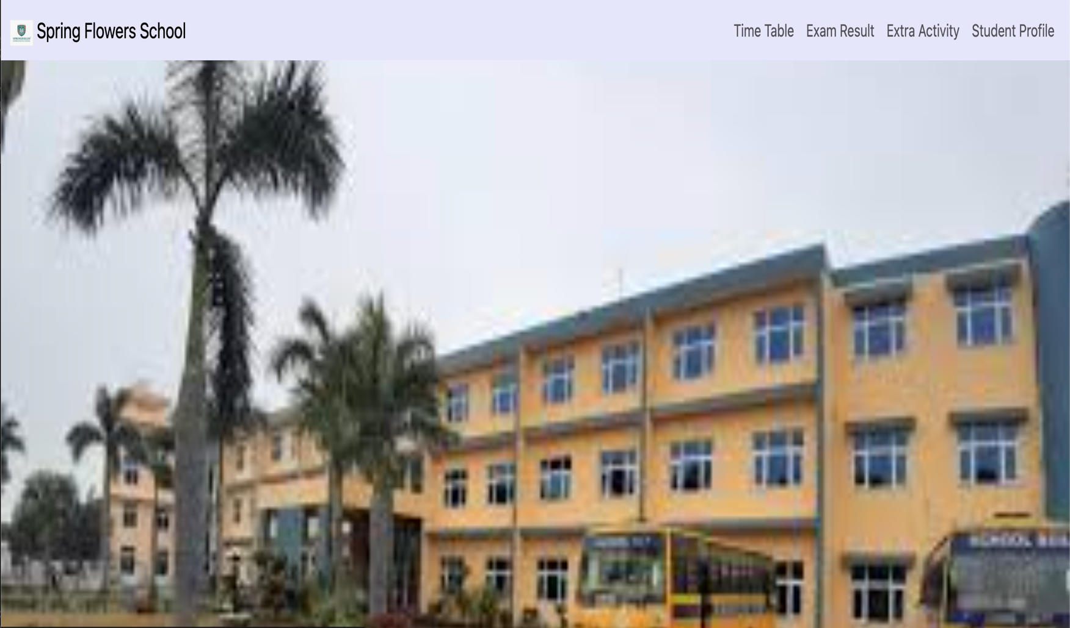

**7.2 Checkpoint – 2:**

Home page

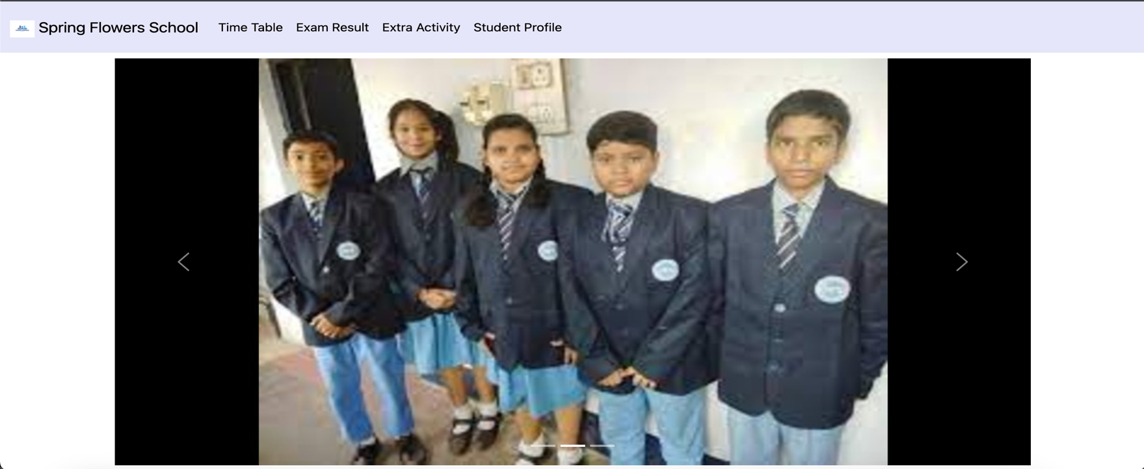

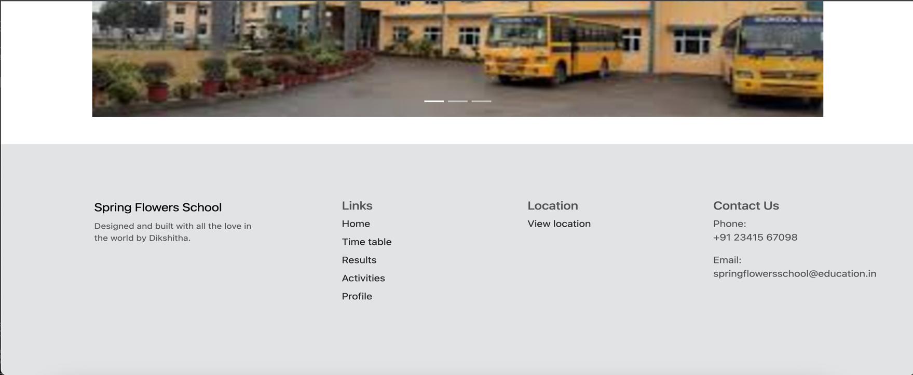

Timetable page

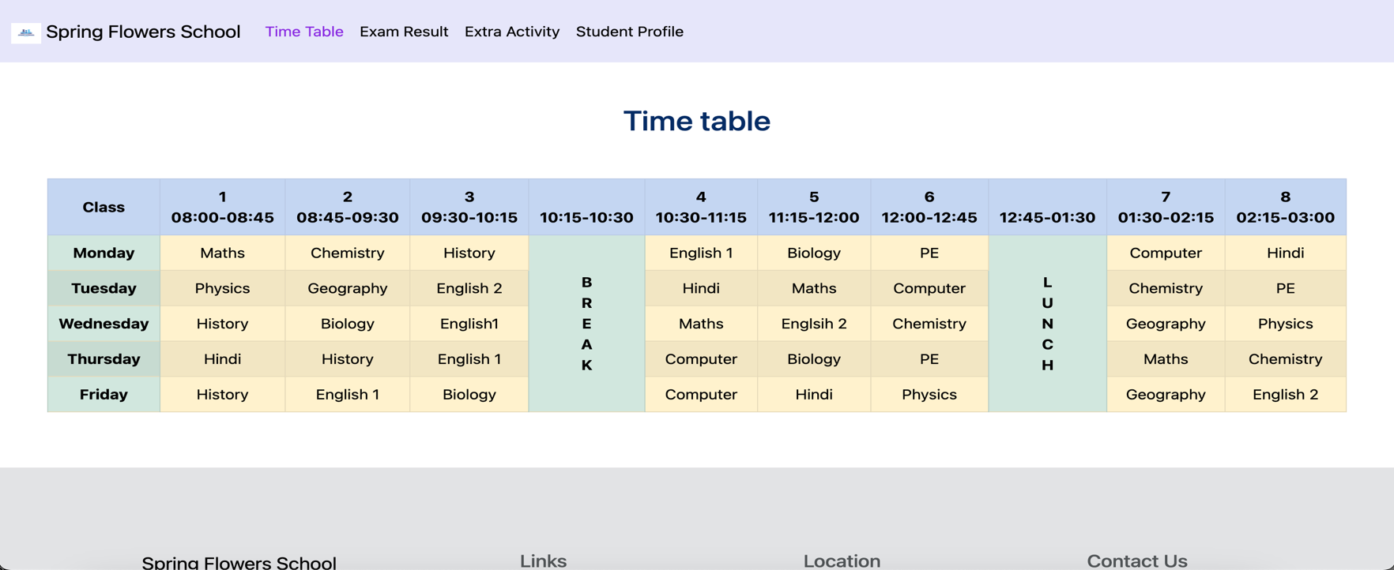

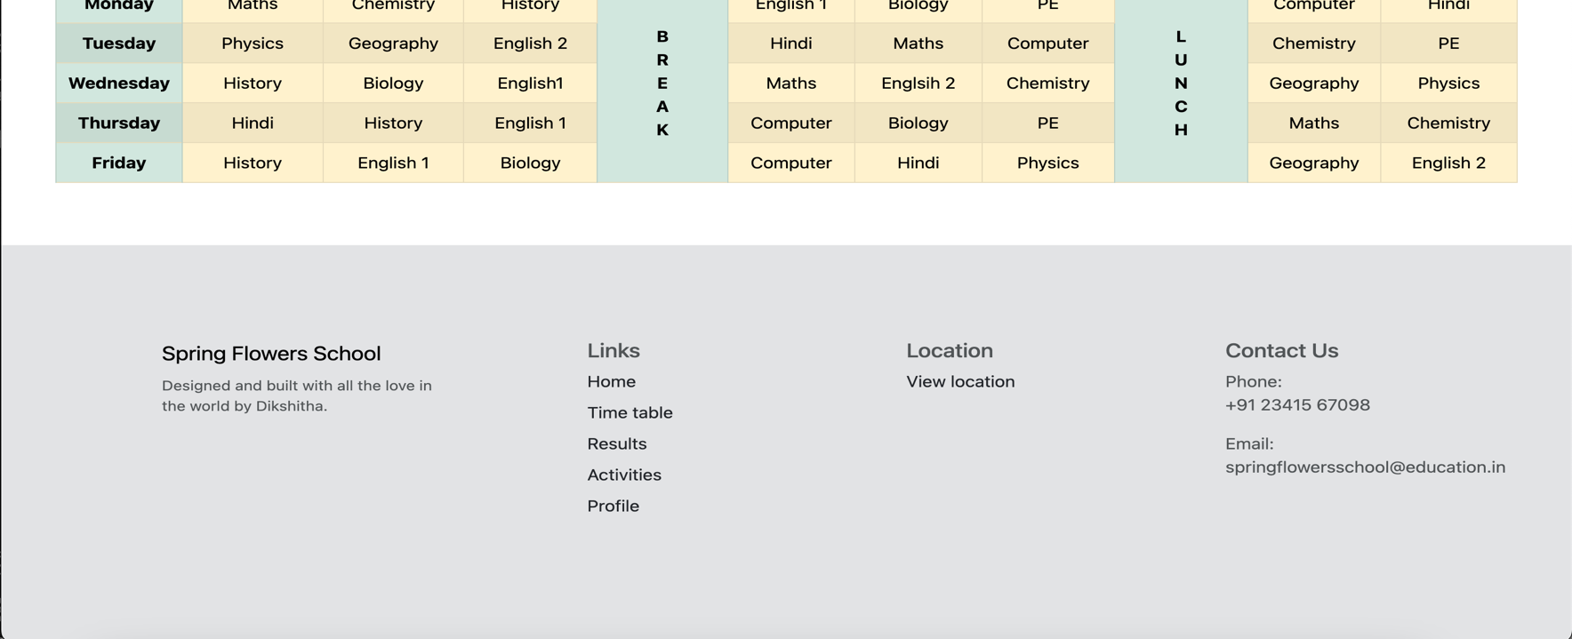

Exam result page

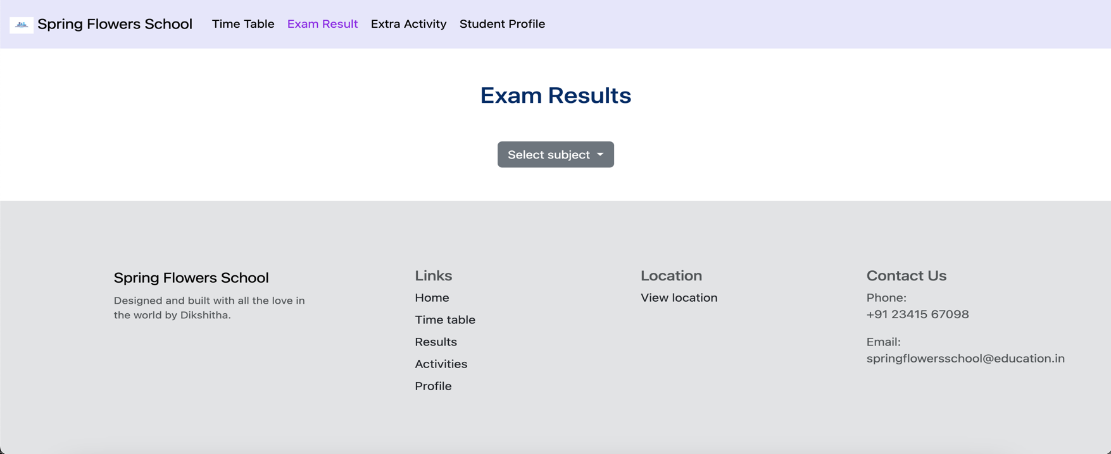

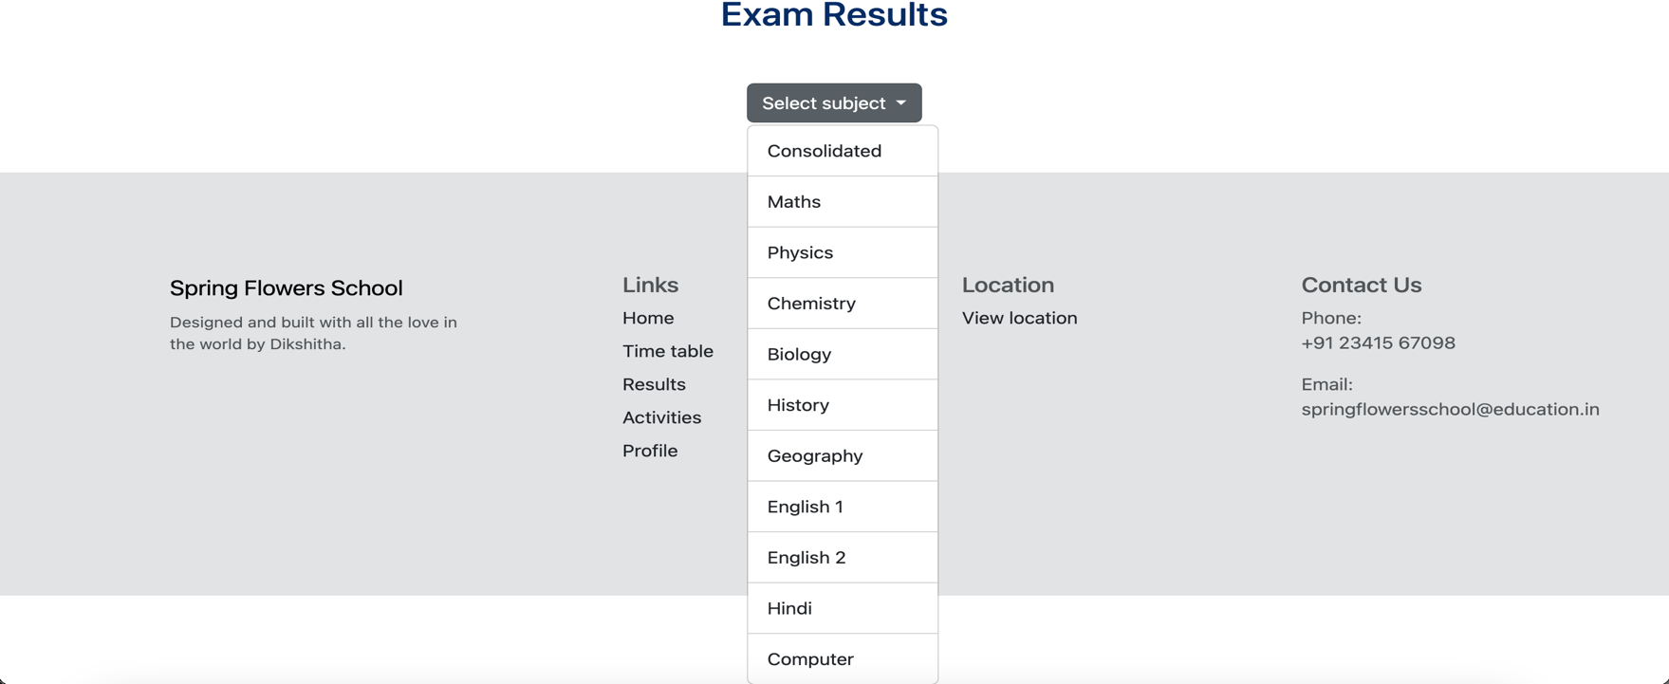

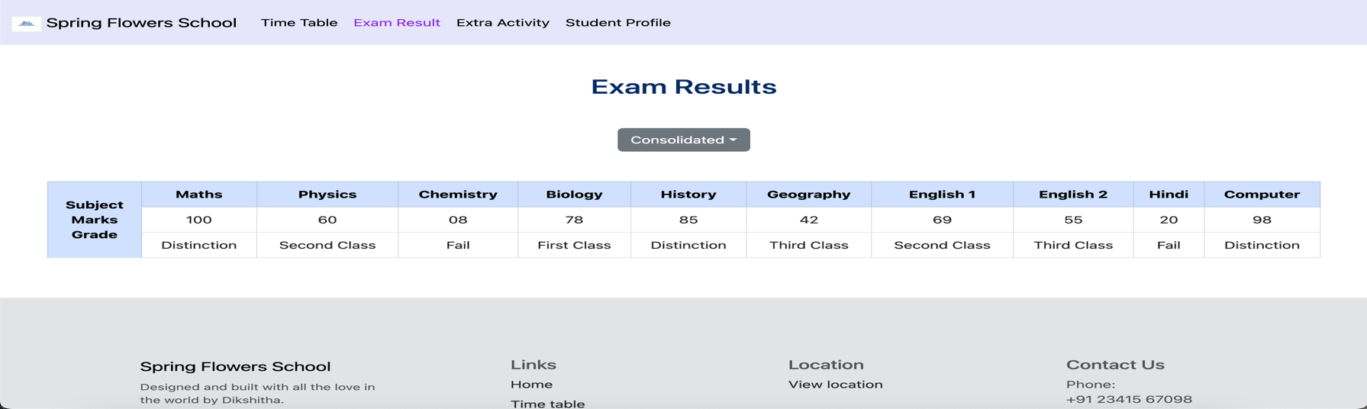

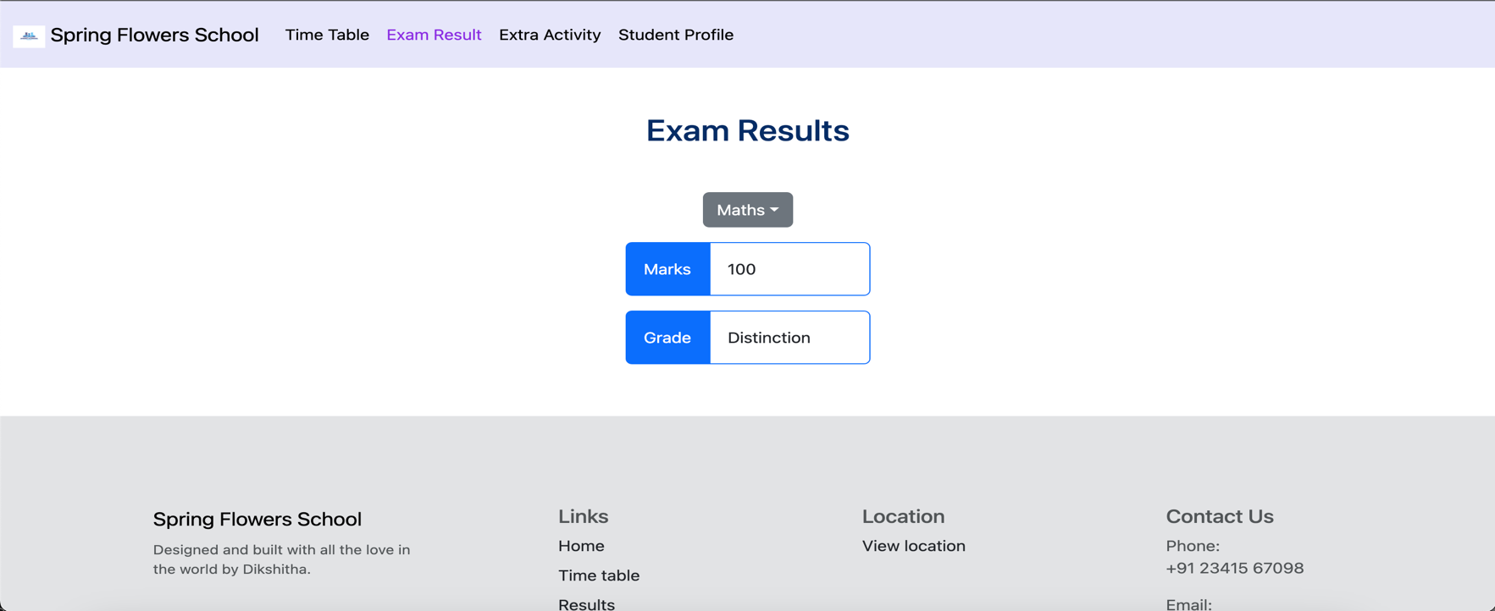

Student profile page

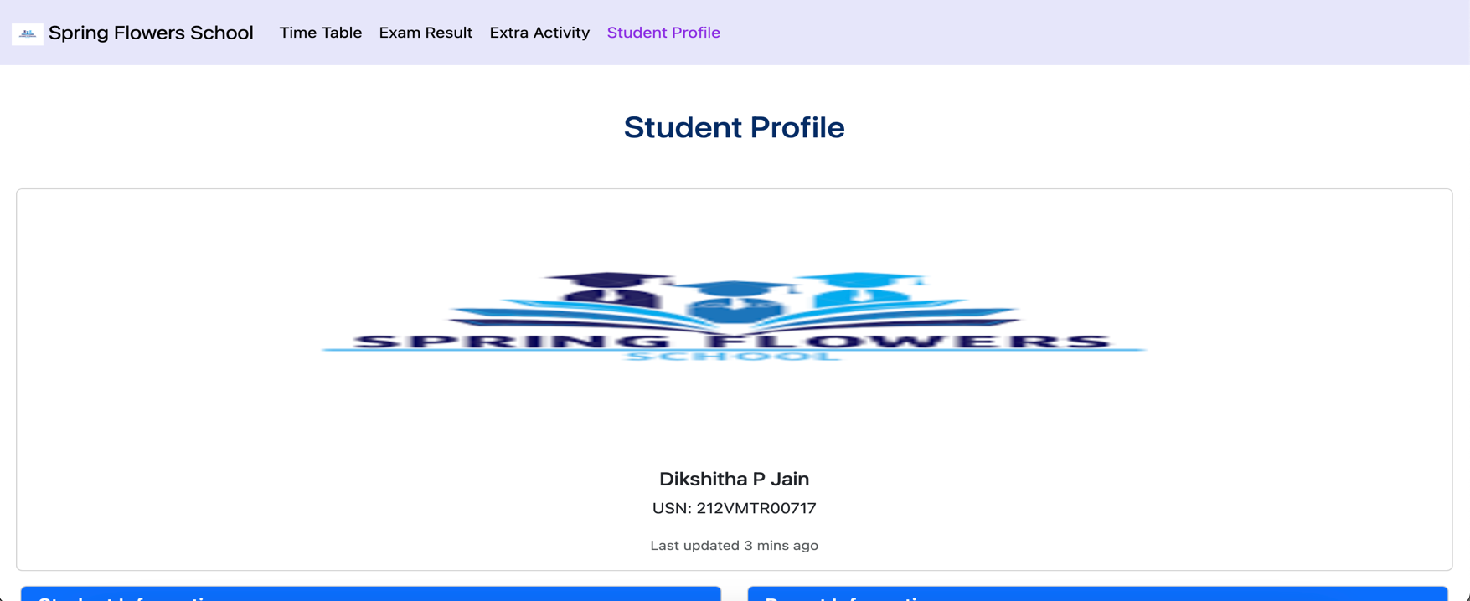

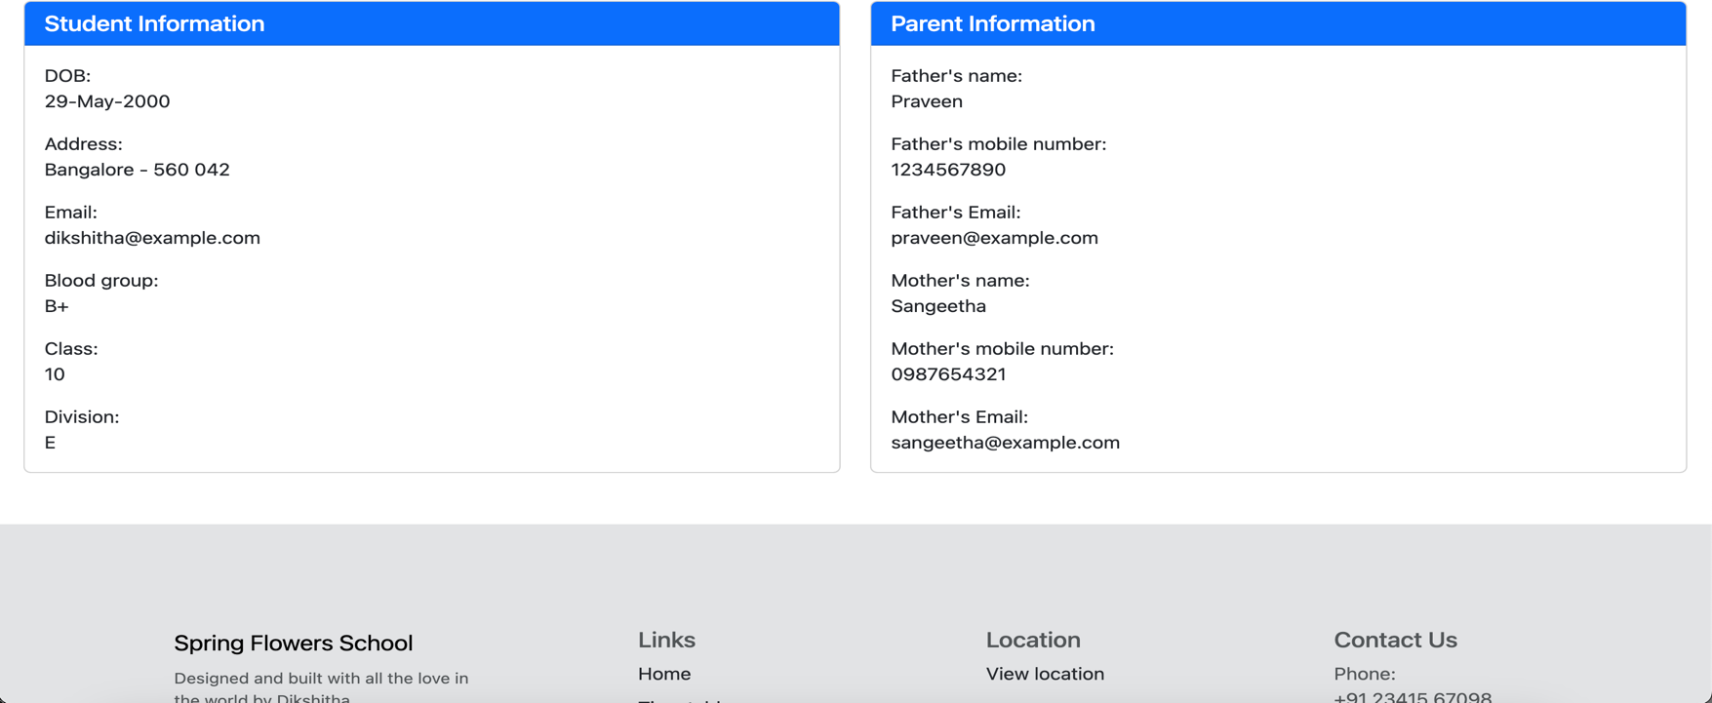

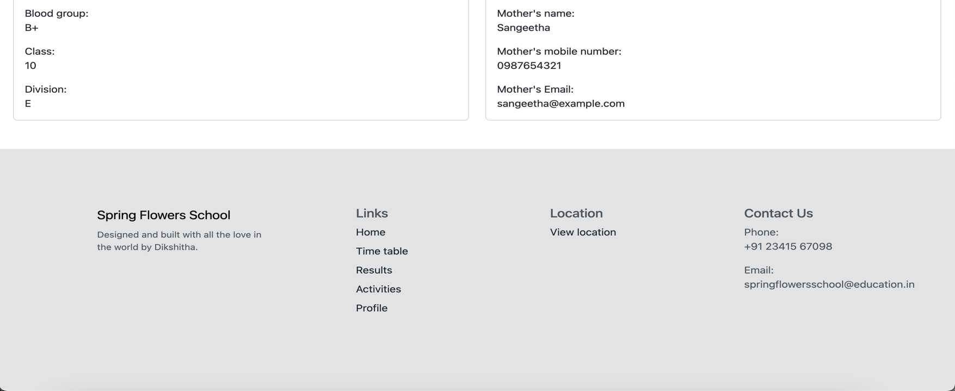

**7.3 Checkpoint – 3:**

Login page

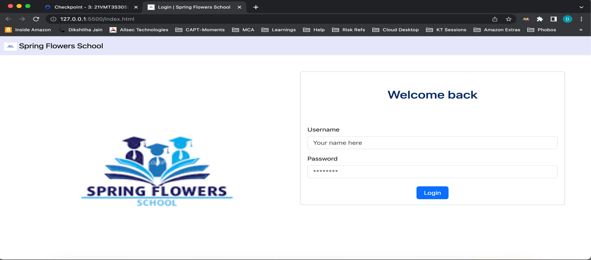

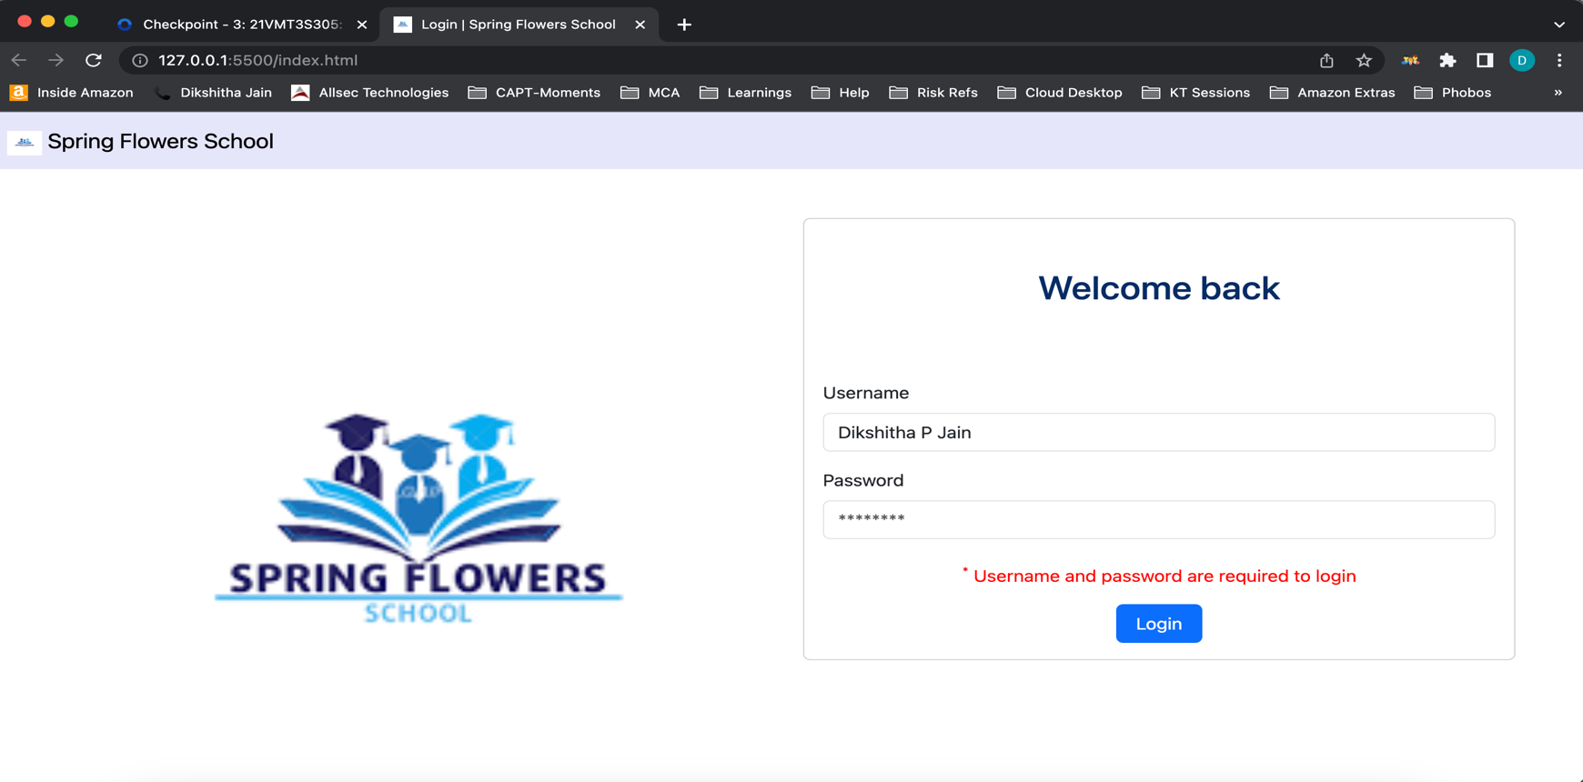

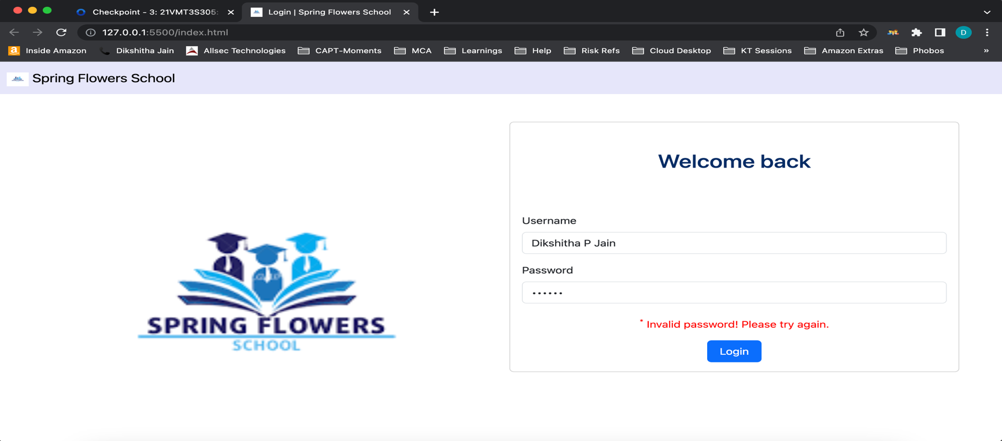

Home page

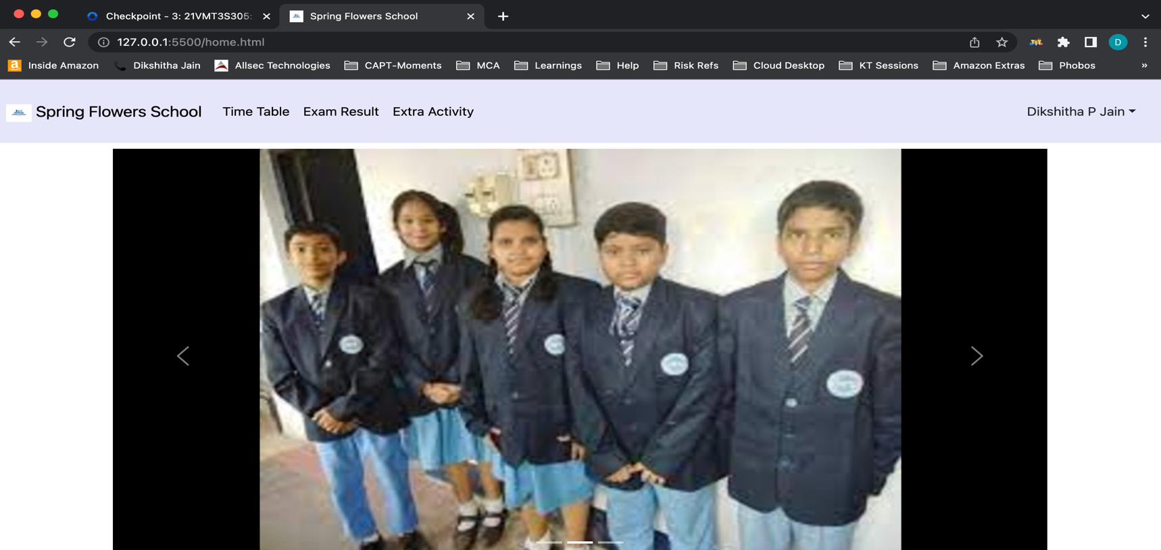

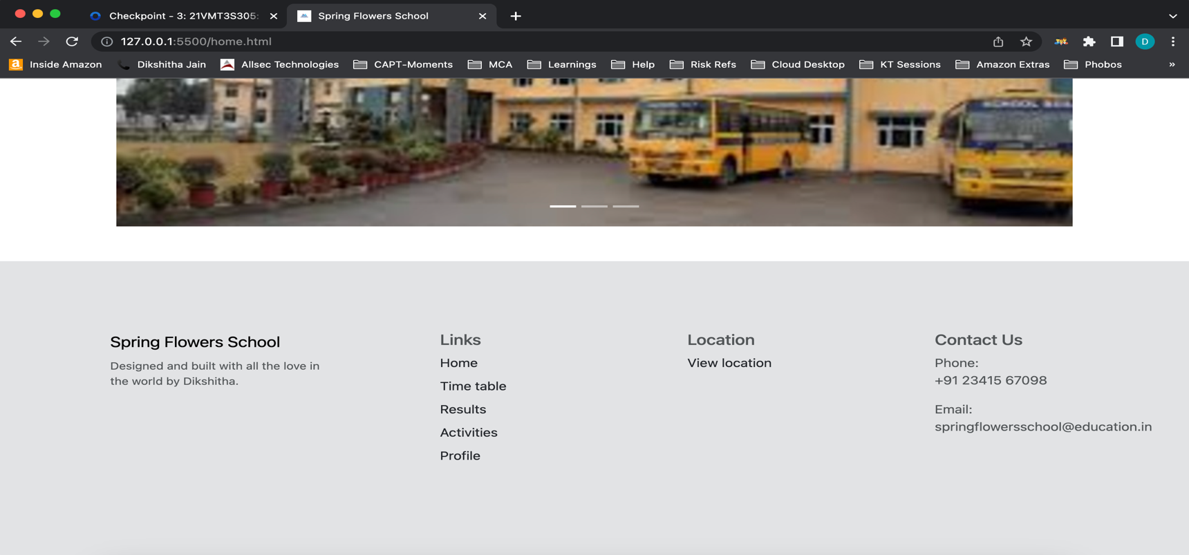

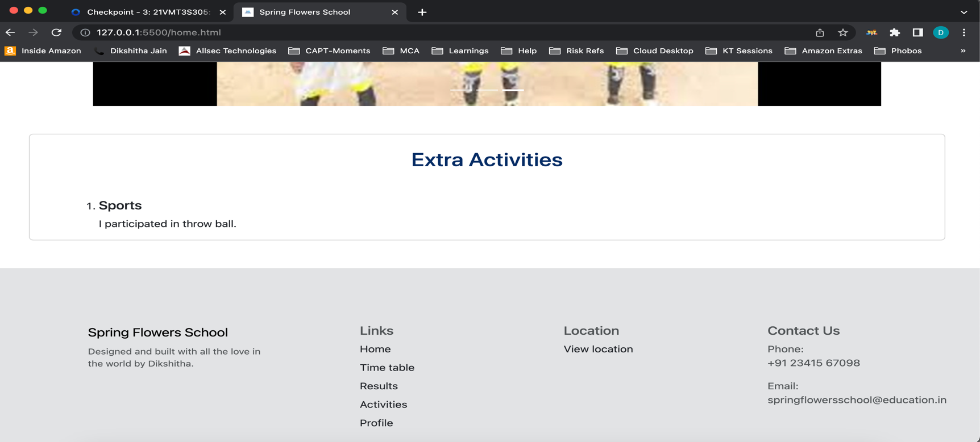

Timetable page

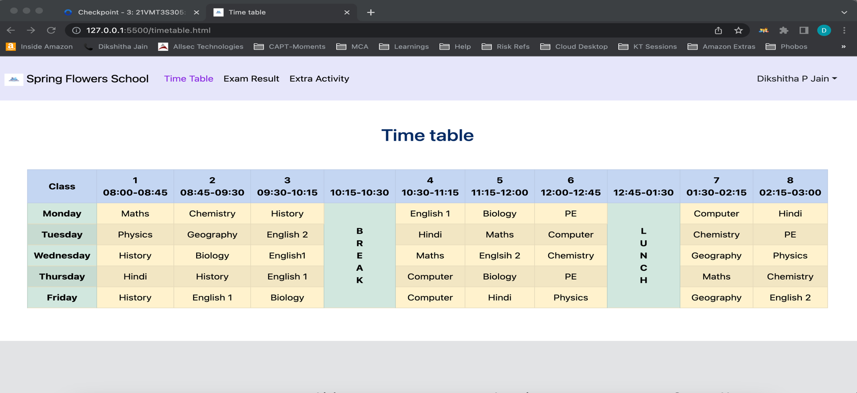

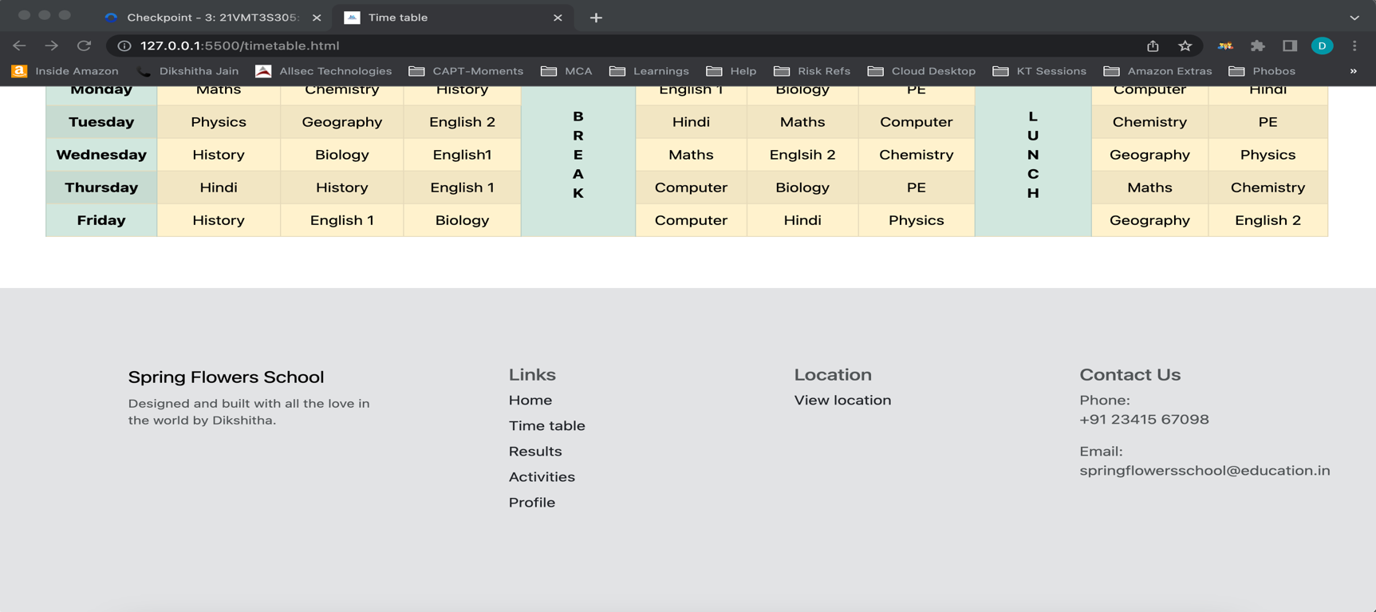

Exam Result page

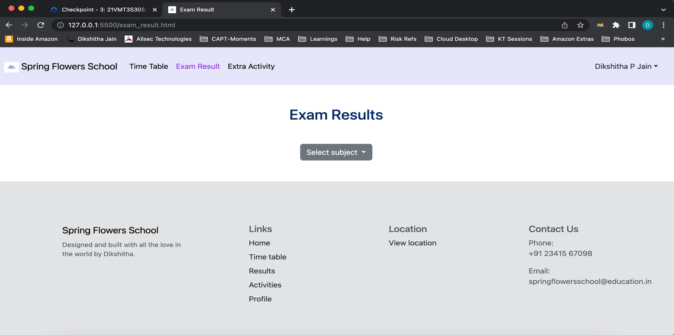

Extra activity page

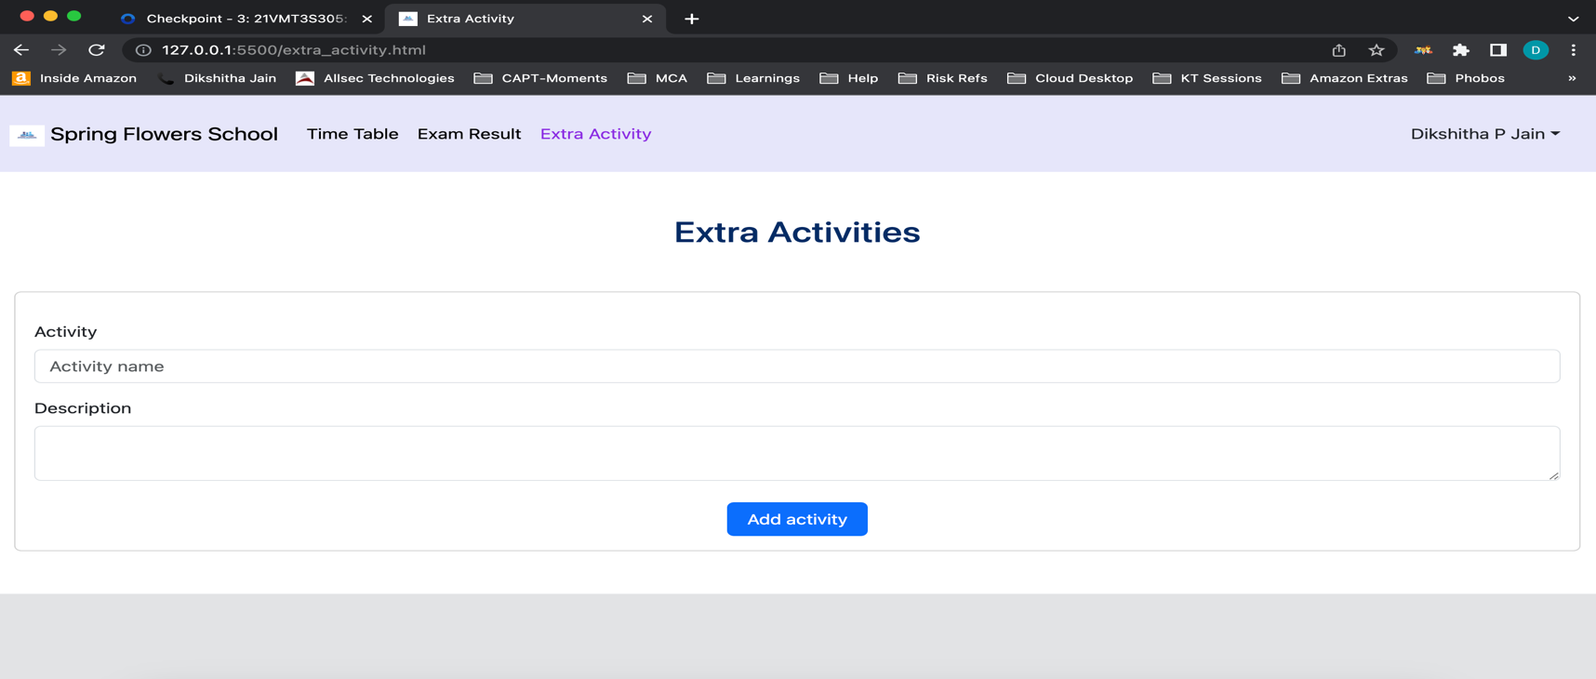

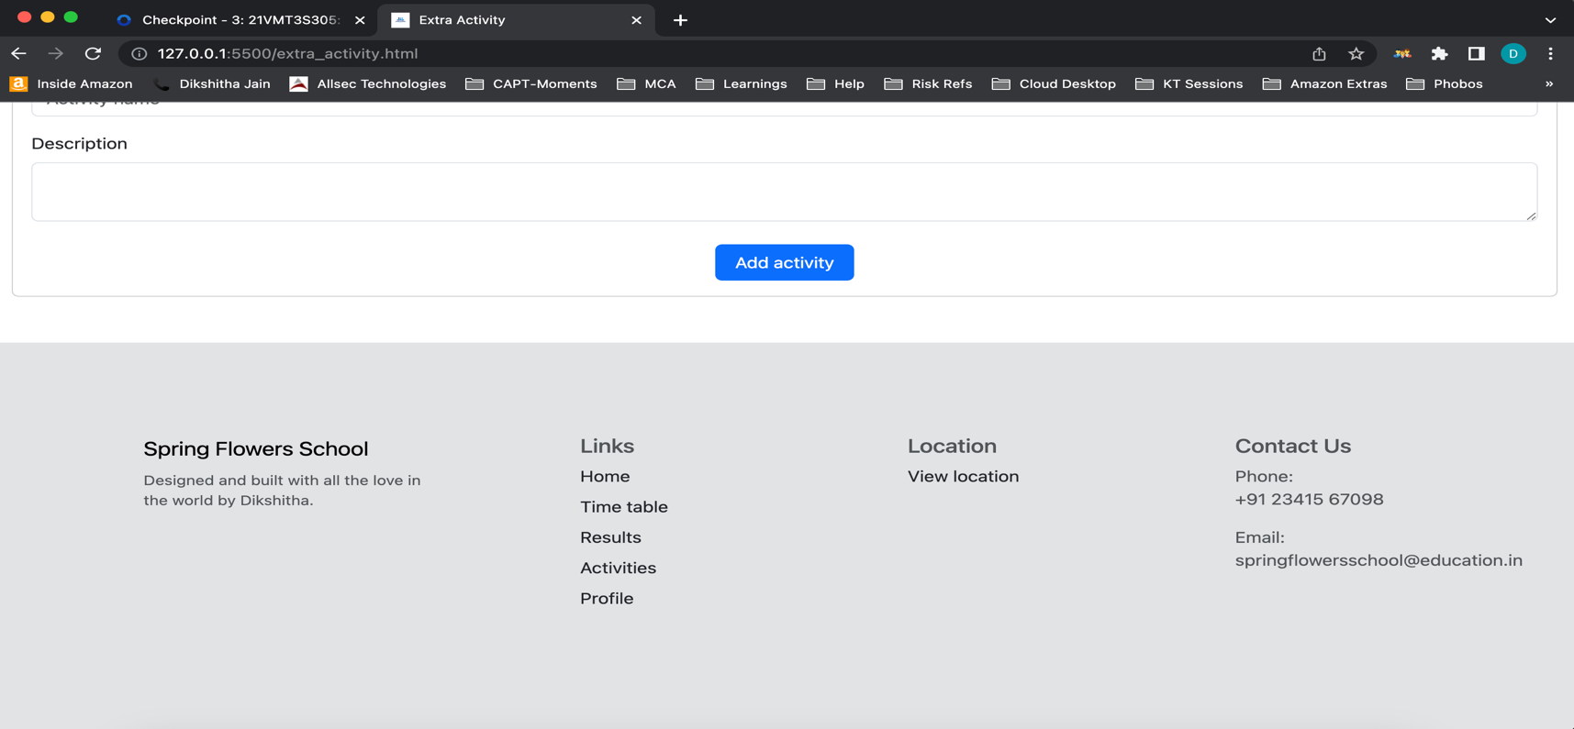

Profile page

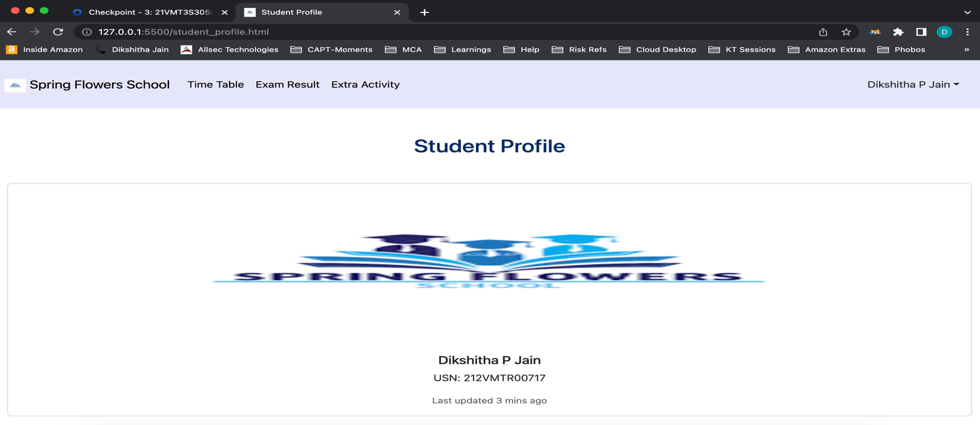

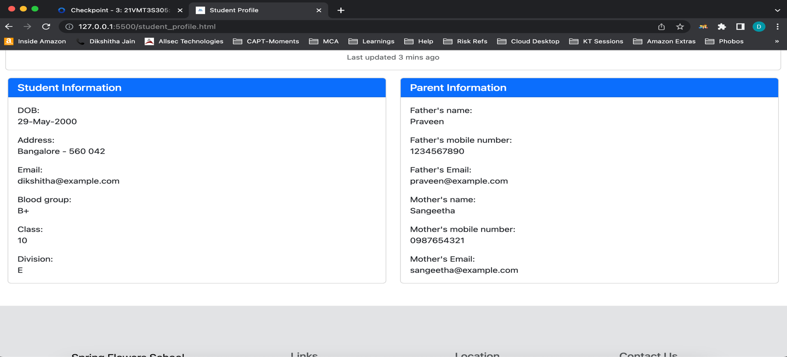

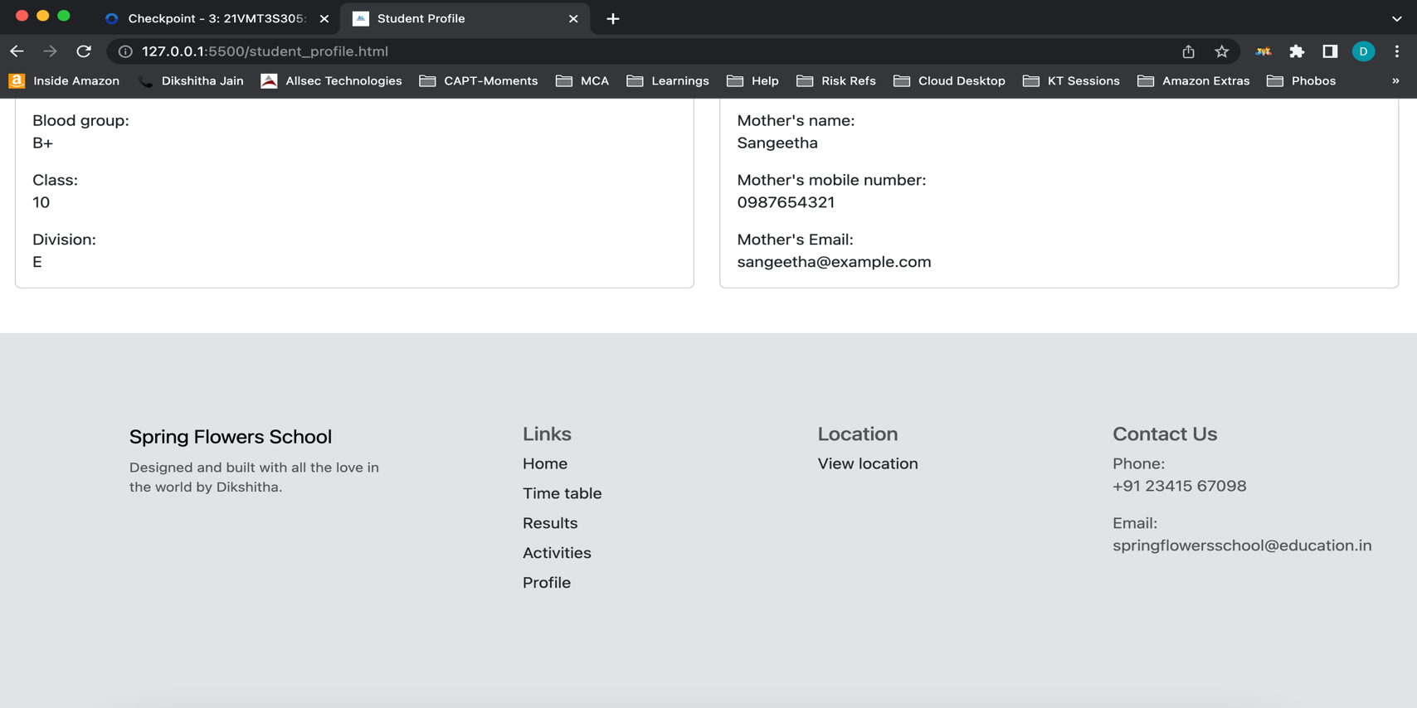

**7.4 Checkpoint – 4:**

Login page

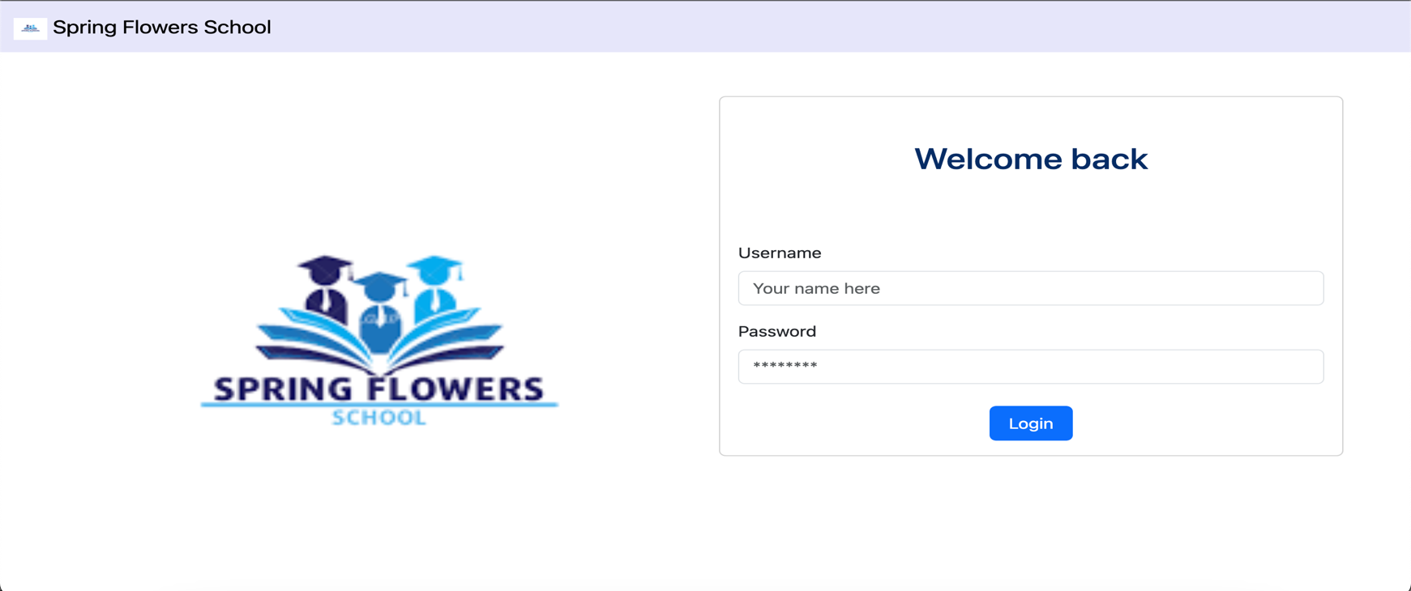

Home page

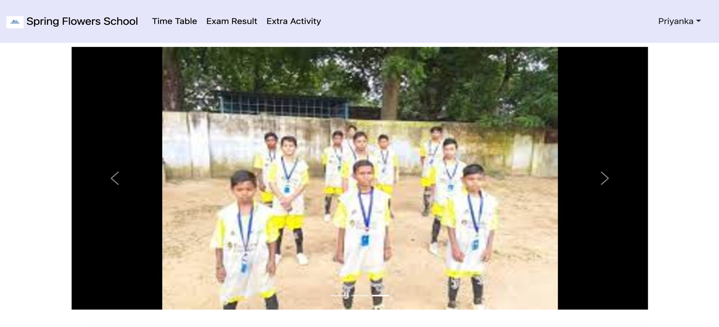

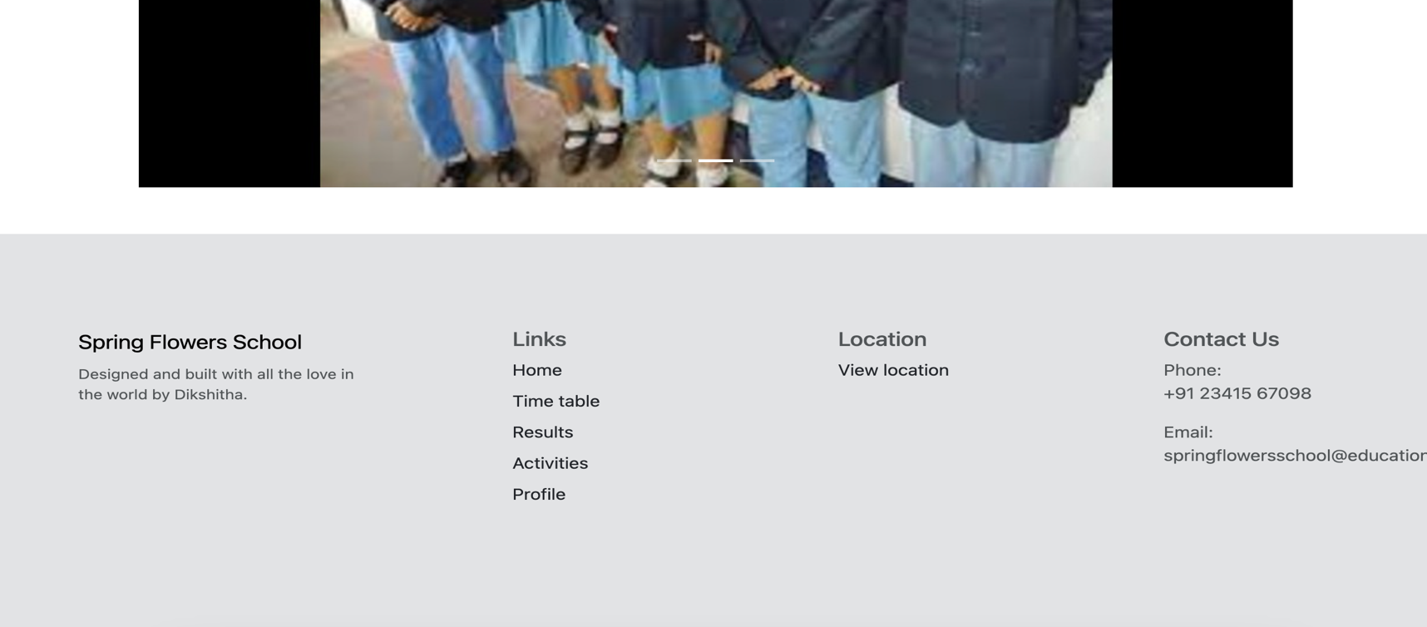

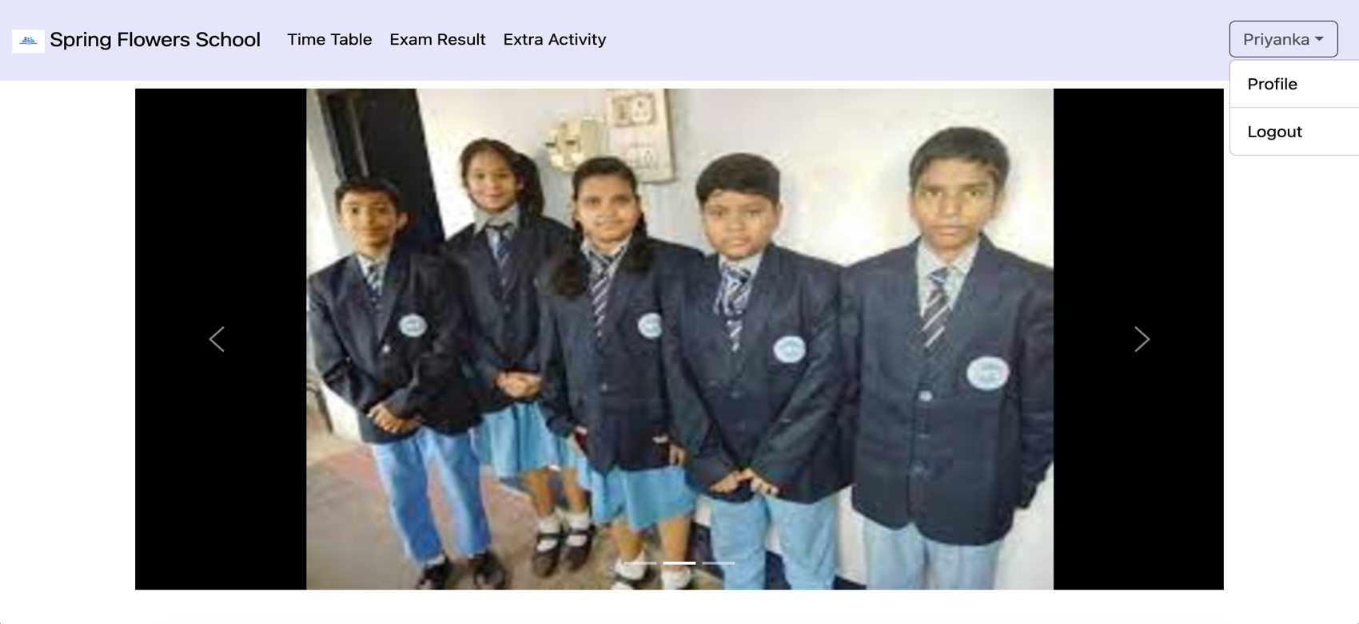

Timetable page

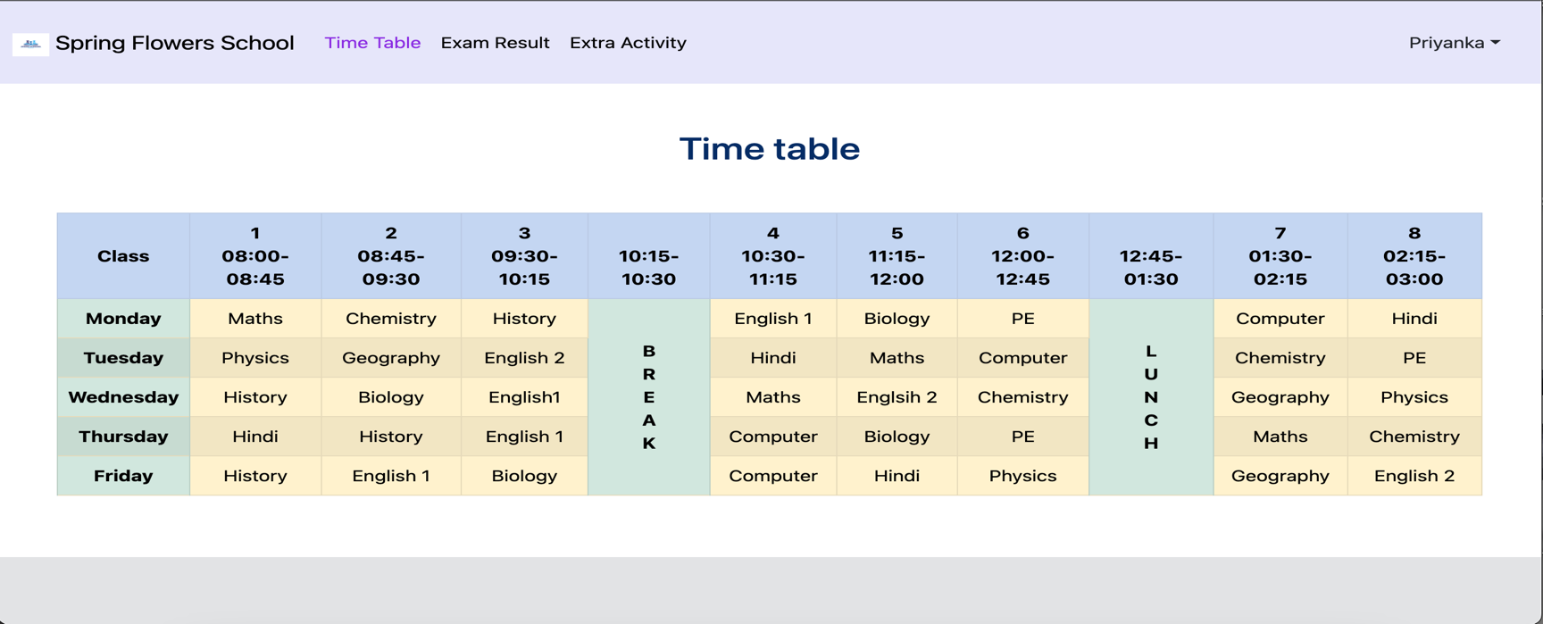

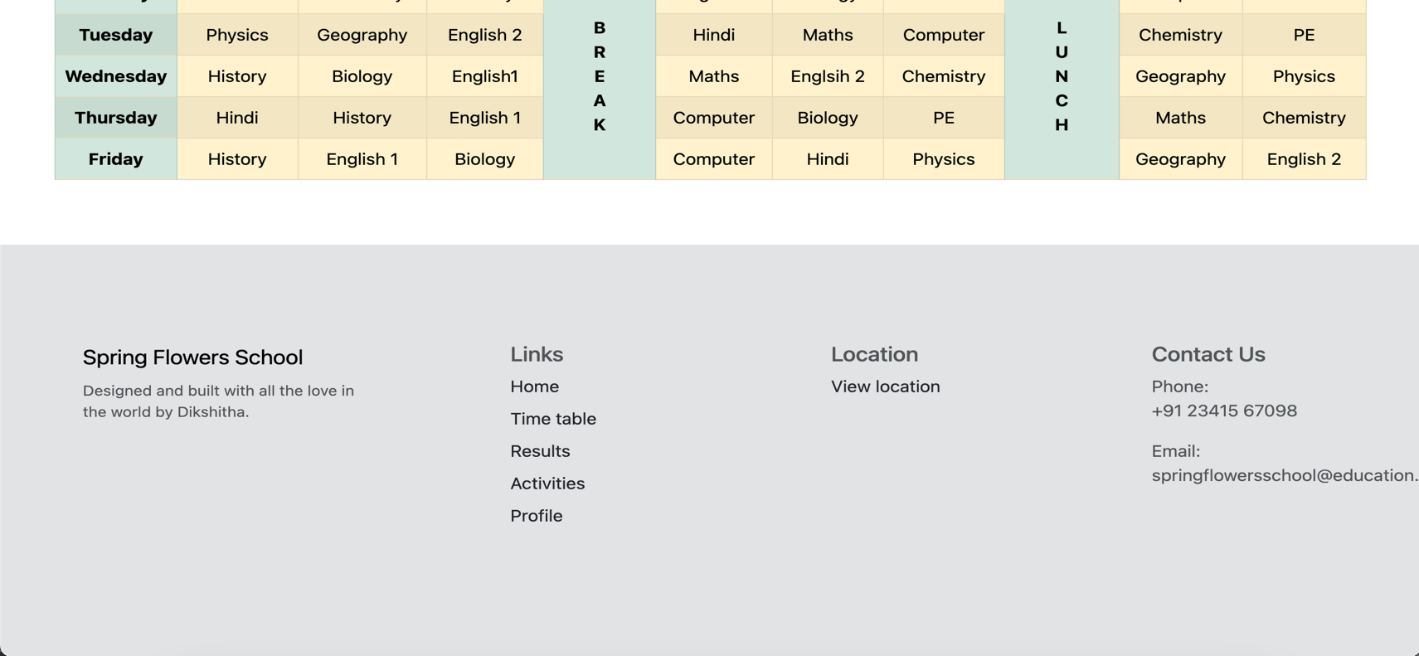

Exam result page

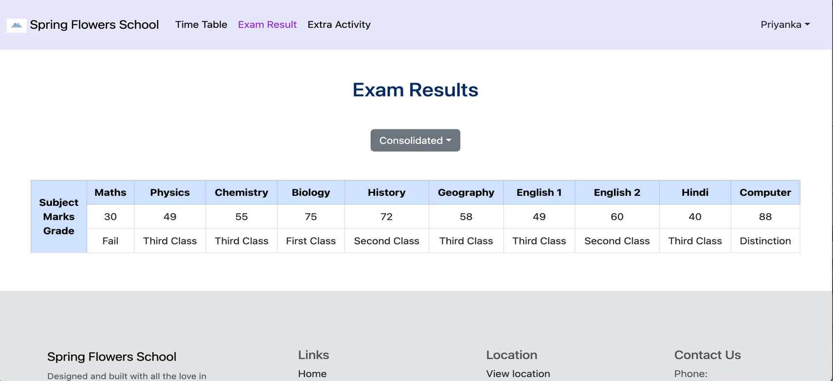

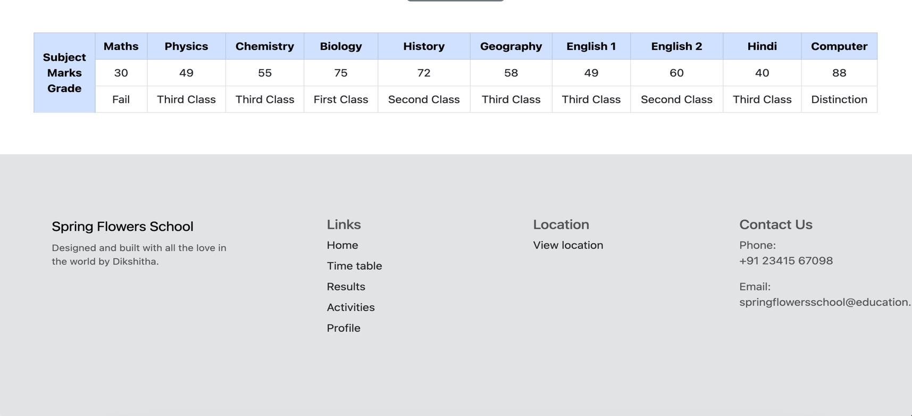

Extra activity page

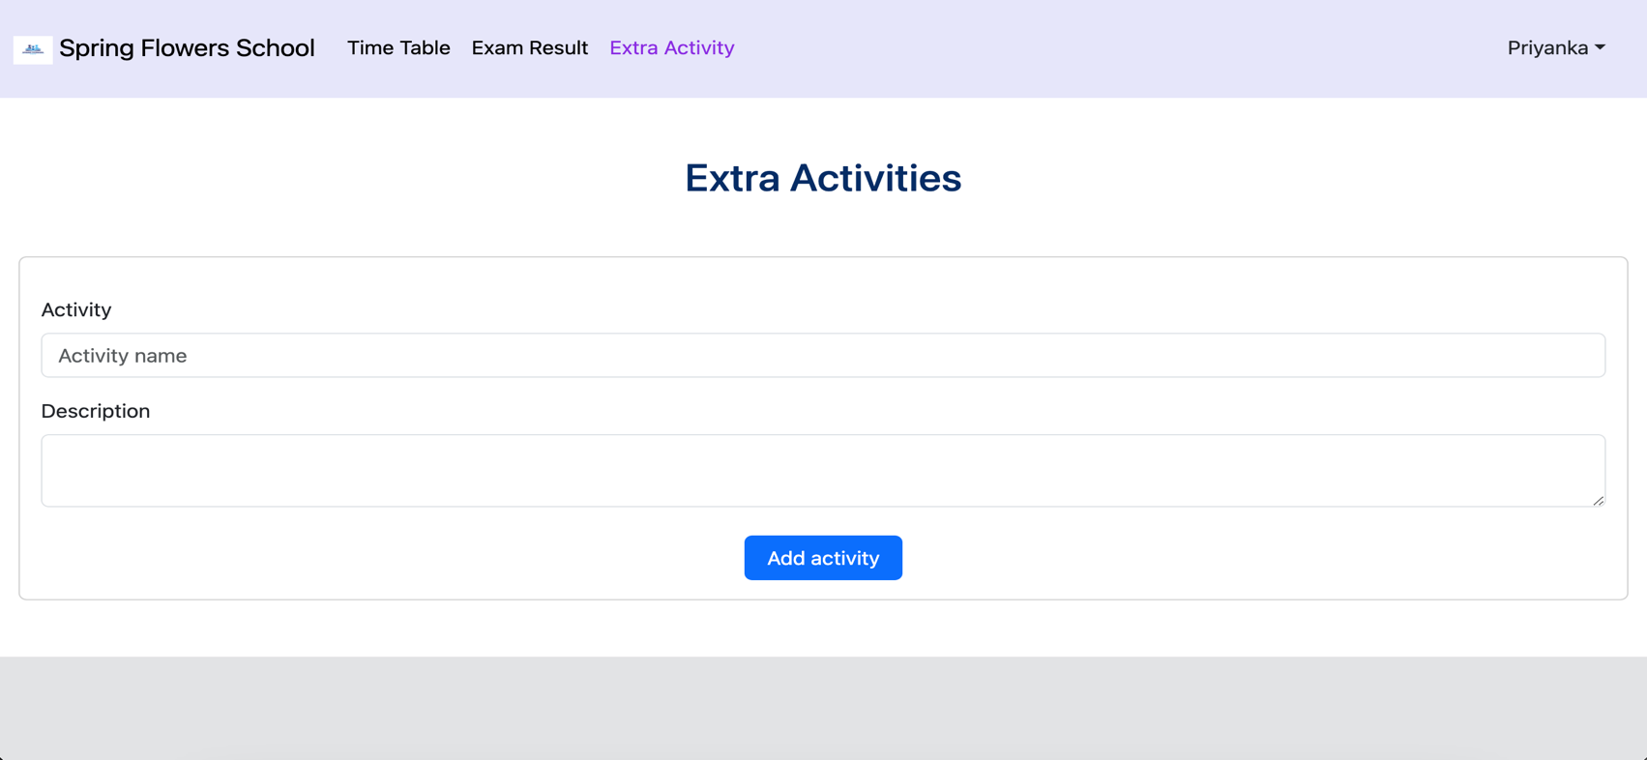

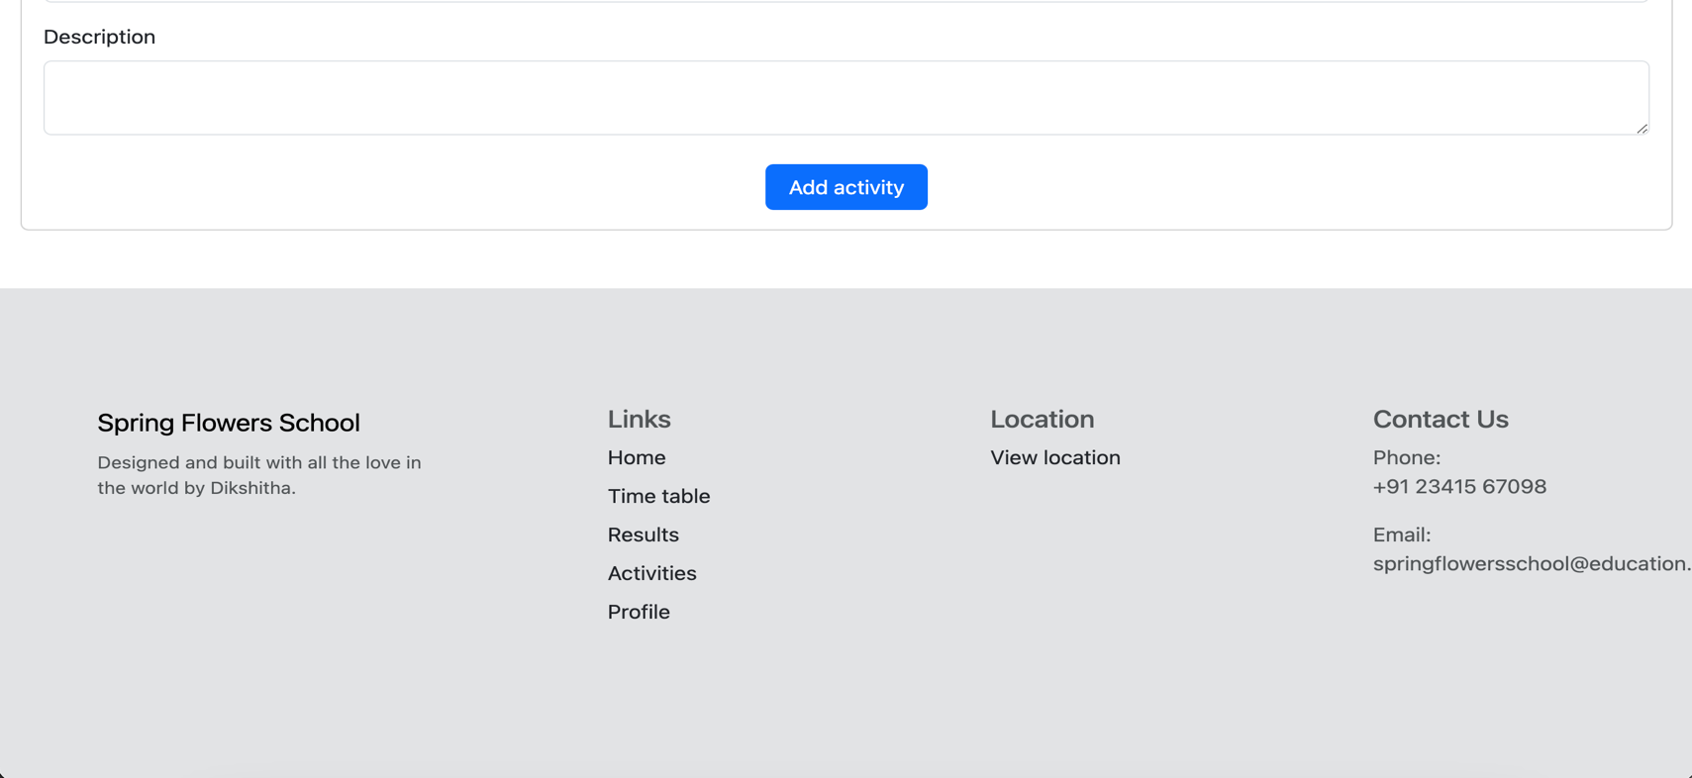

Student profile page

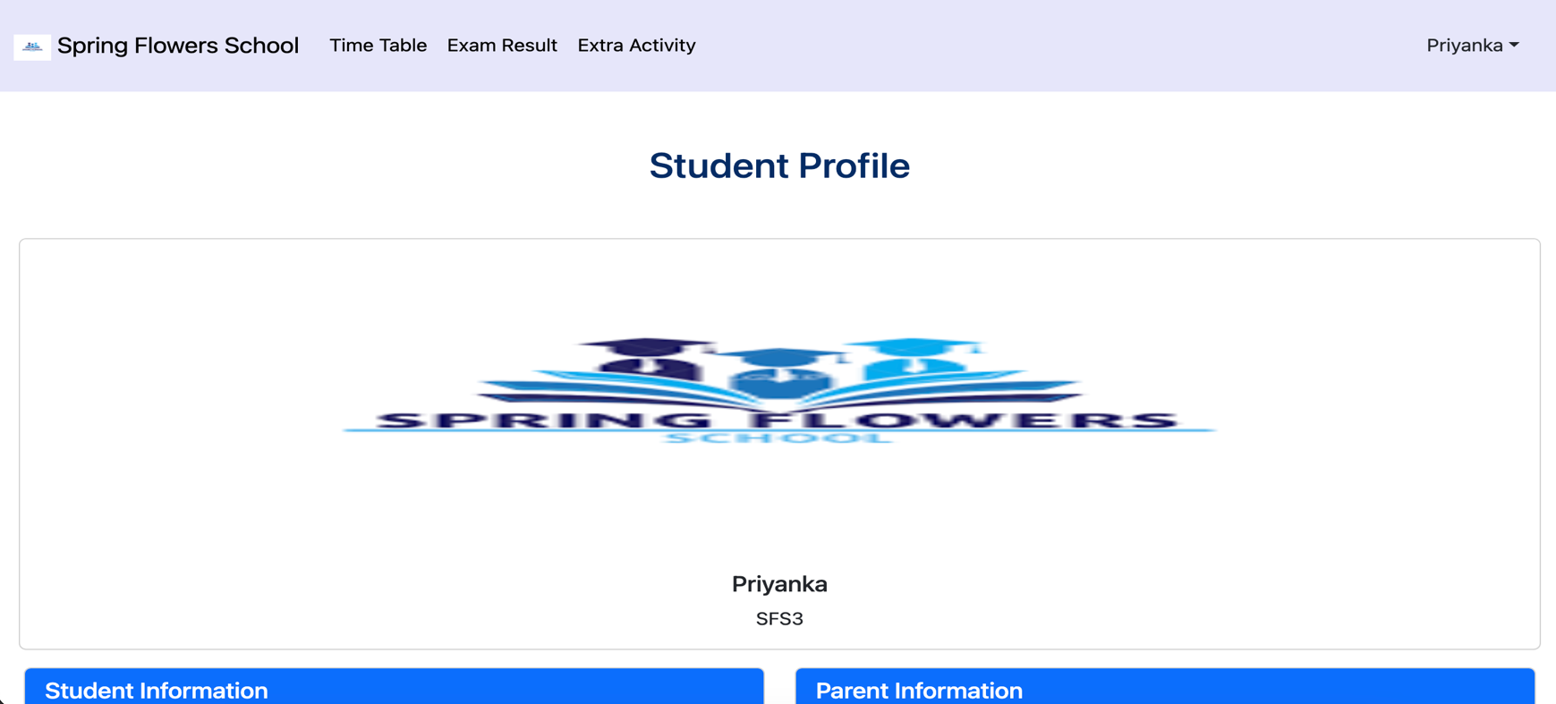

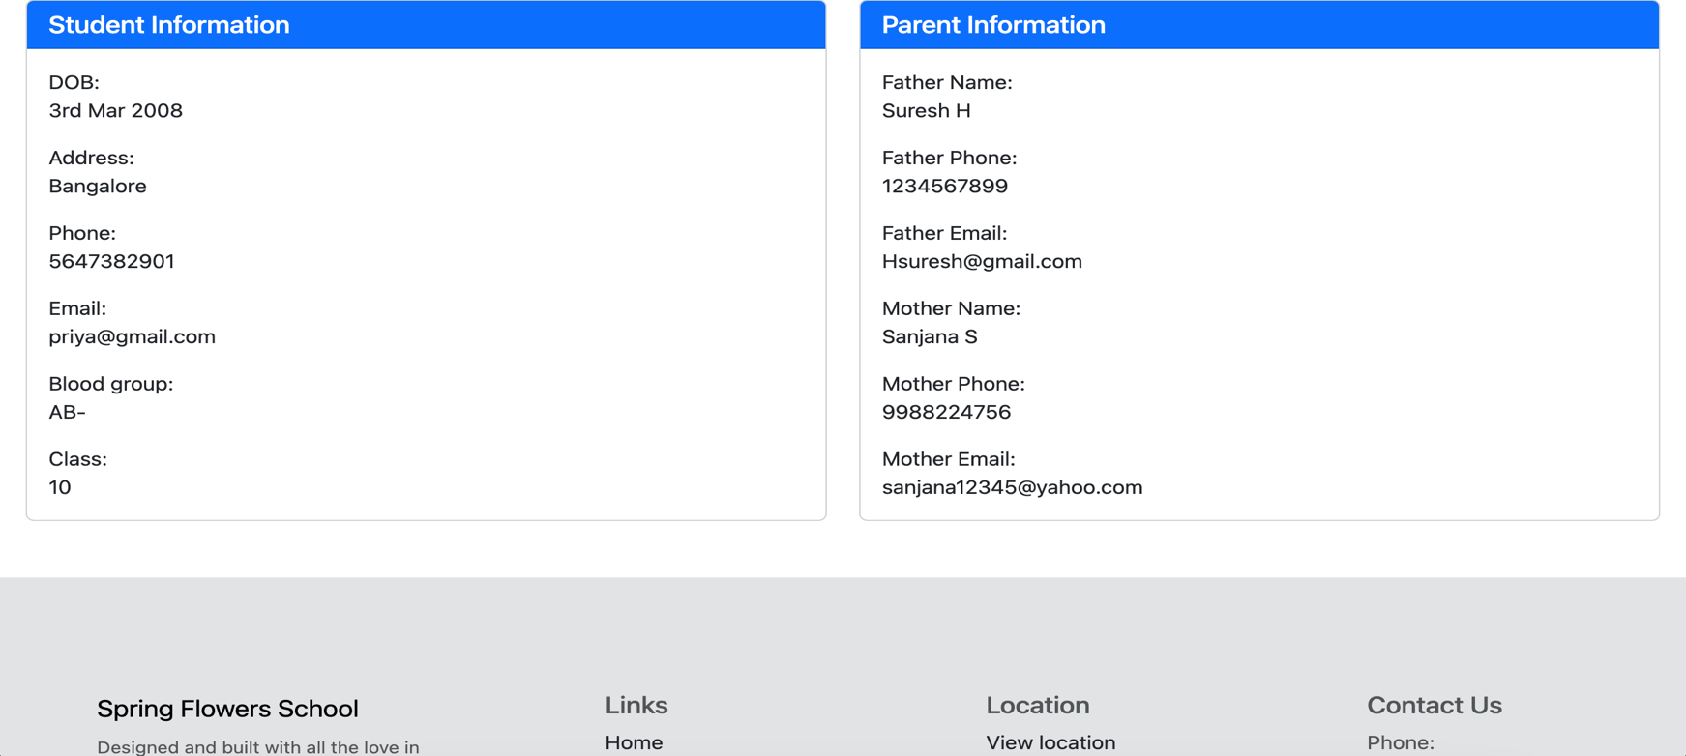

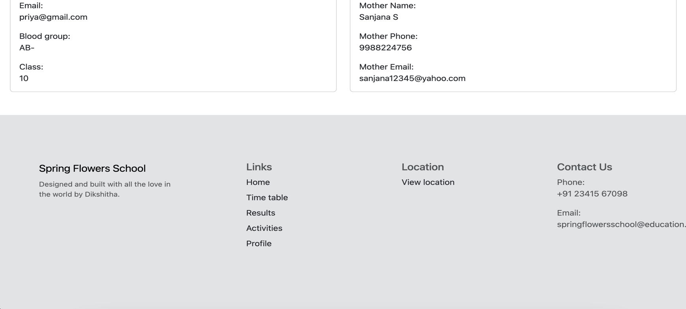

# Validation

1. A user is allowed to access the portal only upon successful login.
2. A user can add an activity only if both activity name and description is provided.
3. Once logged out, a user cannot go back to the previous page.

# Conclusion

A website has successfully been created for Spring Flowers School with all the required features. The project has been accomplished in 4 major checkpoints. With each checkpoint a different feature has been added.

A student can find all the details of their life at Spring flowers by simply logging into the portal by using their username and password.